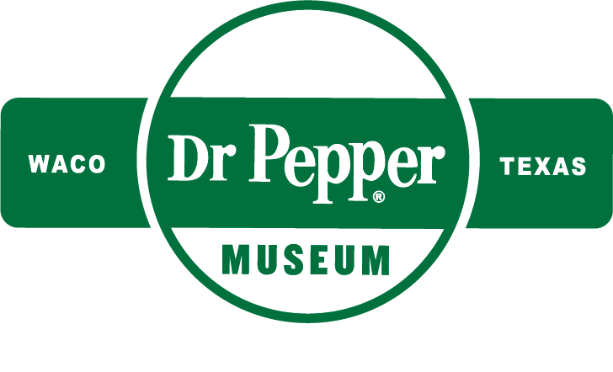
Make-A-Soda
FIELD TRIP
at the Dr Pepper Museum

Let us help you make the most of your
Dr Pepper Museum Fieldtrip!

Dear Teachers,
Thank you for booking a field trip with the Dr Pepper Museum! To ensure a smooth experience and help you make the most of your field trip we have provided you with multiple resources.
We understand that teachers are busy and planning a field trip can be complicated. To aide you in preparing for your field trip, we have an included teacher checklists, overviews for both teachers and students, and an order form parents. Please review, edit, and use them to benefit your class.
At the Museum, we believe that a meaningful field trip is more than just the hours you spend at the Museum. It begins with you in your classroom. By facilitating lessons in your classroom that relate to the fieldtrip, your visit can deepen your students’ understanding of concepts. To help you do this, we have multiple free lesson plans and resources available on our website for you to utilize.
Thank you,
The Dr Pepper Museum Education Team

Table of Contents
Teacher Checklist
Museum Overview for Teachers
Parent Letter/Fieldtrip Form
Museum Overview for Chaperones

Field Trip Checklist
PRE-FIELDTRIP
- Book your field trip on the Dr Pepper Museum website
- Complete paperwork for your district
- Schedule transportation
- Distribute permission slips
- Send home parent letters/fieldtrip forms
- Ensure a minimum 10:1 ratio of students to adults
- Collect student field trip money
- Complete the form email from the Museum to confirm the number of people attending and order Little Pepper Books, Float Upgrades, or Goodie Bags if you haven’t already done so.
- Provide an overview of the Museum for students
- Facilitate a lesson(s) about Museum content
- Check for any updates on Museum parking or procedures

DURING FIELDTRIP
- Ensure all supplies required by your district are on the bus (ex: medicine, paperwork, or school phone)
- Ensure all students have a lunch and resources (ex: optional worksheets)
- Arrive at the Museum 15 to 5 minutes prior to your field trip start time
- Drop students and teachers off at drop off on the side of the building
- Gather students at the picnic tables
- Send one teacher to meet with the Museum staff at the admissions desk to pay for the field trip and collect wrist bands
- The Museum staff will take it from there

AFTER FIELDTRIP
- Gather students at the picnic tables
- Distribute Dr Pepper to students either in the courtyard or put them on the bus
- Facilitate lunch in the courtyard allowing for bathroom breaks using the Museum’s lobby restrooms
- Count students to ensure every student is with the group and on the bus
- Facilitate a relevant lesson upon returning to school or the next day
Museum Overview: Teachers
Field Trip Information:
- Length: 1 Hour
- Price: $7 per participant (students, parents, teachers, and bus drivers)
- Includes: Make-A-Soda Field Trip
  - Admission to both Museum buildings and all exhibits
  - Introduction and informal gallery talks from Museum educators
  - 1 hour self-guided tour of the Museum galleries
  - 1 hour facilitated Make-A-Soda program in which all participants can make 1 bottle of soda
  - 1 can of Dr Pepper per participant
- Location: The Dr Pepper Museum
300 South 5th Street
Waco, TX 76701
- Parking: Buses cannot park in the Museum lot
  - Students should be dropped off on of the side of the main building, at Mary and 5th Street
  - Buses can pay to park down the block at University Baptist Church or park in free parking elsewhere downtown
Museum Overview:
- Museum Mission: The Museum’s mission is to educate and entertain the general public through the collection, preservation, interpretation, and exhibition of objects relevant to the history of the soft drink industry, and through that example, the free enterprise economic system.
- Buildings: The Museum is located in downtown Waco in two historic Buildings. The main Museum building was the Artesian Manufacturing and Bottling Company building and was where Dr Pepper was first bottled on a large scale. The Museum’s second building was the Kellum Rotan Grocery Store, one of the oldest buildings in downtown.
- Exhibits: The Museum is constantly changing, so you can expect to see different exhibits when you visit each year. Exhibits span both Museum buildings and vary in topics. Our permanent exhibits include, but are not limited to: a model of the Old Corner Drug Store, an exhibit about the historic bottling factory, an exhibit about advertising in gas stations, an exhibit about beverage chemistry, an exhibit on entrepreneurship, and an exhibit about Lunch Counter protests. In addition to our many permanent exhibits, we have multiple exhibits that showcase advertisements in the beverage industry, connecting them to history and modern media literacy. For more details about our current exhibits, visit the Museum’s website.
- Dr Pepper History: Dr Pepper was invented in 1885 in the Old Corner Drug Store in Waco, Texas by Dr. Charles Alderton. Originally, it was created and sold as a medicine; carbonated water was seen as a cure-all medicine that unfortunately was bad tasting, so flavored syrup was added. As the soda grew in popularity and machines improved, Dr Pepper was made on a large scale by the Circle A company in the building that is now the main Museum building. Throughout the years, Dr Pepper and the soft drink industry have changed in response to innovative discoveries and social changes. One notable change it was advertised as a medicine, then a health drink, and is now a treat. Today, Dr Pepper is a member of the Keurig Dr Pepper Company’s family of brands.

Tips for a smooth visit:
- Prepare Groups of Students: The Museum educator will ask that students be separated into small groups with a chaperone or teacher for both the self-guided tour and the Make-A-Soda portion. By taking the time to plan ahead which students will be with which adult, you can add 15 minutes of directing adults and kids that could be used having fun in the Museum.
  - If you have more than 30 students in the group, be prepared to split the entire group into two smaller groups so that half can attend Make-A-Soda while the other half attend the tour, then switch.
  - Museum staff will assume a minimum of 5 students will be in each group, but teachers are welcome to have more.
- Tell Students Your Schedule: Just like in the classroom, on a field trip students have difficulty learning if they are worrying about physical needs like food and safety. You can help your students be ready to learn by telling them when they will eat, when they can go to the restroom, and what they will be doing after the field trip.
- Introduce the Museum Before You Arrive: To make the most of your field trip, give students an overview of the Museum and your learning objectives before they arrive. You can utilize resources provided by the Museum to do a simple introduction or facilitate relevant lessons.
- Email us if you have a project! Our educators would love to know if you have a project or particular TEKS you are connecting to the field trip in advance so they can ensure your students learn about the topic you are interested in. Like most Museums, we connect to a broad range of topics and are happy to cater the field trip to your needs.

Teacher Resources:
- Lesson plans: The Museum offers free lesson plans, units, and resources that align with TEKS and connect to various grades and subjects. Visit the Museum website to download them for free.
- Virtual Field Trips: The Museum offers a free virtual tour that takes students around the Museum and includes information from various experts at the Museum. Also, the Museum offers a virtual fieldtrip that allows students to create, market, and budget for their own soda business; this field trip is available to purchase and download on the Museum website.
- Teacher Professional Development: The Museum offers multiple forms of professional development for CPE credits. Teachers can watch virtual professional development videos on the Museum website and Museum YouTube page. The Museum typically offers two in-person professional development sessions a year, visit the Museum website for an updated schedule.

How is this different than the Create a Soft Drink Field Trip?
- The Make-A-Soda Field Trip is the new and improved version of the Create a Soft Drink field trip the Museum has offered in the past. This new version of the field trip has some changes to ensure food safety standards are met and to make the experience overall better for students. The changes include…
  - The tour portion of the field trip is self-guided, allowing groups to spend more time in exhibits that interest them. The educator will still provide an introduction and will be facilitating informal gallery talks throughout the Museum.
  - Every student can make their own soda recipe to take home rather than picking one for their group. Then, students will work in a group to create a soft drink company.
  - Every participant, chaperones and teachers included, are invited to make a bottle of soda and to work with students to make soda companies.
  - Every participant, chaperones and teachers included, will receive a can of Dr Pepper at the end of the visit. Teachers are welcome to distribute these at school for kids to take at home rather than drink in the courtyard.

Our Class is Going on a Field Trip to the...
Dr Pepper Museum

LEARN ABOUT OUR TRIP:

When: insert date and time of trip
Where: The Dr Pepper Museum in Waco, Texas
Why: Briefly explain what the learning objective is for the trip. For example, to learn about persuasive writing.

What: provide a schedule for the day, including all stops and lunch breaks. For example:
9:00 – Leave school on buses
9:45 – Arrive at the Dr Pepper Museum
10:00 – Tour the Museum
11:00 – Make-A-Soda
11:00 – Drink Dr Pepper and eat lunch in the Museum courtyard

LEARN ABOUT THE DR PEPPER MUSEUM:

To help you get ready for your visit to the Dr Pepper Museum, here are some things you will learn about. Pick one topic you really want to learn more about.

  - Dr Pepper was invented in Texas.
  - In history, people believed that soda was healthy.
  - Dr Pepper advertises drinks in many different ways.
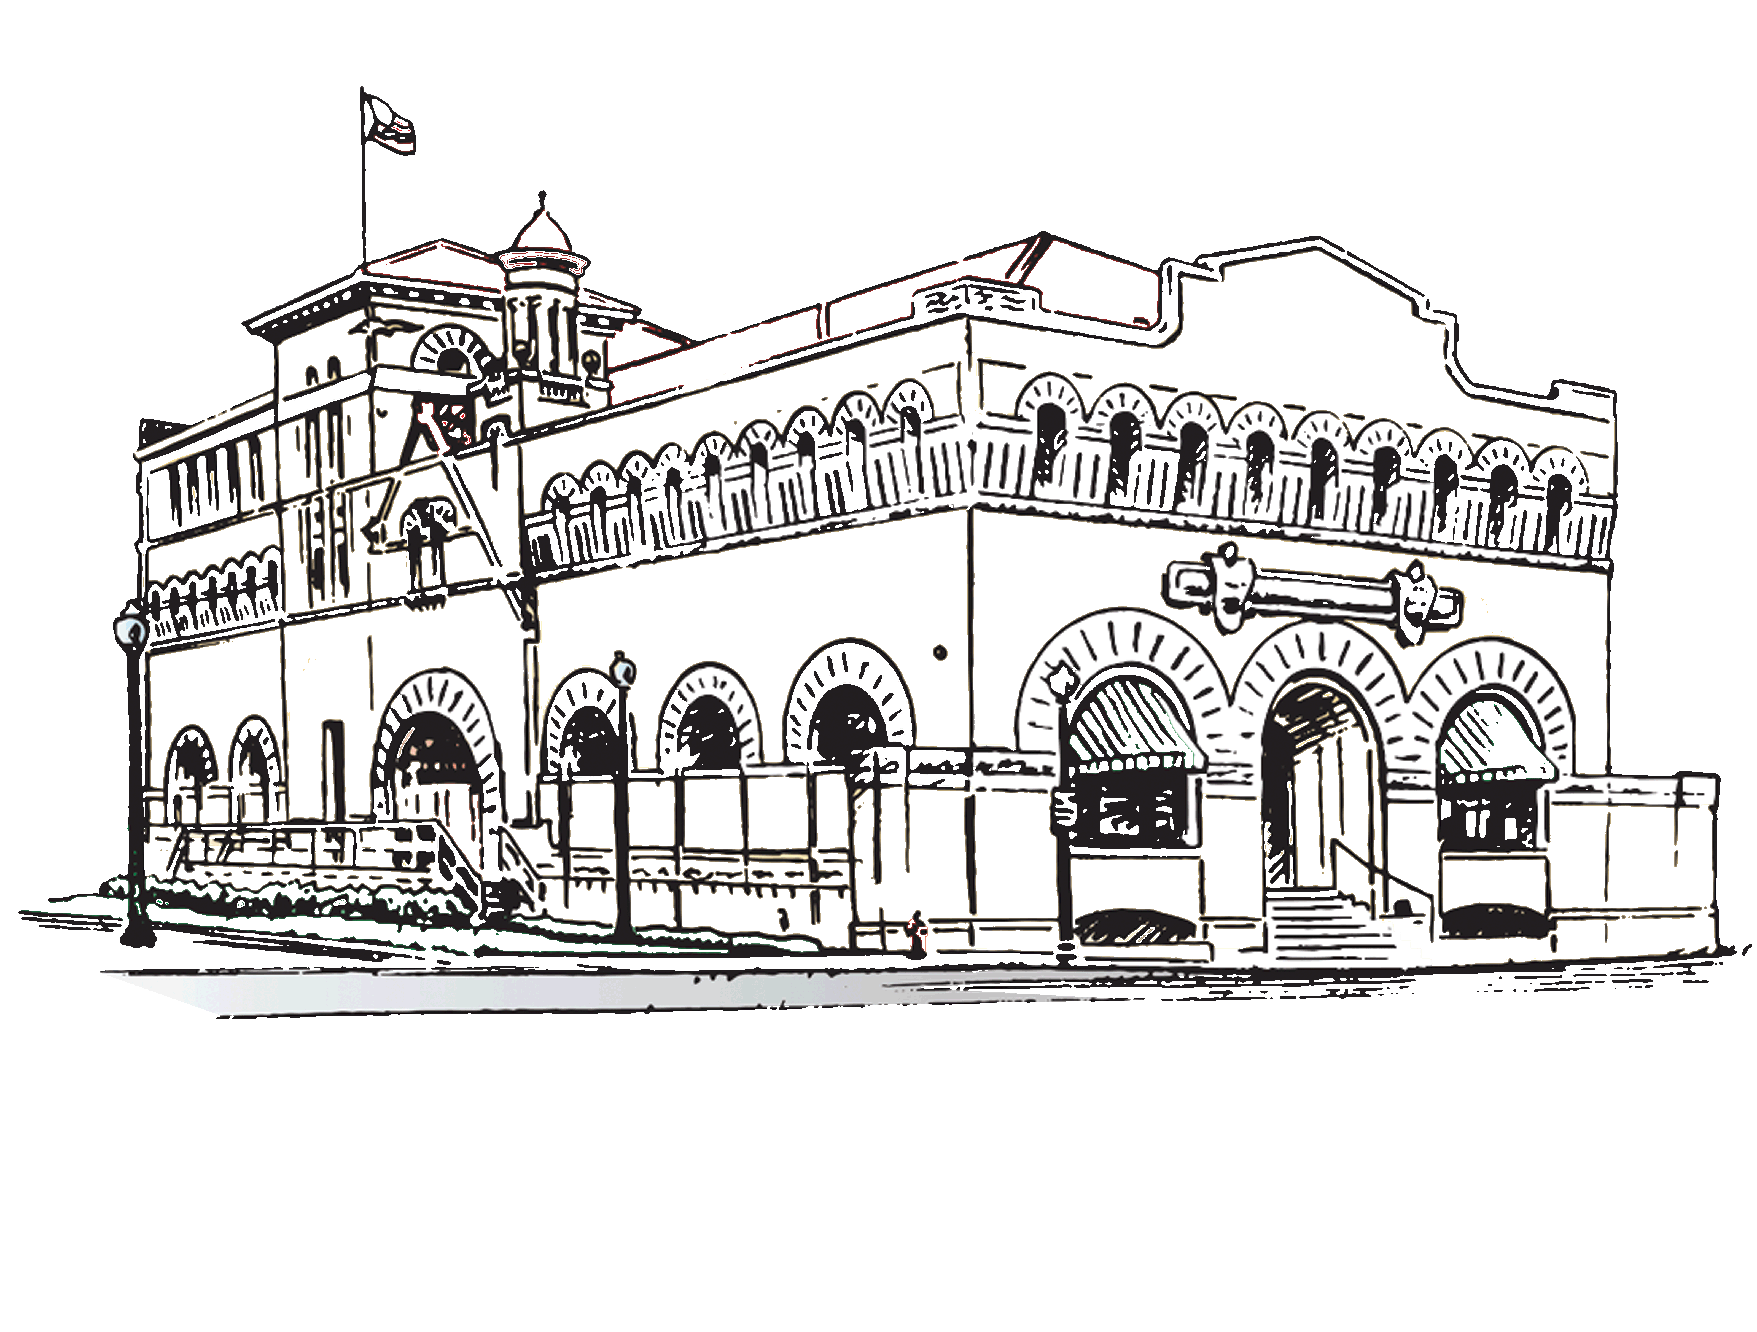
  - Many different machines have been used to make Dr Pepper.
  - Dr Pepper is a part of a big soda family.
  - There are many different ways to move Dr Pepper to stores.
  - There are many different jobs that make soda possible.

Our Class is Going on a Field Trip to the...
Dr Pepper Museum

Dear Parents and Guardians,

Our class will be going on a field trip to visit the Dr Pepper Museum! Students and chaperones who attend the field trip must send money for their admission to school in advance.
- Student Admission ($7): This includes your student’s admission into both Museum buildings, a bottle of original soda the student makes, and a free can of Dr Pepper.
- Chaperone Admission ($7): This includes your admission into both Museum buildings, a bottle of original soda the participant makes, and a free can of Dr Pepper.
The Museum offers add-ons to field trips that you can order for your child if you so choose, but they are not requirements for your child to attend.
- A Little Peppers Activity Book ($5): This is an activity book designed to engage your student with activities throughout the Museum.
- A Goodie Bag ($5): Order your child a small bag of souvenirs from the Museum’s gift shop that will be given to your student’s teacher to give your child at the end of the trip.
- A Dr Pepper Float Upgrade ($5): Order your child a cup of vanilla ice-cream to make a Dr Pepper float out of their included can of soda after their field trip.

So that your child can attend the field trip and we can have an accurate count of what we will order from the Museum, please complete the form below, include it and the payment in an envelope, and send it back to school with your child by xx/xx/xxxx.
Thank you!

- - - - - - - - - - - - - - - - - - - - - - - - - - - - - - - - - - - - - - - - - - - - - - - - - - -
Dr Pepper Museum Field Trip Form

My child, ______________________________________________ will have the following on their field trip to the Dr Pepper Museum:

- Student Admission ($7)
- Chaperone Admission ($7 per adult and any additional child)
- A Little Peppers Activity Book ($5)
- A Goodie Bag from the Museum Gift Shop ($5)
- A Dr Pepper Float Upgrade from the Soda Fountain ($3)

Total: _______

Parent or Guardian Name: Parent or Guardian Signature:

____________________________________________ ___________________________________________
Museum Overview: Chaperones
Field Trip Information:
- Length: 1 Hour
- Price: $7 per participant (students, parents, teachers, and bus drivers)
- Includes: Make-A-Soda Field Trip
  - Admission to both Museum buildings and all exhibits
  - Introduction and informal gallery talks from Museum educators
  - 1 hour self-guided tour of the Museum galleries
  - 1 hour facilitated Make-A-Soda program in which all participants can make 1 bottle of soda
  - 1 can of Dr Pepper per participant
- Parking: Chaperones can park in the Museum’s lot for $10 or park in free street parking that is available.
Museum Overview:
- Museum Mission: The Museum’s mission is to educate and entertain the general public through the collection, preservation, interpretation, and exhibition of objects relevant to the history of the soft drink industry, and through that example, the free enterprise economic system.
- Buildings: The Museum is located in downtown Waco in two historic Buildings. The main Museum building was the Artesian Manufacturing and Bottling Company building and was where Dr Pepper was first bottled on a large scale. The Museum’s second building was the Kellum Rotan Grocery Store, one of the oldest buildings in downtown.
- Exhibits: The Museum is constantly changing, so you can expect to see different exhibits when you visit each year. Exhibits span both Museum buildings and vary in topics. Our permanent exhibits include, but are not limited to: a model of the Old Corner Drug Store, an exhibit about the historic bottling factory, an exhibit about advertising in gas stations, an exhibit about beverage chemistry, an exhibit on entrepreneurship, and an exhibit about Lunch Counter protests. In addition to our many permanent exhibits, we have multiple exhibits that showcase advertisements in the beverage industry, connecting them to history and modern media literacy. For more details about our current exhibits, visit the Museum’s website.
- Dr Pepper History: Dr Pepper was invented in 1885 in the Old Corner Drug Store in Waco, Texas by Dr. Charles Alderton. Originally, it was created and sold as a medicine; carbonated water was seen as a cure-all medicine that unfortunately was bad tasting, so flavored syrup was added. As the soda grew in popularity and machines improved, Dr Pepper was made on a large scale by the Circle A company in the building that is now the main Museum building. Throughout the years, Dr Pepper and the soft drink industry have changed in response to innovative discoveries and social changes. One notable change it was advertised as a medicine, then a health drink, and is now a treat. Today, Dr Pepper is a member of the Keurig Dr Pepper Company’s family of brands.

Chaperone Recommendations:
- The field trip includes a self-guided tour of the Museum, while an educator will give a brief introduction and be available in the galleries, it is up to wonderful chaperones and teachers to help kids engage with the Museum. To help make your student’s field trip a success chaperones can…
  - Stay with an assigned group of students at all times
  - Manage time so that students can see all exhibits in the hour allotted
  - Start the group in a part of the Museum without other students so that it isn’t crowded
  - Ask students questions about the exhibits, such as:
    - What do you notice about that machine?
    - How does that advertisement persuade you to buy Dr Pepper?
    - Do you think that advertisement is effective/good?
    - What do you think about that bottle?

