Civil Rights & Civic Responsibility
Subject: Social Studies
Topics: Civil Rights Movement, Waco History, Citizenship, Civics, Democracy, Culture

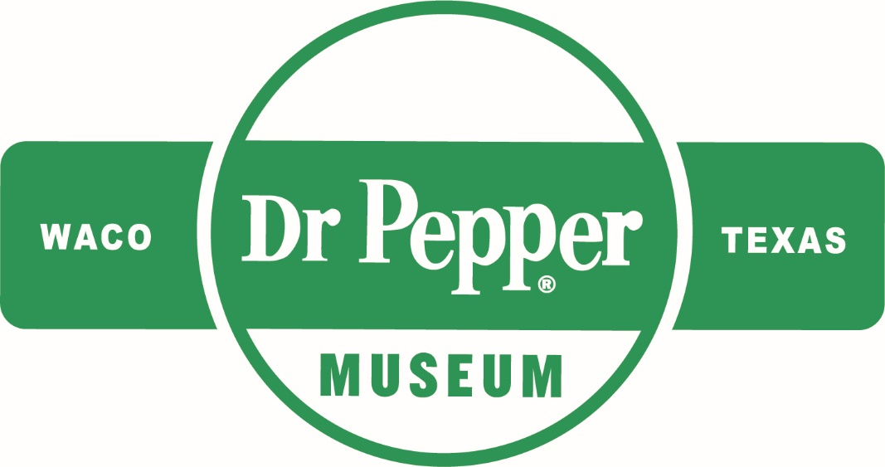
Introduction
Dear Teacher,
At the Dr Pepper Museum, we teach economics, history, and other concepts through the story of Dr Pepper and the Soft Drink industry. For this unit, we have focused on the story of the Civil Rights Movement nationally and locally and how this impacted communities. We designed activities that will help students explore history, democracy, and civic participation. These concepts and activities connect to our new Sit Down to Take a Stand exhibit. We are committed to supporting you as you teach this complex area of history in your classroom.
We look forward to connecting your class with the story of the national, state, and local Civil Rights Movement and inspiring your students to take responsible civic action.
This lesson plan is designed to help you create lessons for your classroom that connect to the Sit Down to Take a Stand exhibit at the Dr Pepper Museum. Lessons are typically cross curricular and are tied to TEKS. We suggest that you take these lessons and accommodate them to meet your class’s needs.
Enjoy!
Your Dr Pepper Museum Staff

Overview
Grade Range:
9-12
Subjects:
U.S. History from 1877

Topics:
Civil Rights Movement, Waco History, Citizenship, Civics, Democracy, Culture

Question:
How did the Civil Rights Movement change the lives of citizens nationally and locally?

TEKS:
U.S. History from 1877: 9 (B) (D) (G) (I) (J), 22 (A) (C), 25 (A) (D), 28 (A) (B) (C) (E), 29 (A)

Pre-Lesson

Unit Compelling Question: How did the Civil Rights Movement change the lives of citizens both nationally and locally?
Use this lesson to prepare your students to engage with this topic. This warm-up lesson will orient them to the impacts of personal bias.
Hook: | Have students answer the question, “What does bias mean to you?” in a two-five minute free write session.
Body: | Discuss answers as a class.  Watch this video on unconscious bias and assumptions. Define bias as a group. Explain that bias often impacts how people are represented and that historians, politicians, and journalists can all be biased. Explore the ways that bias can be harmful and how it has led to discrimination.  Explain that confronting bias is a lifelong practice. Discuss ways for students to combat their own biases and how this lesson will prepare them for the rest of the week. Evaluate personal biases as they learn about the Civil Rights Movement.
Product: | Have students write a one – two paragraph reflection on their own personal biases and how they can combat them in their personal lives.
Assessment: | To assess student understanding of this topic, evaluate students’ reflections for responses that incorporate information from the class discussion and video on unconscious bias.

Lesson 1: Reasons for National Civil Rights Movement & Citizenship

Unit Compelling Question: How did the Civil Rights Movement change the lives of citizens both nationally and locally?
TEKS Covered:
U.S. History Since 1877: 9 (B) (D) (G) (I) (J), 22 (A) (C), 25 (A) (D), 28 (A) (C), 29 (A)
Hook: | As a class, watch this video about the Civil Rights Movement. Then, have students write down Civil Rights leaders that they know.
Body: | Discuss the obstacles that Jim Crow laws created for people of color, and ways that Civil Rights leaders dealt with discriminatory laws. Explain to students that expanding Civil Rights required the action of several different kinds of people and that the struggle is ongoing today. Introduce students to different Civil Rights leaders, by watching the videos 7 Civil Rights Leaders You Need to Know and African American Women and the Struggle for Equality.  Allow students class time to research a Civil Rights activist (past or contemporary). Explain that they will need to develop a biography for their chosen activist as well as information on their contributions to the Civil Rights Movement. (Students should use primary and secondary sources to find this information.)
Product: | Students will present on their chosen Civil Rights activist. Presentations should include a photo and a brief biography. Students should outline the activists’ contributions to the Civil Rights Movement and explore how they impacted society. The presentations should include a works cited page.
Assessment: | To assess student understanding of this topic, review students’ presentation for accuracy and attention to detail (grading rubric in materials).

Lesson 2: Civil Rights Movement in Texas
Unit Compelling Question: How did the Civil Rights Movement change the lives of citizens both nationally and locally?
TEKS Covered:
U.S. History Since 1877: 22 (A) (C), 25 (A), 28 (A), 29 (A)
Hook: | Show students images of Civil Rights events in Texas, have them write a caption for what they think is happening in the image (photos in materials).
Body: | Explain to students that fighting for Civil Rights happened across all states, even Texas. Ask students what they think about how Texans mobilized to make changes in their state. Discuss how when different groups work together, they can make big changes in their state or local communities. List different community causes as a class.  Place students in groups of three or four to brainstorm how they could work within their community to take on a problem they care about.
Product: | After brainstorming with their group, ask students to think about a community problem they recognize. Students will draw a poster to explain their problem, what it means to them, and how others can help (see protest poster examples in materials).
Assessment: | To assess student understanding of this topic, review students’ posters to ensure understanding of a community problem.

Lesson 3: Civil Rights Movement in Waco
Unit Compelling Question: How did the Civil Rights Movement change the lives of citizens both nationally and locally?
TEKS Covered:
U.S. History Since 1877: 25 (A), 28 (A) (B) (C) (E), 29 (A)
Hook: | As a class, watch this video, which explores the first sit-in protest.
Body: | Then, have students watch this video, which explores another sit-in protest that happened in Jackson, Mississippi in 1963. Lead a class discussion outlining the ways the first sit-in protest impacted society.  Ask students how the sit-ins and the Civil Rights Movement were deliberately planned out. Tell students that working together for Civil Rights took place across all communities, even local communities, like Waco, and that people worked together to change laws locally.  Using the oral history provided by the Dr Pepper Museum, have the students read the oral history quotes (in materials). After listening as a class, discuss how actions taken by Waco Civil Rights leaders made life better for Waco citizens.
Product: | After the oral history session, have the students reflect on the actions taken by local Wacoans. Using evidence from the oral histories, have students write an argument for the action taken and analyze how the first sit-in protest influenced the protests in Waco. Students should discuss how sit-in protests impacted the Waco community as well as society in the United States.  **You can adapt this lesson to explore the story of the Civil Rights Movement in your city.
Assessment: | To assess student understanding of this topic, review student’s responses for evidence from oral histories that explain why civic action was necessary to end segregation.

Lesson 4: Impacts of Civil Rights Movement - Citizenship, Civics, Civic Responsibility

Unit Compelling Question: How did the Civil Rights Movement change the lives of citizens both nationally and locally?
TEKS Covered:
U.S. History Since 1877: 9 (I), 22 (A), 28 (A) (B) (C), 29 (A)
Hook: | Show students the political cartoons (in materials) and have them write down what they think each one means and how it relates to citizenship.
Body: | Introduce students to responsibilities of citizens, using this video. Explain to students that being a good citizen in a democracy requires their individual participation. Ask students to list the ways they can participate as citizens (voting, volunteering, jury duty, staying informed, etc.).  Ask students how Civil Rights leaders acted as good citizens (helped to change laws, made their communities better, and respectfully held public officials to their word). Empower students to make small changes and to advocate for things they care about. Discuss issues that are important to them.  Write a list of the issues that are important to students. Using the list of problems students care about, have students write their name and the issue they care about the most on a piece of paper. Collect the papers and place students in groups, based on the issues they chose.
Product: | While in groups, students should research their assigned community problem and list solutions. Students (in their assigned groups) will create an action plan or design a museum exhibit to help solve the problem in their community. Action plans and exhibits should include an overview of the issue, what public officials and local organizations can help, the actions people can take (how they can act as responsible citizens), and how their plan will help the community. Museum exhibits should focus on how to educate people about the issue to help solve the problem. Students will develop a presentation and present to the class as a group.  **For students who choose to design a museum exhibit, they can utilize the list of resources (in materials) to analyze past museum exhibits on contemporary issues.  **This can be assigned for homework.
Assessment: | To assess student understanding of this topic, review students’ action plan presentation ensuring that it incorporates information taught in class.

Materials
Lesson 1: Presentation Rubric

 | 1  Needs Improvement | 2  Satisfactory | 3  Superior | 4  Outstanding | Score
Display | Presentation is difficult to read, and grammar errors exist on several slides. No photos are included on the slides. | Presentation is slightly difficult to read, and grammar errors exist on some slides. Few photos are included. | Presentation is easily read, and few grammar errors exist. Photos are used frequently. | Presentation is easily understood by audience and no grammar errors exist. Photos are used throughout the presentation.
Eye Contact | Presenter read from slides frequently and did not make eye contact with the audience. | Presenter read from slides occasionally and sometimes made eye contact with the audience. | Presenter rarely read from slides and managed to look at audience often. | Presenter never read from slides and maintained eye contact with the audience throughout the presentation.
Attention to Detail | Information was not in a logical order and was not applicable to the topic. The presenter did not use primary or secondary sources. | Information was presented relatively logically, and some primary and secondary sources were used. | Information was presented in a logical sequence and several primary secondary and primary sources were used. | Information was exceptionally organized, and the presenter pointed out the primary and secondary sources used.
Accuracy | The information presented was not factual and the presenter did not include a works cited page. | Some of the information presented was accurate and the presenter did include a works cited page. | Information presented was accurate and a complete works cited page was included. | Information was presented in an accurate and engaging way with a complete works cited page.

Lesson 2: Texas Civil Rights Movement Photos
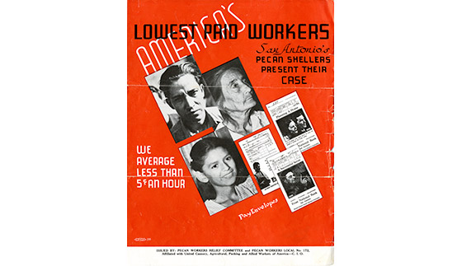
Figure 1. Brochure, “America’s Lowest Paid Workers,” 1938. Courtesy of Bullock Museum.

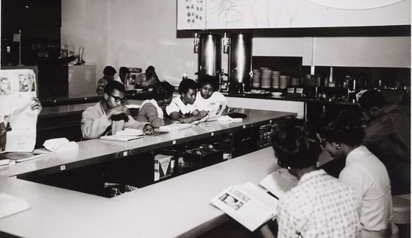
Figure 2. Lunch counter sit-in at Foley’s Department Store, Houston, TX, 1960. Courtesy of Bullock Museum.
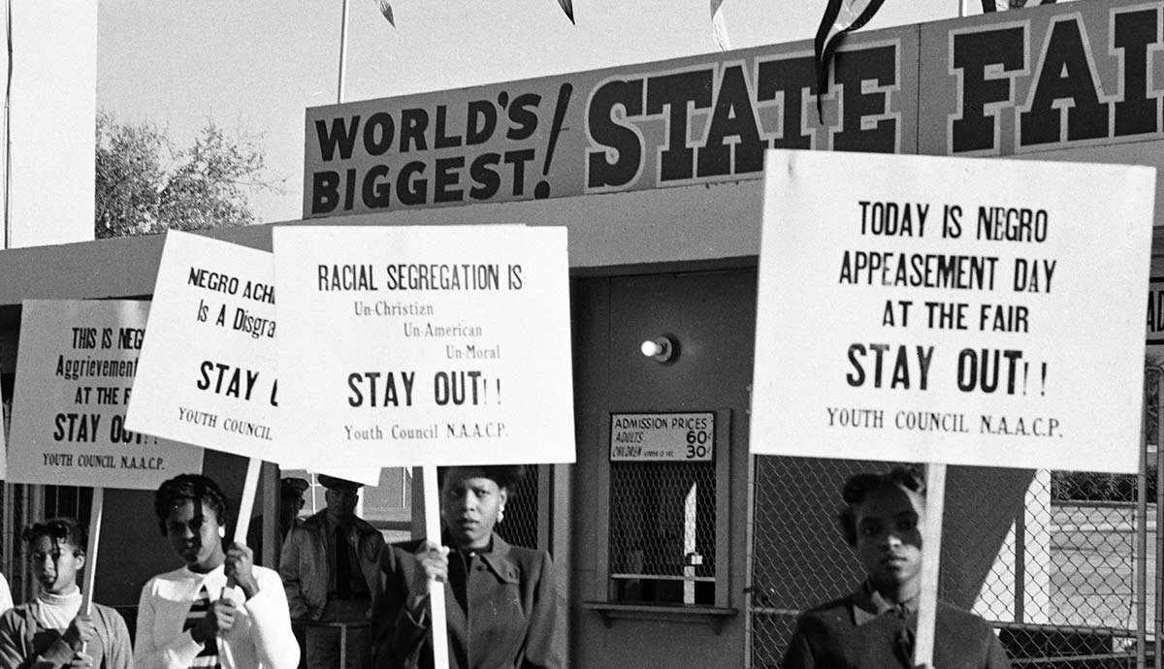
Figure 3. NAACP Youth Council picket line at Texas State Fair by R.C. Hickman, October 1955. Courtesy of Bullock Museum.

Lesson 2: Protest Poster Examples

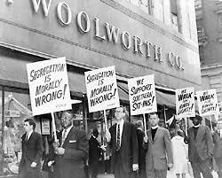
Figure 1. Woolworth Lunch Counter Protest. Courtesy of Library of Congress.

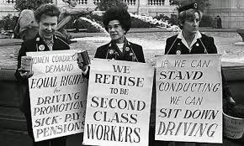
Figure 2. Women’s Rights Protest. Courtesy of historydaily.org.

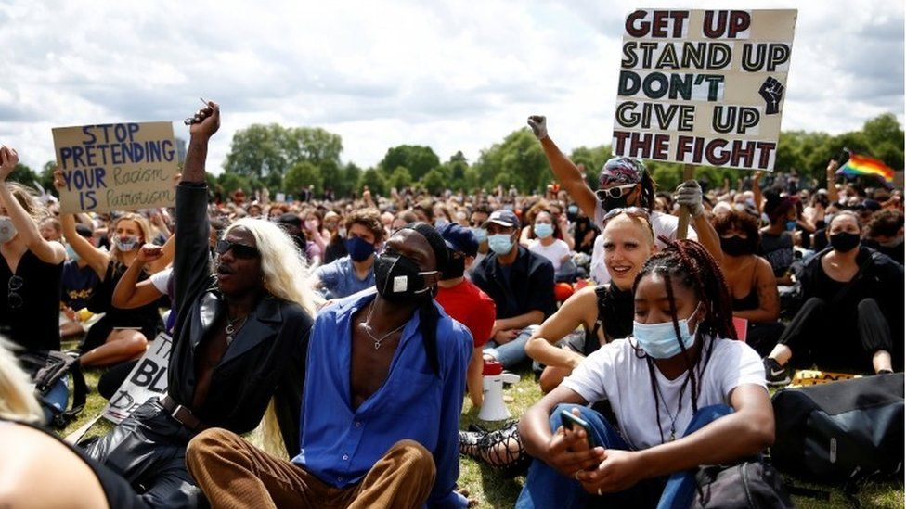
Figure 3. Contemporary Protest. Courtesy of BBC.com.
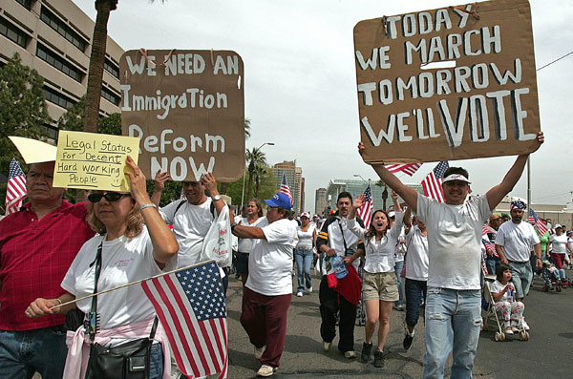
Figure 4. Immigration Reform Protest. Courtesy of Center for American Progress.
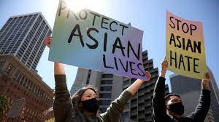
Figure 5. Protestors at Embarcadero Plaza Rally to stop Asian Hate, San Francisco, CA March 2021. Courtesy of NPR.

Lesson 3: Oral Histories
You can read the quotes aloud to students or have students watch the Sit Down to Take a Stand Exhibit video.
Picture | Quote
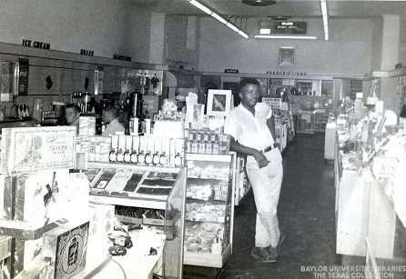  Figure 1. Interior of Pipkins Drugstore, Waco TX. Courtesy of the Texas Collection. | “Even after they kind of declared it, you know, where Blacks can eat, you know, you still, when you go in there you got to stand back, if you sat down, they wouldn’t serve you, they just walk right on by. They’ll serve all the whites, and if any of the Blacks be standing back there, then they ask them what they want.”  “Some stores, you know, they had two cafes up there that we had to go into the back if we went, you know, to eat there. One café, you know, we went into the back, but it was clean, it was nice, and the other one was just like eating in a warehouse, so we very seldom went there because, you know, hey we still paying for it even though we coming in the back.”
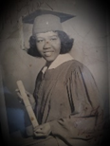  Figure 2. Photo of Cherry Boggess, Student Activist. Courtesy of the Texas Collection.  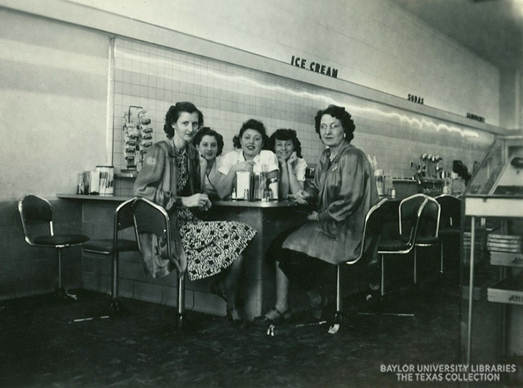  Figure 3. Interior of Pipkins Drugstore, Waco TX. Courtesy of the Texas Collection. | “During the…the demonstrations, you had to be trained how to demonstrate. We were taught how to not say anything. Some of us in..in..in practice were spit on, some, uh, knocked us in the head and we had a couple of them who said, oh hell no, this is not for me.  And I was at Paul Quinn, and one of the fellas, and I can’t remember who it was, he was saying, you know, I went down to Pipkin’s Drug Store to get me a good hot meal, and they told me to get up. I said, ‘well we need to do something cause this doesn’t make sense’. And you’d be surprised, a lot of folks supported us under the table, but wouldn’t come out to do it. Not because they were afraid some of them, you had folks say, ‘I can’t…I can’t do this, my momma’s job might be at stake’, ‘I can’t do this, cause if I get a cigarette, or spat on, or nothing, I’m gonna do it back to them’. But we told them, ‘If you think your temper is gonna go out of whack, you need to support us some other place because we have to turn the other cheek.”  “So, when we uh, came together, we were in Lander’s store. Now what they did in Lander’s store is, when we came down Elm Street, they would call Pipkin’s and tell them we were coming, and the got those stools up. So, Belmuth Fluellen came to me, she said, ‘I will take four of you’, she said, ‘at a time down Turner Street, and, you know, she did, and we were able to sit at the counter because they didn’t see us coming and they didn’t serve any of us.”  After the protest “we got a letter from them, I assumed it came from Pipkin’s, I don’t know if it did or not, but it had it’s ‘I’m sorry, and blah blah blah, and it was a nice letter, and then at the, the last thing was, ‘lunch on us’.
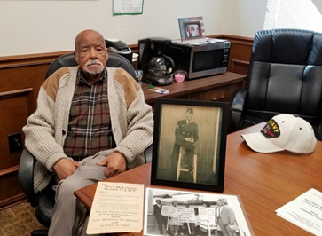  Figure 4. Arthur Fred Joe, Local Civil Rights Leader, Waco TX. Courtesy of the Texas Collection.  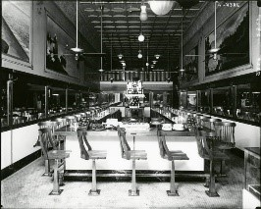  Figure 5. Interior of Vic’s Lunch Counter, Waco TX. Courtesy of the Texas Collection. | “I went in Vic’s, and they kept walking by me, these little waitresses, and they never would come over. And I sat there for about an hour then and finally this lady came over and told me, she said, ‘You’re gonna have to leave’.”  “I said, ‘What you mean?’ I said, ‘I been sitting here for nearly an hour. I want some service’, and she said ‘well, we can’t serve colored folks in here’ I said, ‘well I really, I didn’t want no serve no colored folks’. I said, ‘I really was wanting some bacon and eggs’. [Laughs] It made her mad. So, she dashed off to go get somebody, she must have made a telephone call. I sat there another thirty minutes and I saw this guy come in the door. So, he went on back in the back. About five minutes later, he and this same lady, they came up to the table. He says, uh, ‘Sir, I understand that you just want service here, but we just don’t serve colored people’. I said, ‘why?’, ‘I just don’t know’. I said, ‘looks like you ought to just start this morning’. I said, ‘if I don’t get served today, I’m coming back tomorrow, I’m gonna have a group of folks’. He said, ‘Sir if you don’t mind, would you leave?’ I said, ‘yeah’, I said, ‘but don’t rush me’ I said, ‘but I’m gonna leave because you said you couldn’t serve me, and I’m not gonna sit here much longer because it’s defeating the purpose’, I said, ‘but I’m not giving up’.”  “So that next day, I got me five people, so we sat there about fifteen minutes. I guess the owner this time, he came up. He said, ‘I heard about the incident yesterday.’ I said, ‘Yup’, I said, ‘it was deplorable’. I said, ‘you can do what you wanna do, you can call the police or anybody’. Then I asked the kids, I said, ‘what do y’all want?’ some of them said grits and whatever, biscuit, biscuits and gravy or something, they ordered. I said, ‘you got the order?’, ‘yes sir. Is that all?’, I said, ‘that’s right’. That sucker went in there and he served us, and we were served that day.”

Lesson 4: Political Cartoons
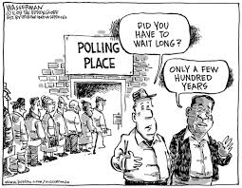

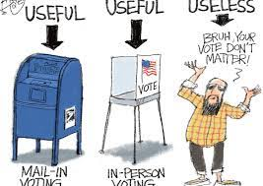
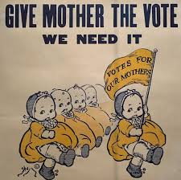
Lesson 4: Museum Exhibit Resources
Your students can use these examples to design their museum exhibits.
- The Lunch Counter Experience at the Center for Civil & Human Rights
- Sit Down to Take A Stand Exhibit at the Dr Pepper Museum & Free Enterprise Institute
- Room to Breathe Exhibit at the Migration Museum
- Recycle Reef Exhibit at the Perot Museum of Nature & Science
- Rightfully Hers: American Women and the Vote Exhibit at the National Archives Museum
- How to Create an Exhibition in Your Classroom

Glossary
accountable: accepting responsibility for one’s own actions.
advocate: recommend or support a cause.
bias: prejudice in favor of or against one thing, person, or group compared with another, usually in a way considered to be unfair.
boycott: refusing to do something as a form of protest.
cause: a principle or movement that one is prepared to advocate for.
citizen: a person who lives in a particular town, city, or country.
civil: relating to citizens and their concerns.
culture: the customs, traditions, arts, and social achievements of a particular group of people or social group (how certain groups of people do certain things).
democracy: a system of government by the people through elected representatives (people have the power through voting)
discrimination: the unfair treatment of different people or things, usually on the grounds of race, age, or sex.
diversity: involving people from different cultures, social groups, and ethnic backgrounds.
enforce: making people follow rules or laws.
impact: having a strong effect on someone or something.
injustice: lack of fairness or justice.
integrate: bring people (or groups) into equal participation in society.
justice: just behavior or treatment.
law: the system of rules that a country uses to regulate the actions of citizens.
local: relating to a particular area or neighborhood.
mobilize: encourage or organize people to act in a certain way to bring about an objective (usually relating to politics or social issues).
movement: a group of people working together to advance their political, social, or artistic ideas.
national: relating to a nation (or country).
oral history: sound recordings of interviews with people who have personal knowledge of past events.
primary source: first-hand account of an event or topic (letters, diary entries, interviews, artifacts, photographs, videos, recordings, etc.).
protest: a public statement or action expressing disapproval of something.
public official: a person who is elected to a public office (President, senator, school board representative, county commissioner, etc.)
right: a moral or legal entitlement to have something or act in a certain way.
secondary source: second-hand information about a topic or event, usually using primary sources (books, articles, documentaries, etc.)
segregation: the enforced separation of different racial groups.
unconstitutional: not following the U.S. constitution or laws.
vote: the right to indicate a choice in an election (through submitting a ballot).

Additional Resources
"Because I’m Latino, I Can’t Have Money?" Kids on Race. YouTube. YouTube, 2015. https://www.youtube.com/watch?v=C6xSyRJqIe8.
“Bias.” National Museum of African American History and Culture, May 31, 2020. https://nmaahc.si.edu/learn/talking-about-race/topics/bias.
“Civil Rights Done Right.” Learning for Justice. Accessed September 8, 2021. https://www.learningforjustice.org/magazine/publications/civil-rights-done-right.
From Sit-Ins to Wade-Ins. YouTube. YouTube, 2017. https://www.youtube.com/watch?v=nd1GjS1pdW8.
“Historical Foundations of Race.” National Museum of African American History and Culture, July 20, 2020. https://nmaahc.si.edu/learn/talking-about-race/topics/historical-foundations-race.
How to Talk to Kids About Race. YouTube. YouTube, 2018. https://www.youtube.com/watch?v=QNEKbVq_ou4.
Implicit Bias. YouTube. YouTube, 2018. https://www.youtube.com/watch?v=OoBvzI-YZf4.
“Race Talk: Engaging Young People in Conversations about Race and Racism.” Anti-Defamation League. Accessed September 8, 2021. https://www.adl.org/education/resources/tools-and-strategies/race-talk-engaging-young-people-in-conversations-about.
Ray, Skylar. “Arvizu v. Waco Independent School District.” Waco History. Accessed September 8, 2021. https://wacohistory.org/items/show/191.
Ray, Skylar. “Marvin C. Griffin.” Waco History. Accessed September 8, 2021. https://wacohistory.org/items/show/204.
Sit Down to Take A Stand. YouTube. YouTube, 2021. https://www.youtube.com/watch?v=tos1WRiWsIk.
“Social Identities and Systems of Oppression.” National Museum of African American History and Culture, July 17, 2020. https://nmaahc.si.edu/learn/talking-about-race/topics/social-identities-and-systems-oppression.
“Talking about Race.” National Museum of African American History and Culture, June 2, 2020. https://nmaahc.si.edu/learn/talking-about-race.
“Teaching Young Children about Race.” Teaching for Change, May 17, 2021. https://www.teachingforchange.org/teaching-about-race.
Texas Activism. YouTube. YouTube, 2020. https://www.youtube.com/watch?v=z6P_gLwuuqo.
https://www.thestoryoftexas.com/discover/campfire-stories/african-americans
Wenger, Regina. “Robert Gilbert.” Waco History. Accessed September 8, 2021. https://wacohistory.org/items/show/212.

It is recommended that this lesson take more than one day or that a portion of it is assigned for homework.
Make sure to emphasize to students that the Civil Rights Movement was an ongoing movement and that the rights of people of color were threatened well before the 1960s.
This content should be reviewed to ensure that it is suitable for your classroom environment.
Important to recognize the contributions of multiple groups to the success of the Civil Rights Movement in Texas (LULAC, NAACP, etc.)
This video includes some violence and should be reviewed to ensure it is appropriate for your classroom environment.
Students can also listen to the oral history by Arthur Fred Joe, Sr, using this link.
If you would like to extend this lesson, you can instruct students to utilize the Waco History App and the Local Civil Rights Sites Map to research other Civil Rights leaders and events in Waco.
Explain to students that museums use stories of the past to start conversations about contemporary issues.
Interview by Harvey Griggs discussing the conditions at the Pipkins Drugstore Lunch Counter.
Interview from Cherry Boggess discussing the sit-in protest at Pipkins Drugstore Lunch Counter.
Interview from Arthur Fred Joe discussing the sit-in protest he staged at Vic’s Lunch Counter in Waco, TX.

