Civil Rights & Civic Responsibility

Subject: Social Studies
Topics: Civil Rights Movement, Waco History, Citizenship, Civics, Democracy, Culture

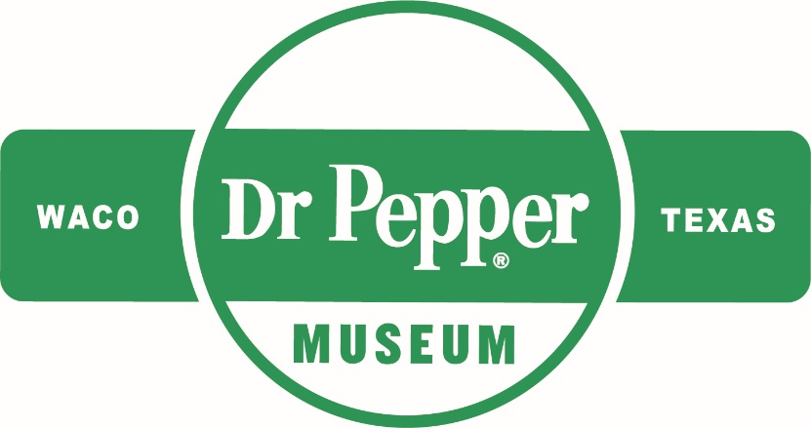
Introduction
Dear Teacher,
At the Dr Pepper Museum, we teach economics, history, and other concepts through the story of Dr Pepper and the Soft Drink industry. For this unit, we have focused on the story of the Civil Rights Movement nationally and locally and how it impacted communities. We designed activities that will help students explore history, democracy, and civic participation. These concepts and activities connect to our new Sit Down to Take a Stand exhibit. We are committed to supporting you as you teach this complex area of history in your classroom.
We look forward to connecting your class with the story of the national, state, and local Civil Rights Movement and inspiring your students to take responsible civic action.
This lesson plan is designed to help you create lessons for your classroom that connect to the Sit Down to Take a Stand exhibit at the Dr Pepper Museum. Lessons are typically cross curricular and are tied to TEKS. We suggest that you take these lessons and accommodate them to meet your class’s needs.
Enjoy!
Your Dr Pepper Museum Staff

Overview
Grade Range:
K-2nd

Topics:
Civil Rights Movement, Waco History, Citizenship, Civics, Democracy, Culture

Question:
How did the Civil Rights Movement change the lives of citizens nationally and locally?

TEKS:
Kindergarten: SS K.7 (A), SS K.8 (A), SS K.13 (A) (B)

First: SS 1.2 (A) (B), SS 1.11 (A) (B), SS 1.12 (A) (B), SS 1.17 (C) (D), SS 1.18
Second: SS 2.2 (A) (B), SS 2.9 (A), (B), (C), (D), SS 2.10 (A) (B) (C), SS 2.15 (A) (B)

Lesson 1: Differences & Diversity
Unit Compelling Question: How did the Civil Rights Movement change the lives of citizens both nationally and locally?
TEKS Covered:
SS K.5, SS K.10
SS 1.14
Objective: | SWBAT describe differences and celebrate diverse cultures represented in their classroom by creating and discussing self-portraits.
Hook: | Hold up a hand mirror and look at your reflection. Model thinking aloud and list three unique things you like about yourself as an individual.
Body: | Ask the class what they know about differences and different families. Explain that we all have physical differences but that differences make us better.  Outline instructions for self-portrait assignment.
Product: | Have the class create self-portraits. Students can write three things that they love about themselves and their differences. Post them up in class to celebrate each student’s individuality.

Lesson 2: Reasons for National Civil Rights Movement & Citizenship
Unit Compelling Question: How did the Civil Rights Movement change the lives of citizens both nationally and locally?
TEKS Covered:
SS K.7 (A)
SS 1.2 (A) (B), SS 1.12 (A) (B)
SS 2.10 (A) (B), SS 2.15 (A) (B)
Objective: | SWBAT describe the reasons and identify the people involved in National Civil Rights Movement by listing the discrimination people of color faced and the solutions they found.
Hook: | Ask the class what they know about rules/laws and who enforces them. After they brainstorm, introduce concept of laws and rights using this video.
Body: | Explain concept of unfair laws and watch this video on the early stages of Civil Rights Movement.  Ask class which laws they thought were unfair in the video. Identify ways people responded to the unfair laws (you or your students can make a list while watching the video). Discuss the ways that Civil Rights leaders dealt with unfair laws and how this made them good citizens.
Product: | Have students create their own t-chart comparing the problems that Civil Rights leaders faced, the actions they took, and the solutions that occurred. (Example chart and template in materials.)

Lesson 3: Civil Rights Movement in Texas
Unit Compelling Question: How did the Civil Rights Movement change the lives of citizens both nationally and locally?
TEKS Covered:
SS K.13 (A)
SS 2.2 (A), SS 2.10 (A) (B), SS 2.15 (A) (B)
Objective: | SWBAT identify the ways Texans worked together to improve their communities by discussing the ways citizens can help solve community problems.
Hook: | Show students images of Civil Rights events in Texas, ask them what they think is happening in the pictures.
Body: | Explain to students that working for Civil Rights happened across all states, even Texas. (Use the images from the hook as a point of reference.)  Ask students what they think about how Texans worked together to make changes in their state. Discuss how when different groups work together, they can make big changes in their state or local communities. Brainstorm how they could work with others to take on a problem they care about.
Product: | Have students think about a problem they care about (may need to list examples from brainstorm) Students will draw a poster to explain their problem, what it means to them, and how others can help. (Can use images of protest posters as examples.)

Lesson 4: Civil Rights Movement in Waco
Unit Compelling Question: How did the Civil Rights Movement change the lives of citizens both nationally and locally?
TEKS Covered:
SS K.13 (A) (B)
SS 1.17 (C) (D)
SS 2.2 (B), SS 2.10 (A) (B), SS 2.15 (A) (B)
Objective: | SWBAT interpret the reasons for the sit-in protests in Waco by reading quotes from Civil Rights leaders and describing how the changes they made improved the Waco community.
Hook: | Introduce a new rule in your classroom. For example, you can tell the class that everyone with blue eyes needs to separate from the other students and that they need to walk in the back of the line for the day. Ask students if they think it’s okay to separate the students based on their eye color and make them follow different rules. Ask the separated students if they liked being treated differently.
Body: | Remind students that the Civil Rights Movement happened because certain groups of people were being treated differently (unfairly) and they did not like it. Tell students that working together for Civil Rights took place across all communities, even local communities, like Waco, and that people worked together to change laws locally.  Read the oral history quotes provided by the Dr Pepper Museum (in materials) aloud to the class. Then, create an anchor listing the actions taken by individuals in the Waco community and the result of the action. Discuss why these actions made life better for Waco citizens.
Product: | After the oral history session, have the students reflect on the actions taken by local Wacoans and explain how these actions made positive changes and impacted the Waco community today. (Students could write or draw their interpretation of the positive changes.)

Lesson 5: Impacts of Civil Rights Movement - Citizenship, Civics, Civic Responsibility
Unit Compelling Question: How did the Civil Rights Movement change the lives of citizens both nationally and locally?
TEKS Covered:
SS K.8 (A)
SS 1.11 (A) (B), SS 1.12 (A) (B), SS 1.18
SS 2.9 (A) (B) (C) (D), SS 2.10 (A) (B) (C), SS 2.15 (A) (B)
Objective: | SWBAT identify the qualities of good citizenship by describing the qualities that made Civil Rights leaders good citizens and listing the public officials that help solve community problems
Hook: | Ask students what being a citizen means to them. Remind students of the ways Civil Rights leaders were good citizens.
Body: | Make an anchor chart with the different groups students are a part of to explain that being a citizen is being a member of a town, city, state, and country.  Define what citizenship and democracy means. Explain to students that being a good citizen in a democracy requires their individual participation. Watch this video for examples of good citizenship.  Explain that the leaders of the Civil Rights movement were good citizens because they helped to change laws and make their communities better. Empower students to make small changes and to advocate for things they care about. Discuss issues that are important to them.  Explain to students that public officials help to create and enforce laws. Print pictures of three types of public officials in your community that could help address problems. Outline their roles in the community.
Product: | Taking the poster from lesson 3, have students add the public officials that could help them with their problem.

Unit Assessment
Students present their posters to the class, explaining their problem and the public officials that can help them with it. They should include a solution to their problem and explain how the solution helps their community.

Materials
Lesson 2: Example Chart
Example of the content for Lesson Two.
Problem | Action | Solution
Not allowed to Vote | Created voter registration campaigns. | Laws were passed to allow people to vote. (Voting Rights Act of 1965)
Not allowed to sit on buses | Boycotted riding the bus | Laws were passed (Civil Rights Act of 1964)
Could not eat at restaurants | Sit-in protests | Laws were passed (Civil Rights Act of 1964)

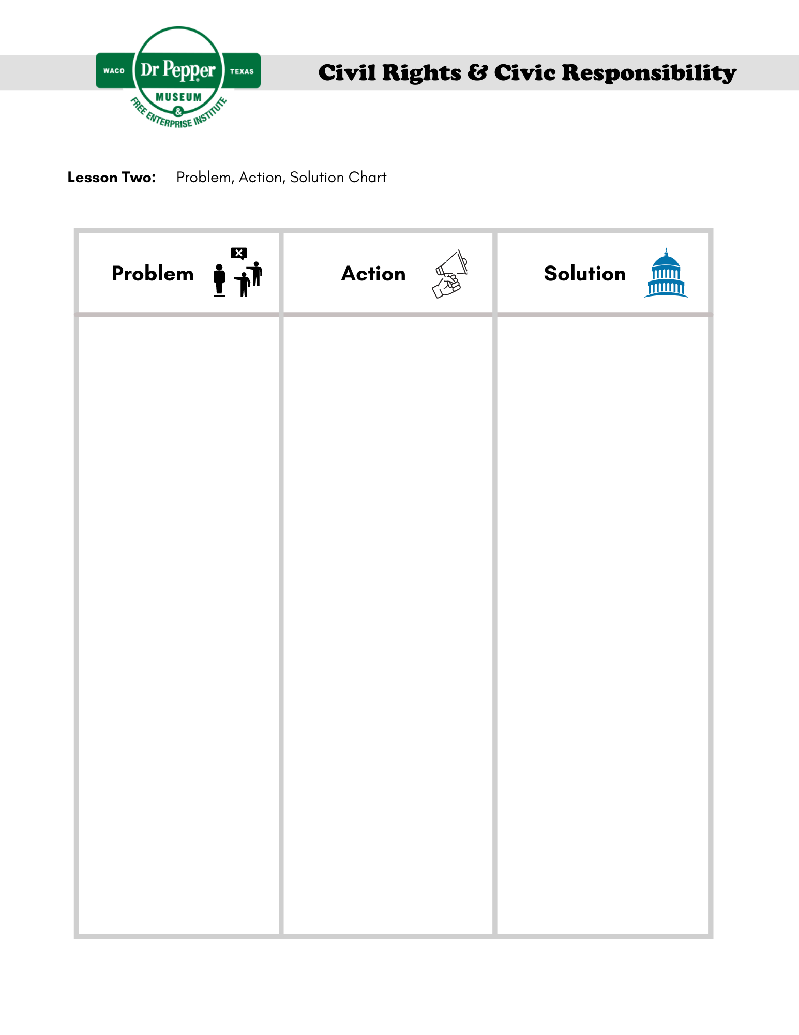
Lesson 3: Texas Civil Rights Movement Photos

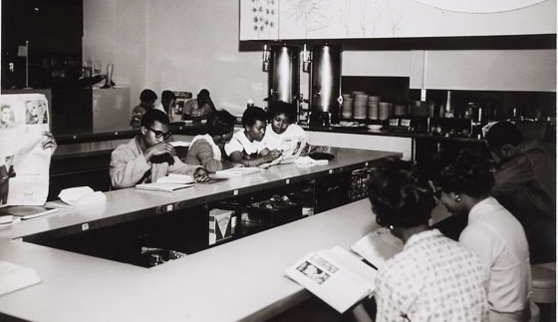
Figure 1. Lunch counter sit-in at Foley’s Department Store, Houston, TX, 1960. Courtesy of Bullock Museum.

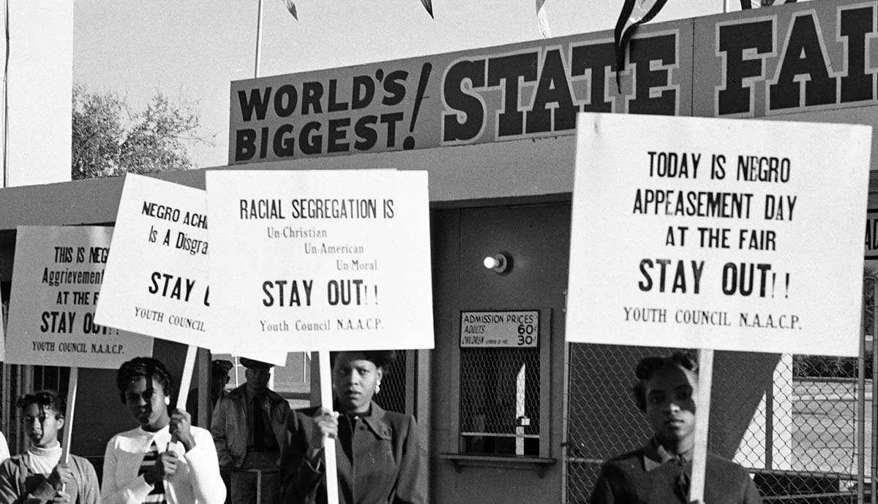
Figure 2. NAACP Youth Council picket line at Texas State Fair by R.C. Hickman, October 1955. Courtesy of Bullock Museum.

Lesson 4: Oral Histories
You can read the quotes aloud to students or have them watch the Sit Down to Take a Stand video.
Picture | Quote
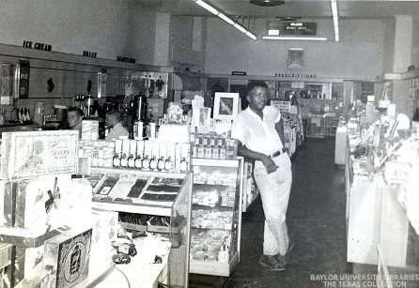  Figure 1. Interior of Pipkins Drugstore, Waco TX. Courtesy of the Texas Collection. | “When you go in there you got to stand back, if you sat down, they wouldn’t serve you, they just walk right on by.”
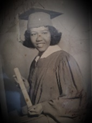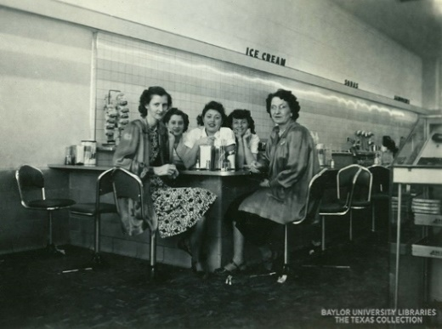  Figure 3. Interior of Pipkins Drugstore, Waco TX. Courtesy of the Texas Collection.  Figure 2. Photo of Cherry Boggess, Student Activist. Courtesy of the Texas Collection. | “We were able to sit at the counter….. and they didn’t serve any of us.”  After the protest, “we got a letter from them, I assumed it came from Pipkin’s….but it had it’s ‘I’m sorry, and blah blah blah, and it was a nice letter, and then at the, the last thing was, ‘lunch on us.”
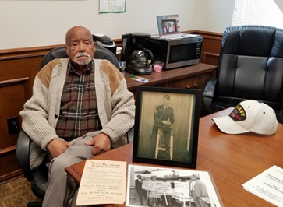  Figure 4. Arthur Fred Joe, Local Civil Rights Leader, Waco TX. Courtesy of Waco Tribune Herald.  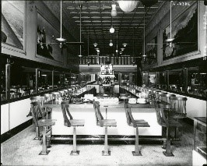  Figure 5. Interior of Vic’s Lunch Counter, Waco TX. Courtesy of the Texas Collection. | “I went in Vic’s and they kept walking by me, these little waitresses, and they never would come over. And I sat there for about an hour then and finally this lady came over and told me, she said, ‘You’re gonna have to leave’.”  “So that next day, I got me five people, so we sat there about fifteen minutes. I guess the owner this time, he came up. He said, ‘I heard about the incident yesterday,” and “that sucker went in there and he served us, and we were served that day.”

Glossary
accountable: accepting responsibility for one’s own actions.
advocate: recommend or support a cause.
boycott: refusing to do something as a form of protest.
cause: a principle or movement that one is prepared to advocate for.
citizen: a person who lives in a particular town, city, or country.
civil: relating to citizens and their concerns.
culture: the customs, traditions, arts, and social achievements of a particular group of people or social group (how certain groups of people do certain things).
democracy: a system of government by the people through elected representatives (people have the power through voting)
discrimination: the unfair treatment of different people or things, usually on the grounds of race, age, or sex.
diversity: involving people from different cultures, social groups, and ethnic backgrounds.
enforce: making people follow rules or laws.
impact: having a strong effect on someone or something.
injustice: lack of fairness or justice.
integrate: bring people (or groups) into equal participation in society.
justice: just behavior or treatment.
law: the system of rules that a country uses to regulate the actions of citizens.
local: relating to a particular area or neighborhood.
mobilize: encourage or organize people to act in a certain way to bring about an objective (usually relating to politics or social issues).
movement: a group of people working together to advance their political, social, or artistic ideas.
national: relating to a nation (or country).
oral history: sound recordings of interviews with people who have personal knowledge of past events.
protest: a public statement or action expressing disapproval of something.
public official: a person who is elected to a public office (President, senator, school board representative, county commissioner, etc.)
right: a moral or legal entitlement to have something or act in a certain way.
segregation: the enforced separation of different racial groups.
unconstitutional: not following the U.S. constitution or laws.
vote: the right to indicate a choice in an election (through submitting a ballot).

Additional Resources
“Civil Rights Done Right.” Learning for Justice. Accessed September 8, 2021. https://www.learningforjustice.org/magazine/publications/civil-rights-done-right.
“Historical Foundations of Race.” National Museum of African American History and Culture, July 20, 2020. https://nmaahc.si.edu/learn/talking-about-race/topics/historical-foundations-race.
How to Talk to Kids About Race. YouTube. YouTube, 2018. https://www.youtube.com/watch?v=QNEKbVq_ou4.
“Race Talk: Engaging Young People in Conversations about Race and Racism.” Anti-Defamation League. Accessed September 8, 2021. https://www.adl.org/education/resources/tools-and-strategies/race-talk-engaging-young-people-in-conversations-about.
Ray, Skylar. “Arvizu v. Waco Independent School District.” Waco History. Accessed September 8, 2021. https://wacohistory.org/items/show/191.
Ray, Skylar. “Marvin C. Griffin.” Waco History. Accessed September 8, 2021. https://wacohistory.org/items/show/204.
Sit Down to Take A Stand. YouTube. YouTube, 2021. https://www.youtube.com/watch?v=tos1WRiWsIk.
“Social Identities and Systems of Oppression.” National Museum of African American History and Culture, July 17, 2020. https://nmaahc.si.edu/learn/talking-about-race/topics/social-identities-and-systems-oppression.
“Talking about Race.” National Museum of African American History and Culture, June 2, 2020. https://nmaahc.si.edu/learn/talking-about-race.
“Teaching Young Children about Race.” Teaching for Change, May 17, 2021. https://www.teachingforchange.org/teaching-about-race.
Texas Activism. YouTube. YouTube, 2020. https://www.youtube.com/watch?v=z6P_gLwuuqo.
https://www.thestoryoftexas.com/discover/campfire-stories/african-americans
Wenger, Regina. “Robert Gilbert.” Waco History. Accessed September 8, 2021. https://wacohistory.org/items/show/212.

If you want to make this a bit more complex, you can introduce the idea of culture and family traditions and have students write what they love about their cultures/traditions.
This content should be reviewed to ensure that it is suitable for your classroom environment.
You can utilize these links to find the public officials in your area. If you are a Texas teacher, use https://directory.tml.org/. For out of state teachers, use https://www.usa.gov/elected-officials.
Interview from Harvey Griggs discussing the conditions at the Pipkins Drugstore Lunch Counter.
Interview from Cherry Boggess discussing the sit-in protest at Pipkins Drugstore Lunch Counter.
Interview from Arthur Fred Joe discussing the sit-in protest he staged at Vic’s Lunch Counter in Waco, TX.

