Civil Rights & Civic Responsibility
Subject: Social Studies
Topics: Civil Rights Movement, Waco History, Citizenship, Civics, Democracy, Culture

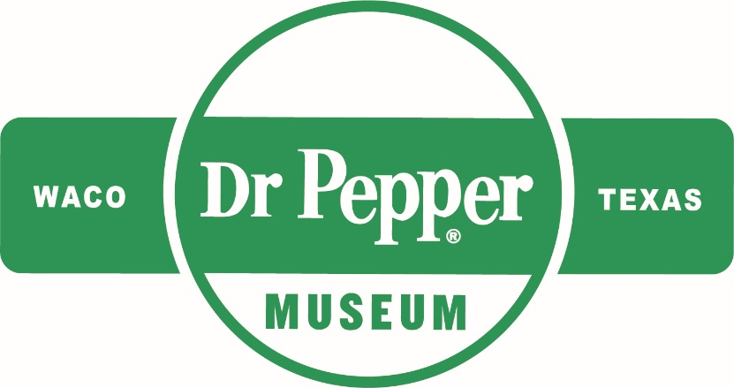
Introduction
Dear Teacher,
At the Dr Pepper Museum, we teach economics, history, and other concepts through the story of Dr Pepper and the Soft Drink industry. For this unit, we have focused on the story of the Civil Rights Movement nationally and locally and how it impacted communities. We designed activities that will help students explore history, democracy, and civic participation. These concepts and activities connect to our new Sit Down to Take a Stand exhibit. We are committed to supporting you as you teach this complex area of history in your classroom.
We look forward to connecting your class with the story of the national, state, and local Civil Rights Movement and inspiring your students to take responsible civic action.
This lesson plan is designed to help you create lessons for your classroom that connect to the Sit Down to Take a Stand exhibit at the Dr Pepper Museum. Lessons are typically cross curricular and are tied to TEKS. We suggest that you take these lessons and accommodate them to meet your class’s needs.
Enjoy!
Your Dr Pepper Museum Staff

Overview
Grade Range:
6-8

Topics:
Civil Rights Movement, Waco History, Citizenship, Civics, Democracy, Culture

Question:
How did the Civil Rights Movement change the lives of citizens nationally and locally?

TEKS:
Sixth: SS 6.1 (B), SS 6.12 (A) (B), SS 6.16 (C), SS 6.17 (B), SS 6.19 (B) (C), SS 6.21 (B) (C) (D) (E), SS 6.22
Seventh: SS 7.7 (D), SS 7.15 (A) (B), SS 7.18 (A) (B), SS 7.20 (A) (B) (C) (D) (E), SS 7.22 (C), SS 7.23
Eighth: SS 8.19 (C), SS 8.23 (D), SS 8.26 (A), SS 8.29 (A) (B) (C) (E), SS 8.31

Lesson 1: Cultural Diversity
Unit Compelling Question: How did the Civil Rights Movement change the lives of citizens both nationally and locally?
TEKS Covered:
SS 6.16 (C), SS 6.17 (B)
SS 7.18 (A) (B)
SS 8.23 (D), SS 8.26 (A
Hook: | Have students answer the question, “What does culture mean to you?” in a two minute free write session.
Body: | Discuss what culture means to the students and the different cultures that they are a part of. Define culture for the class. Ask students about the traditions, music, and art of their cultures.  Instruct students to research a specific aspect of their culture to share with the class. Using online resources (or your school’s available resources), students can research a specific tradition, music, or work of art/literature that represents or defines their culture. Students should include information on why this aspect of their culture is important (this could be a shorter research session, completed in class).  Then, have the students informally present their research to the class, like a show n’ tell (if students choose a work of art or music this should be shown or played for the class).
Product: | After listening to the different presentations on cultures, students should write a one – two paragraph reflection comparing the cultures shared in class to their own.
Lesson 2: Reasons for National Civil Rights Movement & Citizenship
Unit Compelling Question: How did the Civil Rights Movement change the lives of citizens both nationally and locally?
TEKS:
SS 6.12 (A) (B), SS 6.19 (B) (C)
SS 7.7 (D), SS 7.15 (A) (B), SS 7.20 (B)
SS 8.19 (C), SS 8.29 (A)(B) (C)

Hook: | Ask the class what they know about Civil Rights & Civil Liberties, and rules/laws. After they brainstorm, have them compare the two definitions of each.
Body: | Explain to students that the Civil Rights Movement occurred because the rights of people of color were threatened (may be helpful to list the ways they were threatened, i.e., voting, segregation, etc.). As a class, watch this video about the Civil Rights Movement and the Civil Rights Act of 1964 (encourage your students to take notes while watching the video).  Ask the class which laws they thought were unfair in the video. Identify ways people responded to the unfair laws. Discuss the ways that Civil Rights leaders dealt with unfair laws and how this made them good citizens as well as how Civil Rights impacted society.
Product: | Based on the class discussion, have students create a timeline of prominent Civil Rights events. They can use the introductory video as a resource. They should include a brief explanation of the events and the leaders involved.

Lesson 3: Civil Rights Movement in Texas
Unit Compelling Question: How did the Civil Rights Movement change the lives of citizens both nationally and locally?
TEKS Covered:
SS 6.12 (A), SS 6.22
SS 7.7 (D), SS 7.22 (C), SS 7.23
SS 8.19 (C), SS 8.29 (A), SS 8.31

Hook: | Show students images of Civil Rights events in Texas and have them write a caption for what they think is happening in the image (photos in materials).
Body: | Explain to students that fighting for Civil Rights happened across all states, even Texas. Ask students what they think about how Texans mobilized to make changes in their state. Discuss how when different groups work together, they can make big changes in their state or local communities. List different community causes as a class.  Place students in groups of three or four to brainstorm how they could work within their community to take on a problem they care about.
Product: | After brainstorming with their group, ask students to think about a community problem they recognize. Students will draw a poster to explain their problem, what it means to them, and how others can help (see protest poster examples in materials).

Lesson 4: Civil Rights Movement in Waco
Unit Compelling Question: How did the Civil Rights Movement change the lives of citizens both nationally and locally?
TEKS Covered: SS 6.1 (B), SS 6.21 (B) (C) (D) (E), SS 7.7 (D), SS 7.20 (A) (B) (D) (E), SS 7.22 (C), SS 8.29 (A) (C) (E)
Hook: | As a class, watch this video, which explores the first sit-in protest.
Body: | Then, have students watch this video, which explores another sit-in protest that happened in Jackson, Mississippi in 1963 (this video includes some violence, so please review to ensure it is suitable for your classroom). Lead a class discussion outlining the ways the first sit-in protest impacted society.  Tell students that working together for Civil Rights took place across all communities, even local communities, like Waco, and that people worked together to change laws locally.  Using the oral history provided by the Dr Pepper Museum, have the students read the oral histories (in materials). After reading as a class, discuss how actions taken by Waco Civil Rights leaders made life better for Waco citizens.
Product: | After the oral history session, have the students reflect on the actions taken by local Wacoans. Using evidence from the oral histories, have students write an argument for the action taken and analyze how the first sit-in protest influenced the protests in Waco. Students should discuss how sit-in protests have impacted the Waco community today.  **You can adapt this lesson to explore the story of the Civil Rights Movement in your city.
Lesson 5: Impacts of Civil Rights Movement - Citizenship, Civics, Civic Responsibility
Unit Compelling Question: How did the Civil Rights Movement change the lives of citizens both nationally and locally?
TEKS Covered:
SS 6.12 (A) (B), SS 6.22
SS 7.15 (B), SS 7.22 (C), SS 7.23
SS 8.19 (C), SS 8.31

Hook: | Have students write what being a citizen means to them in a short paragraph.
Body: | Explain to students that being a good citizen in a democracy requires their individual participation. List the ways students think that they can that they can participate as citizens (voting, volunteering, jury duty, staying informed, etc.)  Ask students how Civil Rights leaders acted as good citizens (helped to change laws, made their communities better, and respectfully held public officials to their word). Encourage students to make small changes and to advocate for things they care about. Discuss issues that are important to them.  Write a list of the issues that are important to students. Using the list of problems students care about, have students write their name and the top two issues they care about the most on a piece of paper. Collect the papers and place students in groups, based on the issues they chose.
Product: | While in groups, students should research their assigned community problem and list solutions.

Unit Assessment
Using the product from Lesson Five, students (in their assigned groups) will create an action plan presentation to help solve the problem in their community. Action plans should include an overview of the issue, what public officials and local organizations can help, the actions people can take (how they can act as responsible citizens), and how their plan will help the community. Students will present to the class as a group.
Materials
Lesson 3: Texas Civil Rights Movement Photos
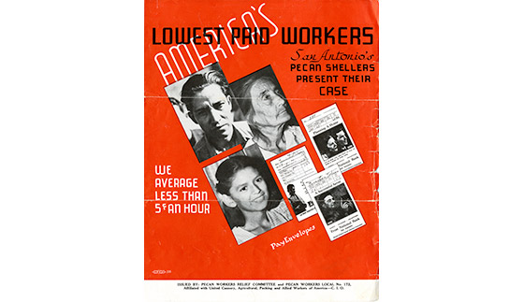
Figure 1. Brochure, “America’s Lowest Paid Workers,” 1938. Courtesy of Bullock Museum.

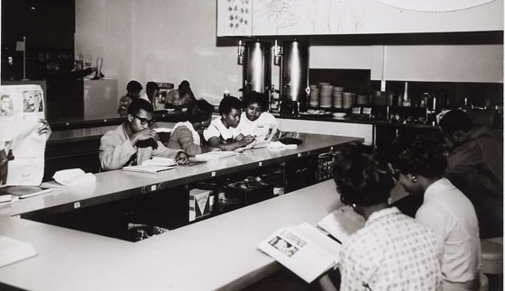
Figure 2. Lunch counter sit-in at Foley’s Department Store, Houston, TX, 1960. Courtesy of Bullock Museum.
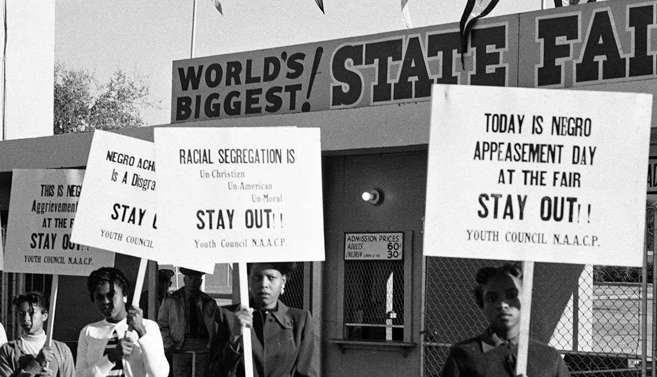
Figure 3. NAACP Youth Council picket line at Texas State Fair by R.C. Hickman, October 1955. Courtesy of Bullock Museum.

Lesson 3: Protest Poster Examples

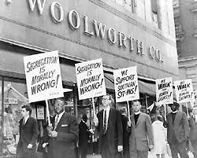
Figure 1. Woolworth Lunch Counter Protest. Courtesy of Library of Congress.

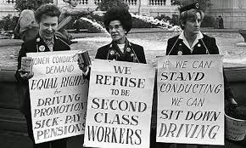
Figure 2. Women’s Rights Protest. Courtesy of historydaily.org.

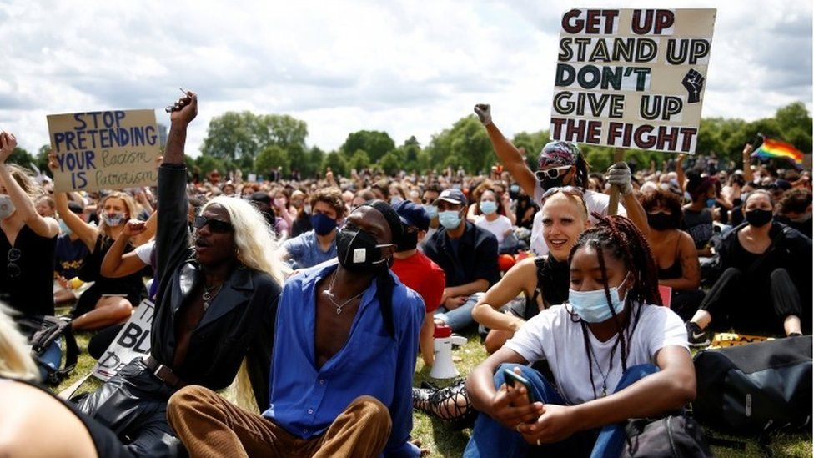
Figure 3. Contemporary Protest. Courtesy of BBC.com.
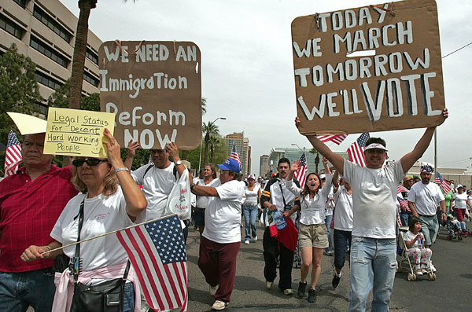
Figure 4. Immigration Reform Protest. Courtesy of Center for American Progress.
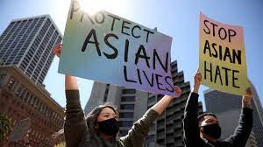
Figure 5. Protestors at Embarcadero Plaza Rally to stop Asian Hate, San Francisco, CA March 2021. Courtesy of NPR.

Lesson 4: Oral Histories
Students can read the quotes from the oral histories below or watch the Sit Down to Take a Stand Exhibit video.
Picture | Quote
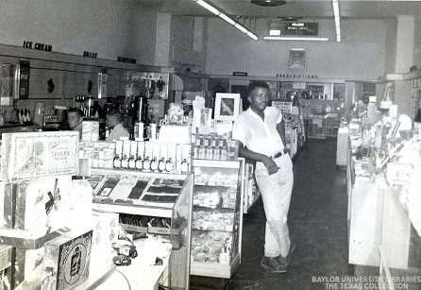  Figure 1. Interior of Pipkins Drugstore, Waco TX. Courtesy of the Texas Collection. | “Even after they kind of declared it, you know, where Blacks can eat, you know, you still, when you go in there you got to stand back, if you sat down, they wouldn’t serve you, they just walk right on by. They’ll serve all the whites, and if any of the Blacks be standing back there, then they ask them what they want.”
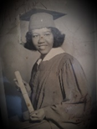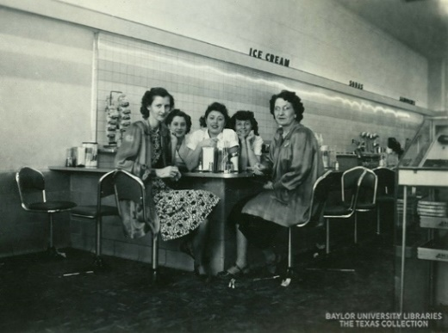  Figure 3. Interior of Pipkins Drugstore, Waco TX. Courtesy of the Texas Collection.  Figure 2. Photo of Cherry Boggess, Student Activist. Courtesy of the Texas Collection. | “During the…the demonstrations, you had to be trained how to demonstrate. We were taught how to not say anything. Some of us in..in..in practice were spit on, some, uh, knocked us in the head”  “We were able to sit at the counter…. and they didn’t serve any of us.”  After the protest, “we got a letter from them, I assumed it came from Pipkin’s…. but it had it’s ‘I’m sorry, and blah blah blah, and it was a nice letter, and then at the, the last thing was, ‘lunch on us.”
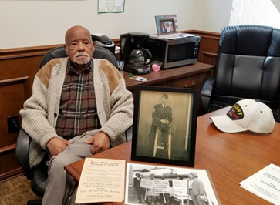  Figure 4. Arthur Fred Joe, Local Civil Rights Leader, Waco TX. Courtesy of Waco Tribune Herald.  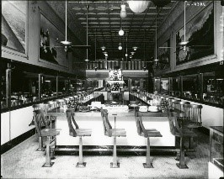  Figure 5. Interior of Vic’s Lunch Counter, Waco TX. Courtesy of the Texas Collection. | “I went in Vic’s, and they kept walking by me, these little waitresses, and they never would come over. And I sat there for about an hour then and finally this lady came over and told me, she said, ‘You’re gonna have to leave’.”  “So that next day, I got me five people, so we sat there about fifteen minutes. I guess the owner this time, he came up. He said, ‘I heard about the incident yesterday.’ I said, ‘Yup’, I said, ‘it was deplorable’.”  “That sucker went in there and he served us, and we were served that day.”

Glossary
accountable: accepting responsibility for one’s own actions.
advocate: recommend or support a cause.
bias: prejudice in favor of or against one thing, person, or group compared with another, usually in a way considered to be unfair.
boycott: refusing to do something as a form of protest.
cause: a principle or movement that one is prepared to advocate for.
citizen: a person who lives in a particular town, city, or country.
civil: relating to citizens and their concerns.
culture: the customs, traditions, arts, and social achievements of a particular group of people or social group (how certain groups of people do certain things).
democracy: a system of government by the people through elected representatives (people have the power through voting)
discrimination: the unfair treatment of different people or things, usually on the grounds of race, age, or sex.
diversity: involving people from different cultures, social groups, and ethnic backgrounds.
enforce: making people follow rules or laws.
impact: having a strong effect on someone or something.
injustice: lack of fairness or justice.
integrate: bring people (or groups) into equal participation in society.
justice: just behavior or treatment.
law: the system of rules that a country uses to regulate the actions of citizens.
local: relating to a particular area or neighborhood.
mobilize: encourage or organize people to act in a certain way to bring about an objective (usually relating to politics or social issues).
movement: a group of people working together to advance their political, social, or artistic ideas.
national: relating to a nation (or country).
oral history: sound recordings of interviews with people who have personal knowledge of past events.
protest: a public statement or action expressing disapproval of something.
public official: a person who is elected to a public office (President, senator, school board representative, county commissioner, etc.)
right: a moral or legal entitlement to have something or act in a certain way.
segregation: the enforced separation of different racial groups.
unconstitutional: not following the U.S. constitution or laws.
vote: the right to indicate a choice in an election (through submitting a ballot).

Additional Resources
“Bias.” National Museum of African American History and Culture, May 31, 2020. https://nmaahc.si.edu/learn/talking-about-race/topics/bias.
“Civil Rights Done Right.” Learning for Justice. Accessed September 8, 2021. https://www.learningforjustice.org/magazine/publications/civil-rights-done-right.
“Historical Foundations of Race.” National Museum of African American History and Culture, July 20, 2020. https://nmaahc.si.edu/learn/talking-about-race/topics/historical-foundations-race.
How to Talk to Kids About Race. YouTube. YouTube, 2018. https://www.youtube.com/watch?v=QNEKbVq_ou4.
“Race Talk: Engaging Young People in Conversations about Race and Racism.” Anti-Defamation League. Accessed September 8, 2021. https://www.adl.org/education/resources/tools-and-strategies/race-talk-engaging-young-people-in-conversations-about.
Ray, Skylar. “Arvizu v. Waco Independent School District.” Waco History. Accessed September 8, 2021. https://wacohistory.org/items/show/191.
Ray, Skylar. “Marvin C. Griffin.” Waco History. Accessed September 8, 2021. https://wacohistory.org/items/show/204.
Seven Aspects of Culture. YouTube. YouTube, 2015. https://www.youtube.com/watch?v=u2a9OP3_-U0.
Sit Down to Take A Stand. YouTube. YouTube, 2021. https://www.youtube.com/watch?v=tos1WRiWsIk.
“Social Identities and Systems of Oppression.” National Museum of African American History and Culture, July 17, 2020. https://nmaahc.si.edu/learn/talking-about-race/topics/social-identities-and-systems-oppression.
“Talking about Race.” National Museum of African American History and Culture, June 2, 2020. https://nmaahc.si.edu/learn/talking-about-race.
“Teaching Young Children about Race.” Teaching for Change, May 17, 2021. https://www.teachingforchange.org/teaching-about-race.
Texas Activism. YouTube. YouTube, 2020. https://www.youtube.com/watch?v=z6P_gLwuuqo.
https://www.thestoryoftexas.com/discover/campfire-stories/african-americans
Wenger, Regina. “Robert Gilbert.” Waco History. Accessed September 8, 2021. https://wacohistory.org/items/show/212.

If you would like, you can use this video for an explanation on culture.
This lesson could be split into two days to accommodate for research and presentations.
This content should be reviewed to ensure that it is suitable for your classroom environment.
This video includes some violence and should be reviewed to ensure it is appropriate for your classroom environment.
Students can also listen to the oral history by Arthur Fred Joe, Sr, using this link.
If you would like to extend this lesson, you can instruct students to utilize the Waco History App and the Local Civil Rights Sites Map to research other Civil Rights leaders and events in Waco.
Interview by Harvey Griggs discussing the conditions at the Pipkins Drugstore Lunch Counter.
Interview from Cherry Boggess discussing the sit-in protest at Pipkins Drugstore Lunch Counter.
Interview from Arthur Fred Joe discussing the sit-in protest he staged at Vic’s Lunch Counter in Waco, TX.

