Civil Rights & Civic Responsibility

Subject: Social Studies
Topics: Civil Rights Movement, Waco History, Citizenship, Civics, Democracy, Culture

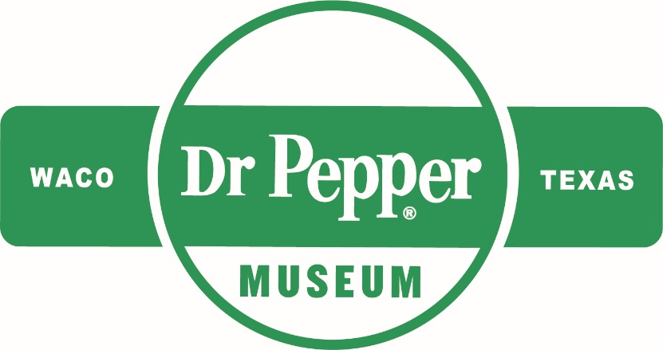
Introduction
Dear Teacher,
At the Dr Pepper Museum, we teach economics, history, and other concepts through the story of Dr Pepper and the Soft Drink industry. For this unit, we have focused on the story of the Civil Rights Movement nationally and locally and how it impacted communities. We designed activities that will help students explore history, democracy, and civic participation. These concepts and activities connect to our new Sit Down to Take a Stand exhibit. We are committed to supporting you as you teach this complex area of history in your classroom.
We look forward to connecting your class with the story of the national, state, and local Civil Rights Movement and inspiring your students to take responsible civic action.
This lesson plan is designed to help you create lessons for your classroom that connect to the Sit Down to Take a Stand exhibit at the Dr Pepper Museum. Lessons are typically cross curricular and are tied to TEKS. We suggest that you take these lessons and accommodate them to meet your class’s needs.
Enjoy!
Your Dr Pepper Museum Staff
Overview
Grade Range:
3-5

Topics:
Civil Rights Movement, Waco History, Citizenship, Civics, Democracy, Culture

Question:
How did the Civil Rights Movement change the lives of citizens both nationally and locally?

TEKS:
Third: SS 3.1 (A), SS 3.9 (A) (B) (C) SS 3.14 (B) (C), SS 3.15 (E), SS 3.16
Fourth: SS 4.15 (B) (C) (E), SS 4.16 (A), SS 4.17 (A), SS 4.21 (B) (C) (D), SS 4.22
Fifth: SS 5.5 (A) (C) SS 5.17 (A) (B), SS 5.21 (A), SS 5.25 (B) (C) (D), SS 5.26

Lesson 1: Cultural Diversity
Unit Compelling Question: How did the Civil Rights Movement change the lives of citizens both nationally and locally?
TEKS Covered:
SS 3.10 (A) (B)
SS 4.17 (A)
SS 5.21 (A)
Objective: | SWBAT develop an appreciation for the diverse cultures represented in their classroom by comparing the cultures of their classmates to their own.
Hook: | Introduce kids to idea of different cultures, using this video.
Body: | Define culture (definition in glossary). Explain that everyone has different traditions, etc. that make them special. Explore the components of culture (food, music, art, traditions, customs, etc.)  Have students create a collage that represents themselves and their culture. After they hand in the collage, post them on a wall in the classroom where they are visible for the class. (The collage can include music choice, foods, family members, traditions, etc.)
Product: | Then, have students take turns reading/viewing their fellow classmates’ collages. Afterwards, use the worksheet templates for them to compare their experiences to those of their classmates (in materials).  **It is recommended that teachers carefully set expectations for this activity. Teachers may want to model this activity for students by providing examples of the ways to respectfully compare cultures and experiences of classmates.
Lesson 2: Reasons for National Civil Rights Movement & Citizenship
Unit Compelling Question: How did the Civil Rights Movement change the lives of citizens both nationally and locally?
TEKS Covered:
SS 3.1 (A), SS 3.9 (A) (B) (C), SS 3.14 (B) (C), SS 3.15 (E)
SS 4.15 (B), SS 4.21 (D), SS 4.22
SS 5.5 (A) (C), SS 5.25 (D)
Objective: | SWBAT describe the reasons and identify the people involved in National Civil Rights Movement by listing the discrimination people of color faced, the actions they took, the solutions they found, and how this made them good citizens.
Hook: | Ask the class what they know about Civil Rights & Civil Liberties, and rules/laws. After they brainstorm, introduce the topic using this video.
Body: | Explain concept of unfair laws and watch this video on the early stages of Civil Rights Movement.  Ask the class which laws they thought were unfair in the video. Identify ways people responded to the unfair laws (you or your students can make a list while watching the video). Discuss the ways that Civil Rights leaders dealt with unfair laws and how this made them good citizens.
Product: | Have students create their own t-chart comparing the problems that Civil Rights leaders faced, the actions they took, the solutions that occurred, and how their actions made them good citizens. (Example chart and worksheet template in materials)

Lesson 3: Civil Rights Movement in Texas
Unit Compelling Question: How did the Civil Rights Movement change the lives of citizens both nationally and locally?
TEKS Covered:
SS 3.1 (A), SS 3.15 (E), SS 3.16
SS 4.21 (D), SS 4.22
SS 5.5 (A)
Objective: | SWBAT identify the ways citizens can make positive changes by analyzing Civil Rights events in Texas and exploring how to create a solution to a community problem.
Hook: | Show students images of Civil Rights events in Texas (in materials) and have them write a caption for what they think is happening in the image.
Body: | Explain to students that fighting for Civil Rights happened across all states, even Texas.  Ask students what they think about how Texans mobilized to make changes in their state. Discuss how when different groups work together, they can make big changes in their state or local communities. Brainstorm how students could work with others to take on a problem they care about. For example, they could write a letter to local leaders about an issue or organize a campaign to help solve a problem (like Civil Rights leaders).
Product: | Ask students to think about a problem they care about (may need to list examples from brainstorm). Students will draw a poster to explain their problem, what it means to them, and how others can help. Use images of Civil Rights protest posters as examples (in materials).

Lesson 4: Civil Rights Movement in Waco
Unit Compelling Question: How did the Civil Rights Movement change the lives of citizens both nationally and locally?
TEKS Covered:
SS 3.1 (A)
SS 4.15 (B), SS 4.21 (C), SS 4.22
SS 5.5 (A) (C)
Objective: | SWBAT interpret the reasons for the sit-in protests in Waco by reading quotes from Civil Rights leaders and describing how the changes they made improved the Waco community.
Hook: | Ask the class if they know what a sit-in or wade-in protest is. After they answer, explain the concept, using this video.
Body: | Remind students that the Civil Rights Movement happened because certain groups of people were being treated differently and they felt it wasn’t right. Tell students that working together for Civil Rights took place across all communities, even local communities, like Waco, and that people worked together to change laws.  Assign the students a person from the Civil Rights Movement in Waco. Using the oral history provided by the Dr Pepper Museum, have the students independently read the oral history (in materials). After the oral history session, break the students into groups based on the person assigned. While in groups, students should discuss the actions taken by their person and how these actions made life better for Waco citizens.
Product: | For Homework:  Using the oral histories, have the students reflect on the actions taken by their local Wacoan. Have students write an argument for the action taken (worksheet in materials). Ask the students to discuss what actions they would’ve taken as their assigned person, using evidence from the oral histories. Students should also include whether they think the actions taken by Civil Rights leaders in Waco produced effective solutions and how those solutions impact the Waco community today.
Lesson 5: Impacts of Civil Rights Movement - Citizenship, Civics, Civic Responsibility
Unit Compelling Question: How did the Civil Rights Movement change the lives of citizens both nationally and locally?
TEKS Covered:
SS 3.9 (A) (C), SS 3.15 (E), SS 3.16
SS 4.15 (B) (C) (E), SS 4.16 (A), SS 4.21 (B) (C) (D)
SS 5.5 (A) (C), SS 5.17 (A) (B), SS 5.25 (B) (C) (D), SS 5.26
Objective: | SWBAT understand the characteristics of good citizens by describing how Civil Rights leaders acted as good citizens and by listing ways to contact public officials to solve a community problem.
Hook: | Challenge students to write as many characteristics of a good citizen as they can in three minutes. Then select students to share the last thing they wrote.
Body: | Remind students of the ways Civil Rights leaders were good citizens.  Make an anchor chart with the different groups students are a part of to explain that being a citizen is being a member of a of a town, city, state, and country.  Define what citizenship and democracy means. Explain to students that being a good citizen in a democracy requires their individual participation. Watch this video for examples of good citizenship and an explanation of democracy.  Explain that the leaders of the Civil Rights movement were good citizens because they helped to change laws, made their communities better, and respectfully held public officials to their word. Empower students to make small changes and to advocate for things they care about. Discuss issues that are important to them.  Explain to students that public officials help to create and enforce laws. Print pictures of three types of public officials in your community that could help address problems. Outline their roles in the community and list how/why students should contact them.
Product: | Taking the poster from lesson 3, have students add the public officials that could help them with their problem and how they would contact them. Have students explain how their plan helps their community.  **If you would like to extend this lesson, you can also have students write a letter to the local public official that can help with their problem.

Unit Assessment
Using the poster from Lesson Three and Five, students will create a community action plan for their problem. Have them create a presentation that outlines their problem, the actions people can take (how they can act as responsible citizens), the public officials that can help with the problem, what solutions they think will be most effective, and how it will improve their community.

Materials
Lesson 1: Cultural Diversity
Refer to these questions and the worksheet templates below for Lesson 1.
- What other traditions did you notice from viewing your classmates’ reflections?
- How do the cultures of your classmates differ from your own?
- What do you think is cool or unique about your classmates and their traditions/culture?

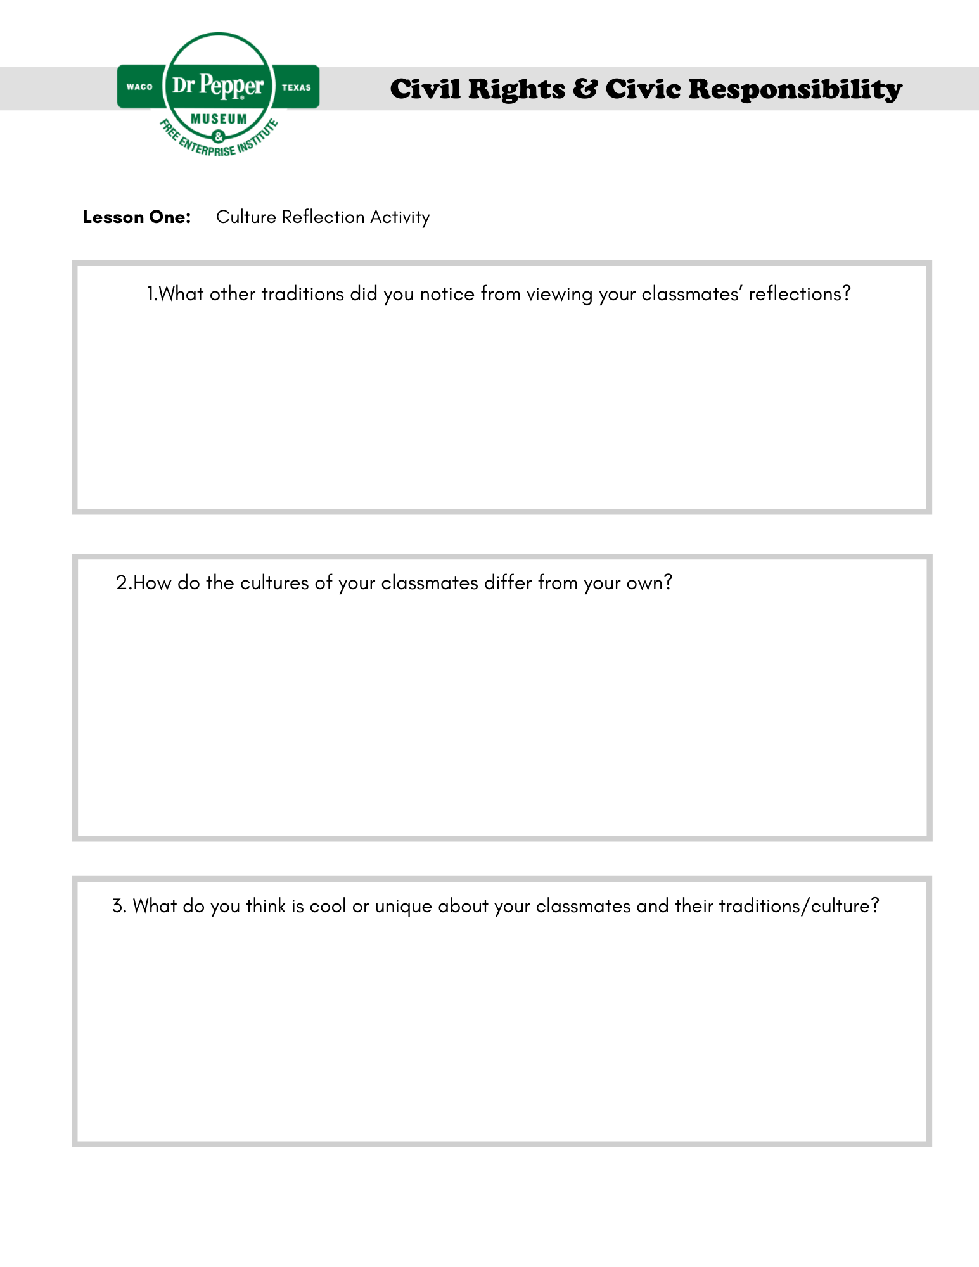
Please refer to this link for an editable worksheet template. This worksheet can be assigned as homework.
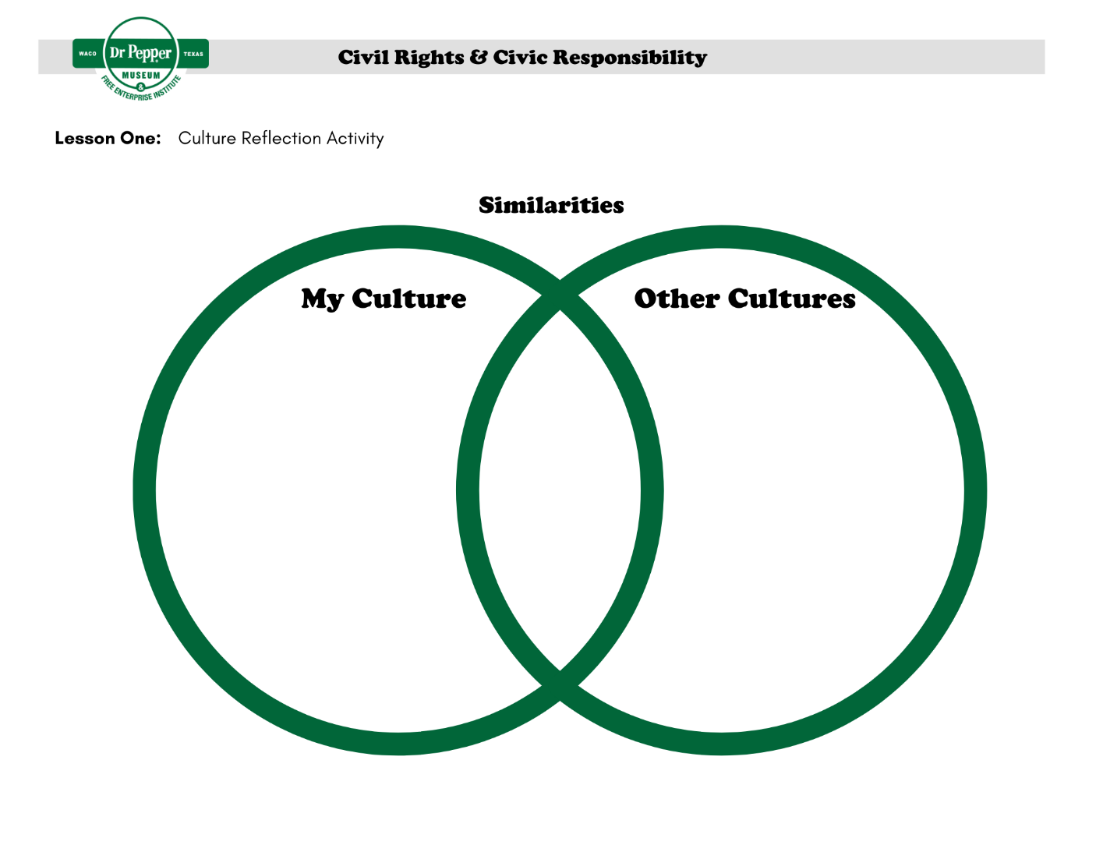
Lesson 2: Example Chart
Example of content for Lesson 2.
Problem | Action | Solution | Citizenship
Not allowed to Vote | Created voter registration campaigns. | Laws were passed to allow people to vote. (Voting Rights Act of 1965) | Advocated for Justice and held public officials accountable.
Not allowed to sit on buses | Boycotted riding the bus | Laws were passed (Civil Rights Act of 1964) | Held public officials accountable.
Could not eat at restaurants | Sit-in protests | Laws were passed (Civil Rights Act of 1964) | Improved the community.
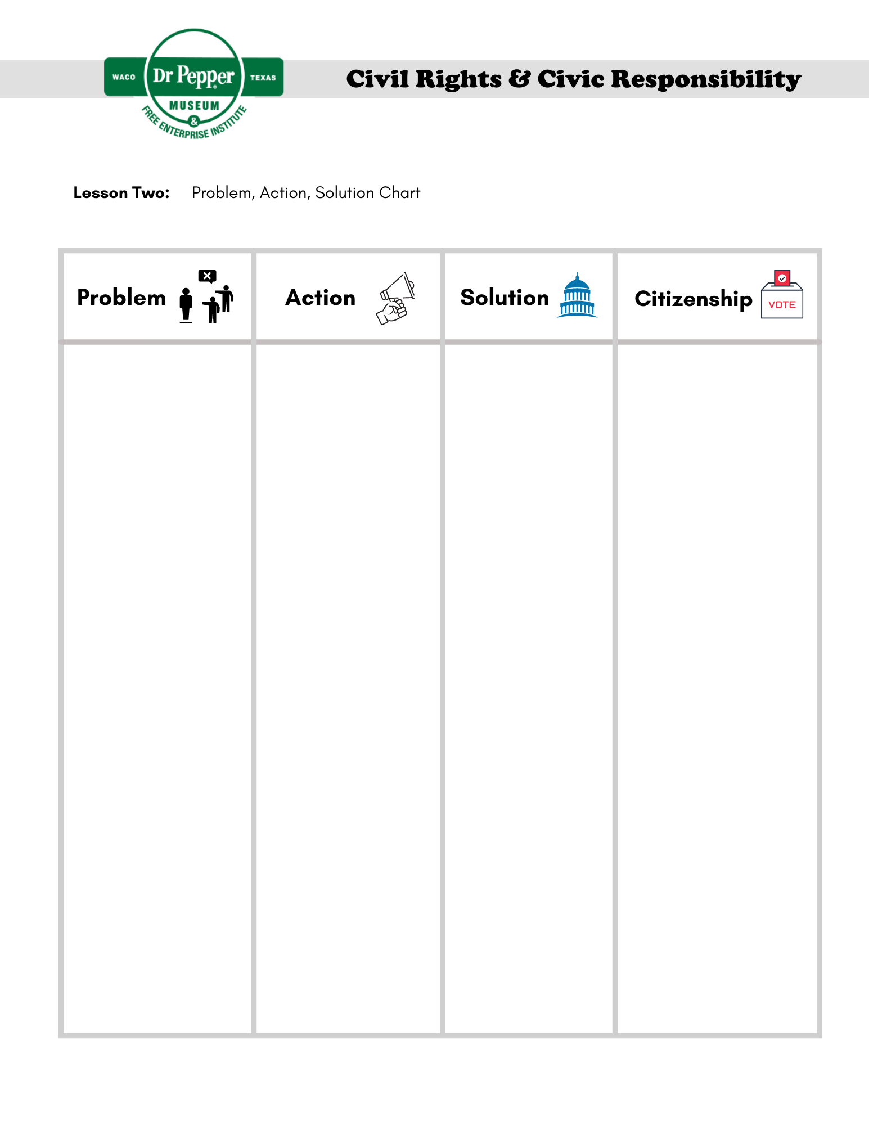
Lesson 3: Texas Civil Rights Movement Photos
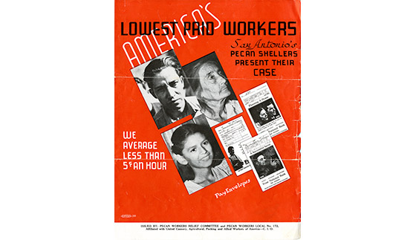
Figure 1. Brochure, “America’s Lowest Paid Workers,” 1938. Courtsey of Bullock Museum.

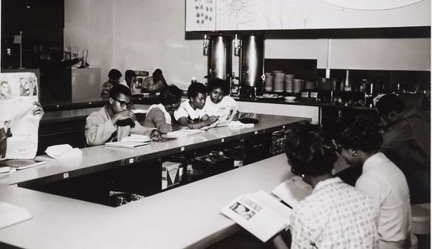
Figure 2. Lunch counter sit-in at Foley’s Department Store, Houston, TX, 1960. Courtesy of Bullock Museum.
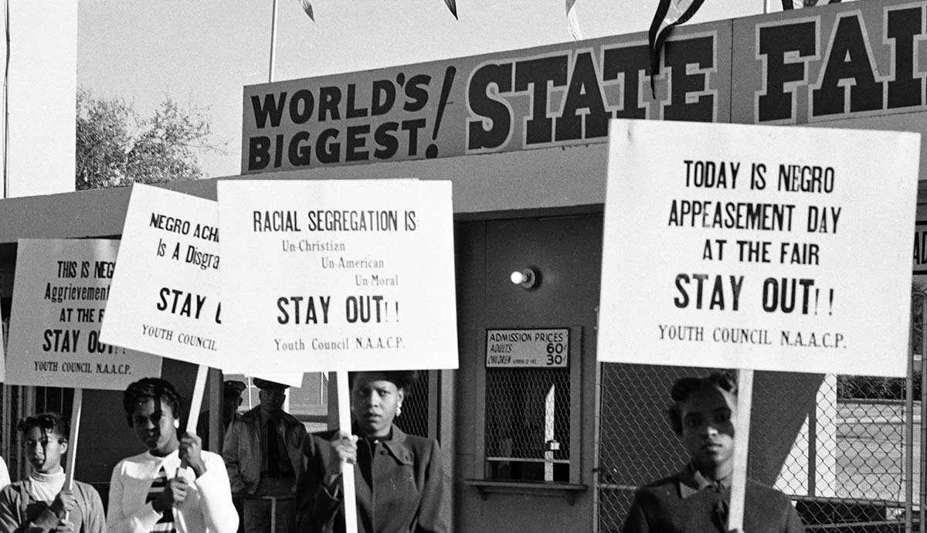
Figure 3. NAACP Youth Council picket line at Texas State Fair by R.C. Hickman, October 1955. Courtesy of Bullock Museum.

Lesson 3: Protest Poster Examples

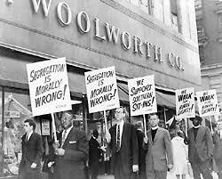
Figure 1. Woolworth Lunch Counter Protest. Courtesy of Library of Congress.

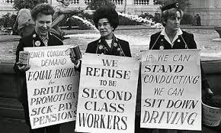
Figure 2. Women’s Rights Protest. Courtesy of historydaily.org.

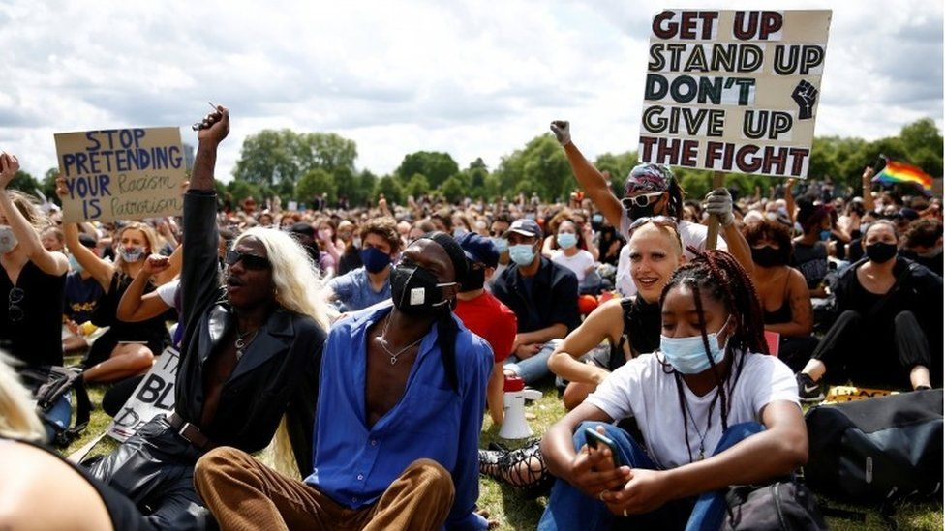
Figure 3. Contemporary Protest. Courtesy of BBC.com.
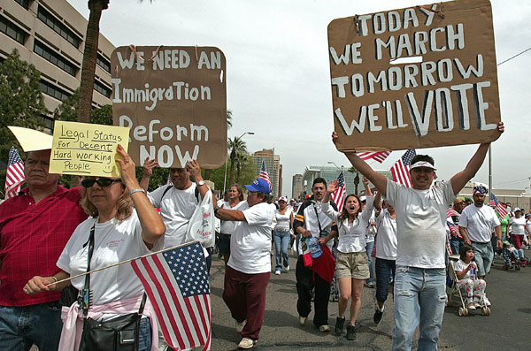
Figure 4. Immigration Reform Protest. Courtesy of Center for American Progress.
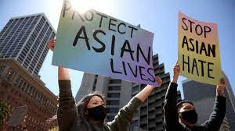
Figure 5. Protestors at Embarcadero Plaza Rally to stop Asian Hate, San Francisco, CA March 2021. Courtesy of NPR.

Lesson 4: Oral Histories
Students can read the quotes from the oral histories below or watch the Sit Down to Take a Stand Exhibit video.
Picture | Quote
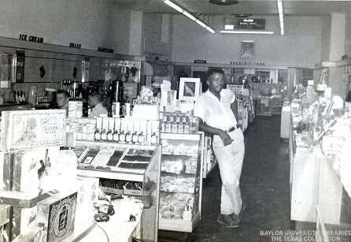  Figure 1. Interior of Pipkins Drugstore, Waco TX. Courtesy of the Texas Collection. | “Even after they kind of declared it, you know, where Blacks can eat, you know, you still, when you go in there you got to stand back, if you sat down, they wouldn’t serve you, they just walk right on by. They’ll serve all the whites, and if any of the Blacks be standing back there, then they ask them what they want.”
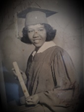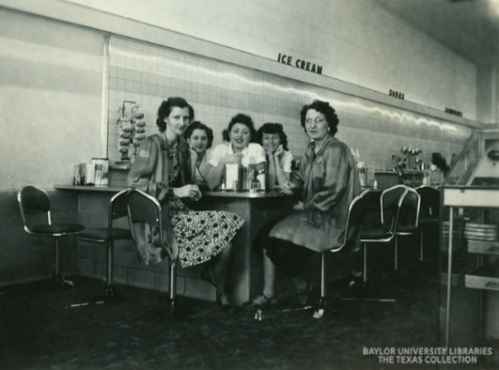  Figure 2. Photo of Cherry Boggess, Student Activist. Courtesy of the Texas Collection.  Figure 3. Interior of Pipkins Drugstore, Waco TX. Courtesy of the Texas Collection. | “During the…the demonstrations, you had to be trained how to demonstrate. We were taught how to not say anything. Some of us in..in..in practice were spit on, some, uh, knocked us in the head”  “We were able to sit at the counter…. and they didn’t serve any of us.”  After the protest, “we got a letter from them, I assumed it came from Pipkin’s…. but it had it’s ‘I’m sorry, and blah blah blah, and it was a nice letter, and then at the, the last thing was, ‘lunch on us.”
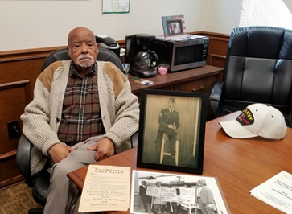  Figure 4. Arthur Fred Joe, Local Civil Rights Leader, Waco TX. Courtesy of Waco Tribune Herald.  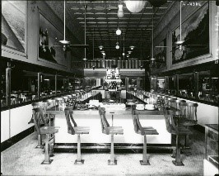  Figure 5. Interior of Vic’s Lunch Counter, Waco TX. Courtesy of the Texas Collection. | “I went in Vic’s, and they kept walking by me, these little waitresses, and they never would come over. And I sat there for about an hour then and finally this lady came over and told me, she said, ‘You’re gonna have to leave’.”  “So that next day, I got me five people, so we sat there about fifteen minutes. I guess the owner this time, he came up. He said, ‘I heard about the incident yesterday.’ I said, ‘Yup’, I said, ‘it was deplorable’.”  “That sucker went in there and he served us, and we were served that day.”

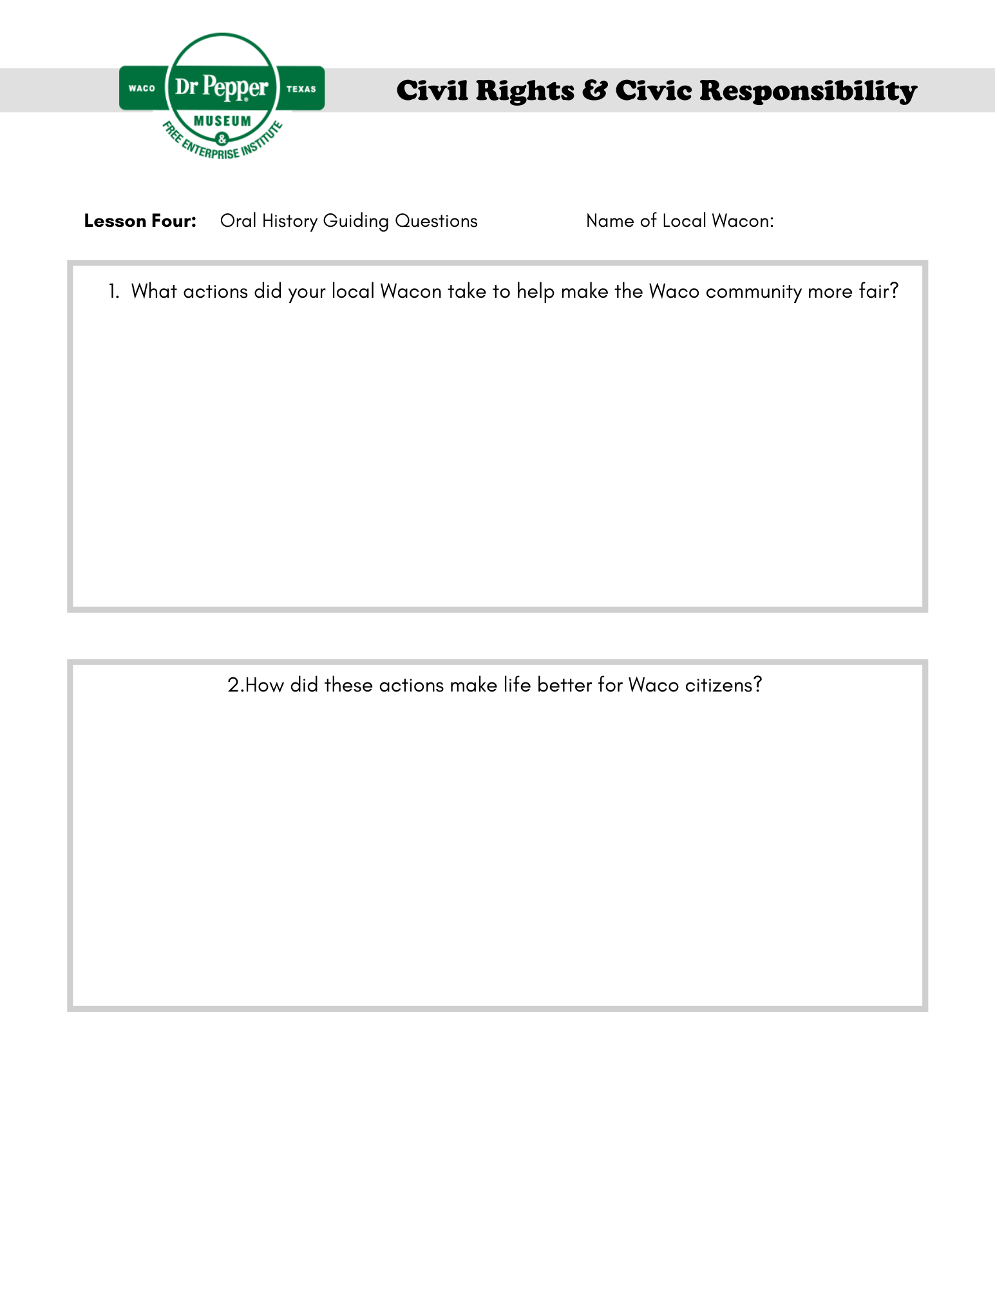
Glossary
accountable: accepting responsibility for one’s own actions.
advocate: recommend or support a cause.
boycott: refusing to do something as a form of protest.
cause: a principle or movement that one is prepared to advocate for.
citizen: a person who lives in a particular town, city, or country.
civil: relating to citizens and their concerns.
culture: the customs, traditions, arts, and social achievements of a particular group of people or social group (how certain groups of people do certain things).
democracy: a system of government by the people through elected representatives (people have the power through voting)
discrimination: the unfair treatment of different people or things, usually on the grounds of race, age, or sex.
diversity: involving people from different cultures, social groups, and ethnic backgrounds.
enforce: making people follow rules or laws.
impact: having a strong effect on someone or something.
injustice: lack of fairness or justice.
integrate: bring people (or groups) into equal participation in society.
justice: just behavior or treatment.
law: the system of rules that a country uses to regulate the actions of citizens.
local: relating to a particular area or neighborhood.
mobilize: encourage or organize people to act in a certain way to bring about an objective (usually relating to politics or social issues).
movement: a group of people working together to advance their political, social, or artistic ideas.
national: relating to a nation (or country).
oral history: sound recordings of interviews with people who have personal knowledge of past events.
protest: a public statement or action expressing disapproval of something.
public official: a person who is elected to a public office (President, senator, school board representative, county commissioner, etc.)
right: a moral or legal entitlement to have something or act in a certain way.
segregation: the enforced separation of different racial groups.
unconstitutional: not following the U.S. constitution or laws.
vote: the right to indicate a choice in an election (through submitting a ballot).

Additional Resources
“Civil Rights Done Right.” Learning for Justice. Accessed September 8, 2021. https://www.learningforjustice.org/magazine/publications/civil-rights-done-right.
“Historical Foundations of Race.” National Museum of African American History and Culture, July 20, 2020. https://nmaahc.si.edu/learn/talking-about-race/topics/historical-foundations-race.
How to Talk to Kids About Race. YouTube. YouTube, 2018. https://www.youtube.com/watch?v=QNEKbVq_ou4.
“Race Talk: Engaging Young People in Conversations about Race and Racism.” Anti-Defamation League. Accessed September 8, 2021. https://www.adl.org/education/resources/tools-and-strategies/race-talk-engaging-young-people-in-conversations-about.
Ray, Skylar. “Arvizu v. Waco Independent School District.” Waco History. Accessed September 8, 2021. https://wacohistory.org/items/show/191.
Ray, Skylar. “Marvin C. Griffin.” Waco History. Accessed September 8, 2021. https://wacohistory.org/items/show/204.
Sit Down to Take A Stand. YouTube. YouTube, 2021. https://www.youtube.com/watch?v=tos1WRiWsIk.
“Social Identities and Systems of Oppression.” National Museum of African American History and Culture, July 17, 2020. https://nmaahc.si.edu/learn/talking-about-race/topics/social-identities-and-systems-oppression.
“Talking about Race.” National Museum of African American History and Culture, June 2, 2020. https://nmaahc.si.edu/learn/talking-about-race.
“Teaching Young Children about Race.” Teaching for Change, May 17, 2021. https://www.teachingforchange.org/teaching-about-race.
Texas Activism. YouTube. YouTube, 2020. https://www.youtube.com/watch?v=z6P_gLwuuqo.
https://www.thestoryoftexas.com/discover/campfire-stories/african-americans
Wenger, Regina. “Robert Gilbert.” Waco History. Accessed September 8, 2021. https://wacohistory.org/items/show/212.

If it is more suitable for your classroom, this activity can be adapted to include a written reflection instead.
If you want to extend this topic, show this video to the class.
This content should be reviewed to ensure that it is suitable for your classroom environment.
Students can also listen to the oral history by Arthur Fred Joe, Sr, using this link.
You can utilize these links to find the public officials in your area. If you are a Texas teacher, use https://directory.tml.org/. For out of state teachers, use https://www.usa.gov/elected-officials.
Interview by Harvey Griggs discussing the conditions at the Pipkins Drugstore Lunch Counter.
Interview from Cherry Boggess discussing the sit-in protest at Pipkins Drugstore Lunch Counter.
Interview from Arthur Fred Joe discussing the sit-in protest he staged at Vic’s Lunch Counter in Waco, TX.

