Emerging Entrepreneurs Pre Field Trip Lesson
Grades: 3rd -5th
Subject: Math and Social Studies
Topics: Free Enterprise System, Budgeting, and Entrepreneurship

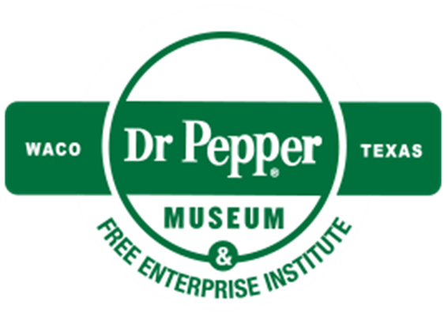
Introduction
Dear Teacher,
At the Dr Pepper Museum and Free Enterprise Institute, we believe that a meaningful field trip is more than just the hours you spent at the museum. It begins with you in your classroom. By facilitating lessons in your classroom that relate to the fieldtrip, your visit can deepen your students’ understanding of concepts.
This lesson plan is designed to help you create lessons for your classroom for the week of your field trip to the Dr Pepper Museum. lessons are typically cross curricular and are tied to TEKS. We suggest that you take these lessons and accommodate them to meet your class’s needs.
Enjoy!
Your Dr Pepper Museum Staff

Overview
Grade Range:
Third Grade, Fourth Grade, and Fifth Grade
Topics:
Free Enterprise System, Budgeting, and Entrepreneurship
Question:
What do I need to know for my Dr Pepper Museum Field Trip?
TEKS:
3rd Grade: 7(C) and 8(A)
4th Grade: 11(B)(C)
5th Grade: 12(A)(B)
Field Trip Connection:
This lesson is intended to be facilitated a few days before an Emerging Entrepreneurs field trip.

Lesson 1: Emerging Entrepreneurs Pre-Field Trip Lesson
Materials:
- Access to the Dr Pepper Museum website
- Terminology Worksheet
Engage:
- As a class, watch a video about a child entrepreneur (https://www.youtube.com/watch?v=baWIgo9FqgU)
Activity 1: Field Trip Introduction
- Remind the students that they will be visiting the Dr Pepper Museum and Free Enterprise Institute. Remind them of any procedures or expectations specific to your class.
- As a class, explore the Dr Pepper Museum website to see what you will find at the museum (drpeppermuseum.com)
Activity 2: Financial Literacy Terms
- As a class, define Free Enterprise System on the worksheet by reading the example.
  - Free Enterprise: Businesses get to choose what to sell and how to sell it. People choose what to buy.
- As individuals or small groups, students will complete the worksheet with the following terms:
  - Entrepreneur: A person who starts their own business.
  - Budget: A plan or record of the money spent and gained.
  - Start Up Loan: Borrowed money to start a project that must be given back.
  - Net Revenue: The money you have after you take away the money you spent.
  - Gross Revenue: The money you make before you take away the money you spent.
  - Corporate Responsibility: Businesses doing the right thing.
Conclusion:
- Remind students of behavioral expectations for the Dr Pepper Museum field trip.
- As individuals, students will write one thing they hope to learn or see at the Dr Pepper Museum on a sticky note.
- Instruct students to put their sticky note on the board.
- To the class, discuss common things students put on the board.

Emerging Entrepreneurs: Vocabulary
Complete the definition below by reading the clue and making your own definition for the word.
Vocabulary Term | Clue | Student Definition
Free Enterprise System | A soda fountain can choose to sell a new flavor of soda. Shoppers can choose to buy that flavor or not.
Entrepreneurs | McKayla chose to start her own business at a lemonade stand.
Budget | The children at the lemonade stand kept track of how much money their supplies cost and how much money they made.
Start Up Loan | With the start up loan, the man bought his soda food truck. When his soda food truck was open, he made enough money to pay the bank back.
Net Revenue | After paying for the honey, lemonade, and sugar, the girl had $50 to keep from the lemonade stand.
Gross Revenue | The woman made $300 after selling her cupcakes at the store.
Corporate Responsibility | Me and the Bees Lemonade is a business that chooses to use honey from responsible beekeepers and donates money to save beehives.

