Classroom Economy Kit
Grade Focus: Elementary
Subject: Financial Literacy

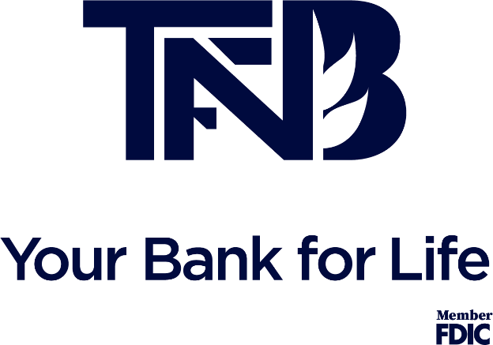
Classroom Economy Kits
Objective:
Students will be able to demonstrate fiscal responsibility by earning, budgeting and spending money in the classroom.
Contents:
- Teacher Directions
- Printable bulletin signs/pockets
- Printable Money
- Printable Student Checkbooks
- Printable Classroom Store Sign
- Printable Coupon and Loan Templates
Directions
- Prepare the materials by editing the templates, printing the materials, and creating your Classroom Economy bulletin board.
- Review with your class the Economy Expectations and procedures as listed on the “Economy Expectations” page.
- Give each student a checkbook, explain how they should use them, and complete examples as a class on the board.
- Either at one time or over the first few weeks, define the economics terms and put them on the word wall.
- Reward and fine students based on their behavior and the expectations you established.
- Facilitate a class store at an established time each day/week.
- Periodically, reflect with the class about there saving, or lack of, and how budgeting is important.
Accommodations and Extensions
This kit is designed so that teachers can change the material to fit their classroom’s needs. Take out any procedures or materials that you think will not fit your class and keep whatever you think will meet your needs. You can also take the Classroom Economy further by analyzing sales with tables and charts, having students earn money during classroom jobs, having students write reflections and goals, or by facilitating a time for students to create and sell their own products.
The Bank of NAME
Est. 2020
Economy Expectations:
Our Classroom Economy is a system for students to earn, manage and spend money based on their behavior.
EARN and LOOSE Money:
The teacher is in charge of giving and taking money when they think it is deserved.
Students can earn money if they…
- Follow instructions well
- Are respectful
- Are kind to others
Students may pay a fine if they…
- Do not follow instructions after 2 warnings
- Are disrespectful
- Steal or are dishonest about money
MANAGE Money
- Students will keep their money in their “safe” at the bank.
- Students will budget their spending in their checkbook.
DEBT and LOANS
If a student spends money they do not have, they will go into “debt” and will be given a “loan”.
Students can pay off a loan by…
- Completing an extra assignment
- Losing a privilege
SPEND Money
Students can spend money at the teacher’s store at (insert appropriate times)
Students can save their money to buy bigger purchases from the store.

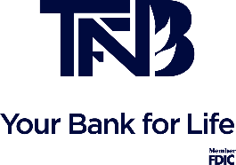
Economy Debt
Loan Currency
Budget Checkbook
Word Wall
Free Enterprise Finance
Purchase Product
Consumer Bank

Student Safes
Use these templates to make the student’s “safes” or pockets to hold their money.
- Copy/paste the template to a new word document.
- Put your student’s name where it says “name”.
- Repeat for each student in your class.
- Print and cut out all pieces.
- Staple the safe to a bulletin board on the right, left, and bottom to make a pocket.

Student Name

ONE DOLLAR
Name Classroom Economy
1
Put your picture here
1
ONE
ONE

Classroom Money
Use these templates to make your own money!
- Put your name where it says “name”.
- Add your picture in the circle by deleting the text, selecting the circle, clicking “shape fill”, insert picture, and selecting a picture of yourself.
- Repeat steps one and two for all four bills.
- Copy and paste as many of the bill you need onto a blank word document.

TWENTY DOLLAR
Name Classroom Economy
20
Put your picture here
20
TWENTY
TWENTY
FIVE DOLLAR
LAR
Name Classroom Economy
5
Put your picture here
5
FIVE
FIVE

TEN DOLLAR
Name Classroom Economy
10
Put your picture here
10
TEN
TEN
The Bank of NAME
Est. 2019

Official Check Book
_________________

Date | +/- | Amount | What Happened?
TOTAL:
TOTAL:
TOTAL:
TOTAL:
TOTAL:
TOTAL:
TOTAL:
TOTAL:
TOTAL:
Name’s Store
COST | COUPON
3 Dollars | Insert a coupon for students to buy like “sit anywhere”
5 Dollars | Insert a coupon for students to buy like “sit anywhere”
10 Dollars | Insert a coupon for students to buy like “sit anywhere”
15 Dollars | Insert a coupon for students to buy like “sit anywhere”
- Dollars | Insert a coupon for students to buy like “sit anywhere”
25 Dollars | Insert a coupon for students to buy like “sit anywhere”
30 Dollars | Insert a coupon for students to buy like “sit anywhere”
40 Dollars | Insert a coupon for students to buy like “sit anywhere”
50 Dollars

Loan
___________ borrowed $___.00 from Name.
This loan will be paid by ___/___
by: ____________________________________________________________________________________
Loans and Coupons
Use these templates to make your own loans and coupons!
- Put your name where it says “name”.
- Copy and paste the template onto a new word document and print however many you need.
- When students need either a loan or a coupon, write in the information for the specific loan or coupon.

Coupon
On ___/___, ____________ bought
__________________________________________________________
Teacher initials: ______

