Marketing Strategies and Social Issues Research
Grade Range: Fifth Grade
Subjects: English and Social Studies
Topics: Research, Persuasive Writing, Evaluating Media,
Marketing, and Advertising

Introduction
Dear Teacher,
At the Dr Pepper Museum and Free Enterprise Institute, we believe that a meaningful field trip is more than just the hours you spent at the museum. It begins with you in your classroom. By facilitating lessons in your classroom that relate to the field trip, your visit can deepen your students’ understanding of concepts.
These Inquiry Units are designed to help you create lessons for your classroom for the week of your field trip to the Dr Pepper Museum. They are cross curricular and are tied to TEKS. We suggest that you take these units and accommodate them to meet your class’s needs.
Enjoy!
Your Dr Pepper Museum Staff

A special thank you to the Baylor School of Education for developing inquiry units for the Dr Pepper Museum and Free Enterprise Institute.

Dr. Barbara Purdum-Cassidy
Molly Adams
Hannah Arnold
Marlin Black
Meredith Bringe
Katie Brown
Alicia Chamberlain
Elizabeth Downey
Ellie Duda
Natalie Elam
Makenzie Harrison
Claire Hudson
Kirby Jarzombek

Dr. Neil Shanks
Audrey Johnston
Sahira Kodra
Alex Lodenberg
Chloe Marshall
Jae Moore
Grace Mueller
Audrey Sossaman
Rachel Steitz
Claire Tate
Sarah Tinlin
Abigail Traylor
Hannah Tucker

Overview
Grade Range: Fifth Grade

Topics:
Free Enterprise, Civil Rights, Research, Persuasive Writing, Evaluating Media, Marketing, and Advertising

Compelling Question:
How do companies use marketing strategies to appeal to their audiences?

TEKS:
Fifth Grade: (Social Studies) 5A, 13E, 21B, 26B
(English) 12A, 12B, 14B, 19, 23A, 23B

Field Trip Connection:
These lessons are designed for the week after a Very Important Pepper trip. You can also add to the field trip by participating in a Create a Soft Drink (2 hr) or Engaging the Economy (4 hr).

Inquiry Unit Plans

Unit Compelling Question: How do companies use marketing strategies to appeal to their audiences?
Lesson 1  How do companies use gender to appeal to target audiences? | Lesson 2  How do companies use race to appeal to target audiences? | Lesson 3  What marketing strategies did companies use history? | Lesson 4  What marketing strategies do companies use today? | Lesson 5  How can companies use constructive marketing strategies to advertise a product?
TEKS Covered:  (SS) 5A, and 13E  (ELA) 12A, 12B, 14B, 25A, and 25B | TEKS Covered:  (SS) 5A, and 13E  (ELA) 12A, 12B, 14B, 25A, and 25B | TEKS Covered:  (SS) 5A, 13E, and 21A  (ELA) 12A, 12B, 14B, 25A, and 25B | TEKS Covered:  (SS) 5A, 13E, and 21A  (ELA) 12A, 12B, 14B, 25A, and 25B | TEKS Covered:  (SS) 5A, 13E, 21A, 26B  (ELA) 12A, 12B, 14B, 19 25A, and 25B
Objective:  TSWBAT create a research plan and collect research on the use of gender in marketing. | Objective:  TSWBAT follow a research plan and collect research on the use of race in marketing. | Objective:  TSWBAT follow a research plan and collect data on marketing strategies used in history. | Objective:  TSWBAT follow a research plan and collect data on marketing strategies used today. | Objective:  TSWBAT create an advertisements using constructive marketing strategies and their research.
Hook:  Show students a commercial that uses gender appeal as a persuasive technique. (Dr Pepper 10) (One of a kind woman) | Hook:  Show students advertisements or commercials describe the people depicted in them. (Lesson 2: Lack of Diversity in Advertising Examples) | Hook:  Show students commercials from history and ask them to describe the advertising techniques in them. (Just what the Dr Ordered 1988) (Dr Pepper Difference) (Godzilla) (I’m a Pepper) | Hook:  Show students commercials that are popular today and ask them to describe advertising techniques in them. (Lil Sweet) (The Adventures of Dr Pepper) (Fansville)(Cherry On) | Hook:  Show students a commercial that uses positivity and inclusivity as a persuasive tool and ask the students to reflect on how effective they are. (Project #showus)(Apple- Inclusivity & Diversity)(Nike-Greatness)
Body:  Explain that advertisements use techniques to sell their goods/services. Some commercials use “Gender Appeal”, a technique that speaks to only men or women.  Show students the research plan they will use for week and demonstrate how to fill out the template. (Marketing Research Plan and Template x4).  Provide students with instructions and information necessary to utilize available research tools. (Pebble-Go)  Instruct students to complete their research utilizing the tools and template. Instruct them to research 3 ways an advertisement catered to a specific race | Body:  Explain that advertisements are sometimes made for a specific audience and can not include a group of people. For most of history, and in some advertisements today, the only people shown in commercials or ads were white.  Remind students of the research plan an  information necessary to utilize available research tools. (Pebble-Go)  Instruct students to complete their research utilizing the tools and template. Instruct them to research 3 ways an advertisement catered to a specific race | Body:  Explain that advertisements change to match what people like during that time in history. People today can learn about people in history by watching the commercials that were made for them.  Remind students of the research plan an  information necessary to utilize available research tools. (Pebble-Go)  Instruct students to complete their research utilizing the tools and template. Instruct them to research 3 ways companies advertised in history. | Body:  Remind students that advertisements change to match what people like. People today can learn about the community they live in by observing the commercials that are made for them.  Remind students of the research plan an  information necessary to utilize available research tools. (Pebble-Go)  Instruct students to complete their research utilizing the tools and template. Instruct them to research 3 ways companies advertised today. | Body:  Remind students of the types of persuasion in advertising they researched. Reflect as a class on ways companies can advertise their products in a constructive way.  Instruct groups of students to use their research to create a persuasive new commercial for Dr Pepper. Their commercial should address a problem in advertising and uses a persuasive technique that they thought was successful.  Invite students to perform their commercial for their class.  As an extension, instruct the students to write an explanation of their commercial, the persuasive techniques thy used and why it addressed a problem with advertising.
Product:  Students will complete research pertaining to marketing/persuasive strategies used in advertising by finding three samples of evidence and then reflecting on what they can learn from that information. |  |  |  | Product:  Students will create and perform a commercial.
Unit Assessment:
Students will be assessed on their completed research and their commercial presentations considering their use of constructive marketing and use of persuasive techniques.

Materials
Lesson 2: Examples of Lack of Diversity in Advertising
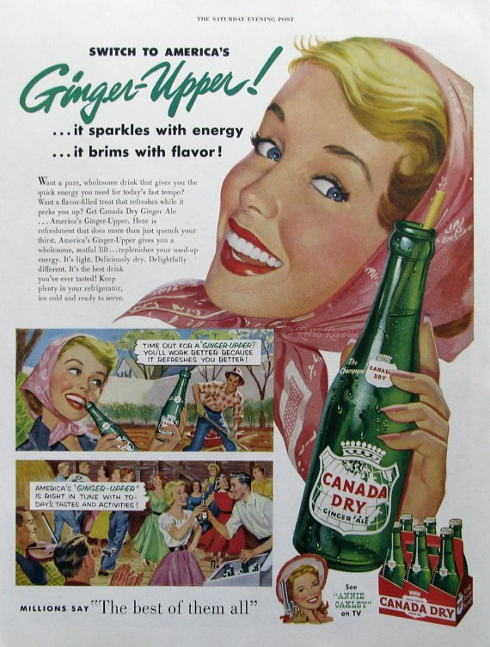
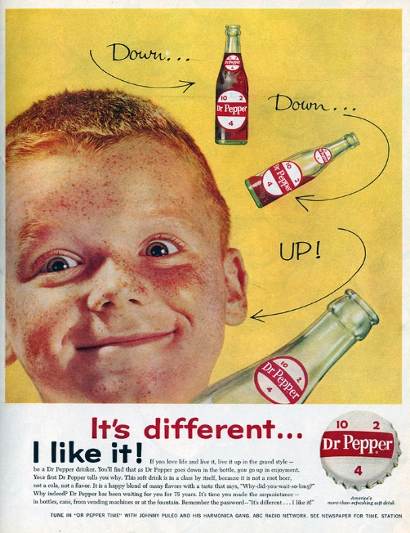
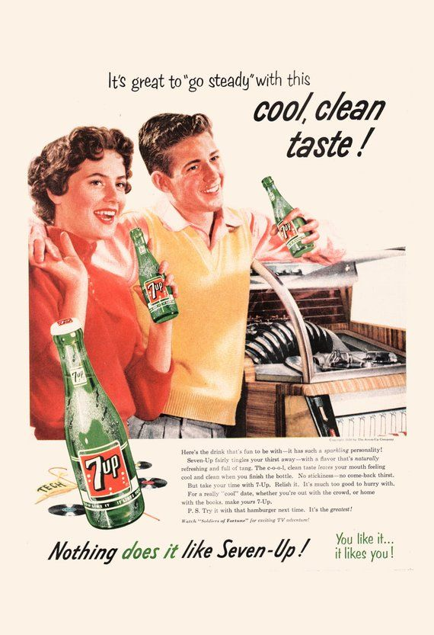

Marketing Strategies: Research Plan

Research Question: ________________________________________________________________

Day 1: I will research ____________________________________________________ using __________________________________________________________________________
Day 2: I will research ____________________________________________________ using __________________________________________________________________________
Day 3: I will research ____________________________________________________ using __________________________________________________________________________
Day 4: I will research ____________________________________________________ using __________________________________________________________________________

Research Topic:

______________________________________________

Evidence 1 Evidence 2 Evidence 3
Source: Source: Source:

Description: Description: Description:

What did you learn from your research?

