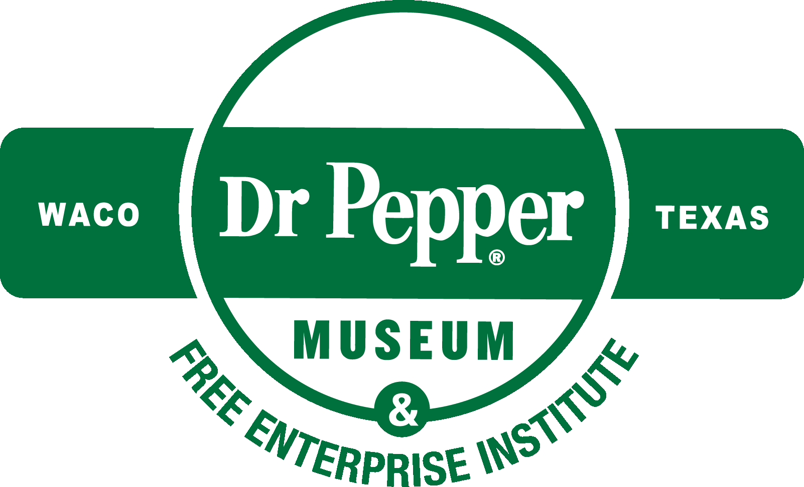
The W.W. “Foots” Clements
Free Enterprise Institute
at the Dr Pepper Museum

The Art of Advertising

Lesson Plan and Resource Guide

Introduction: What makes commercials and advertisements effective? To sell their product, companies must create a positive image around their product so people will want to buy it. The name of the product, the logo, and the slogan accompanying it are all designed to attract customers.

In this lesson, students will select a printed advertisement that inspires them. They will then play a “name that logo” game and learn about elements of effective logos and slogans. Students will identify the marketing strategies of several slogans and commercials, and then create their own collage-style advertisement using the printed advertisement they chose as a guide.

Objectives: Students will be able to identify elements of effective advertising (appealing name, eye-catching logo, interesting slogan that makes a claim, commands the reader, or creates a good image of the product) and apply them to their own work. Students will be able to analyze the message and evaluate the persuasiveness of different advertisements.

Grade Level: 5-6
Standards: Texas Essential Knowledge and Skills (TEKS): 117.117.4 (A); 117.202.1 (D); 117.202.4 (A), (B); 110.7.10 (A), (C), (D); 110.22.9 (A), (C), (D)

Time Requirement: 45 minutes (1 class period)

Materials: Printed advertisements (see Additional Resources), PowerPoint or Additional Resources activities, markers, poster board, scissors, glue, old magazines
Key Terms:
- Advertise: To make something known generally in public, especially in order to sell it
- Advertisement: A picture, short film, song, etc. which tries to persuade people to buy a product or service, or makes people aware of a product
- Logo: A picture or design that a company uses to advertise its products
- Market: To make goods available to buyers in a planned way which encourages people to buy more of them
- Marketing: A job that involves encouraging people to buy a product or service
- Slogan: A short easily remembered phrase, especially to advertise an idea or product

Directions: This lesson can be taught with our PowerPoint presentation or by printing out the Additional Resources section below.

Hook: As students enter the classroom, have them each choose a printed advertisement that interests them. Each student will use their advertisement for an activity at the end of the lesson.

“Name that Logo” Game: Play the game with your students using the power point; divide the class into groups or play as a class. Wrap up this section by explaining to the students that “an appealing product name and eye-catching logo are important advertising components.” (10 minutes)

Slogan analysis: Using the power point, explain to the students that “effective slogans often 1) make a claim, 2) command you to do something, or 3) create a good image or association.” Present the five examples of effective slogans and ask students to “decide which strategy each slogan uses.” Students will write down their answers on a piece of paper, then discuss each slogan’s strategy as a class. (10 minutes)

Commercials: Using the power point, show the students 3 examples of effective commercials (see below) and ask them to “decide which strategy each commercial uses.” Students will write down their answers on a piece of paper, then discuss each commercial’s strategy as a class. (10 minutes)

Application: Have students write down which strategy their magazine advertisement uses. Then they can create their own collage-style advertisement using markers, poster board, and magazine cutouts. Students should use their chosen magazine advertisement as a guide to creating their own advertisement for that product. (15 minutes)

Assessment: Students should be able to accurately identify the marketing strategy of each slogan/commercial. Collect the papers with students’ answers at the end of class to see how many strategies they correctly identified.

Additional Resources: Includes print advertisements, “name that logo” game, slogan examples, and links to commercial examples below.

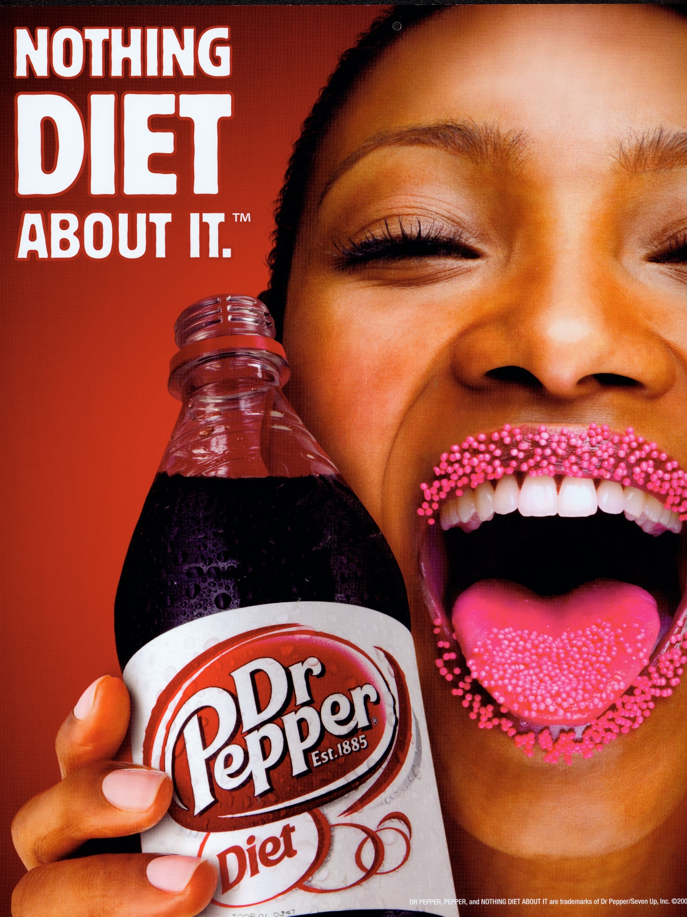Diet Dr Pepper Advertisement: Good Image

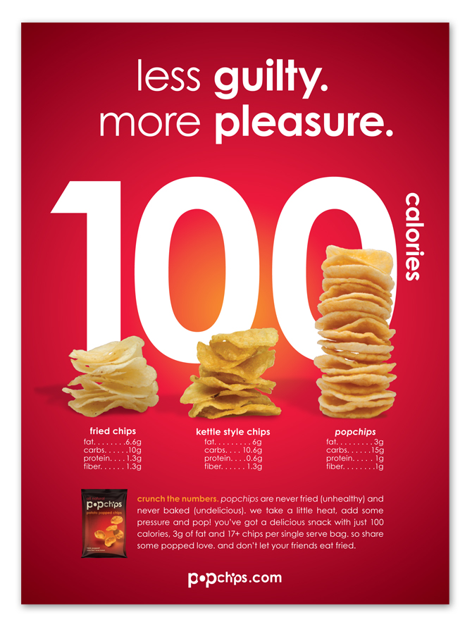PopChips Advertisement: Makes a Claim

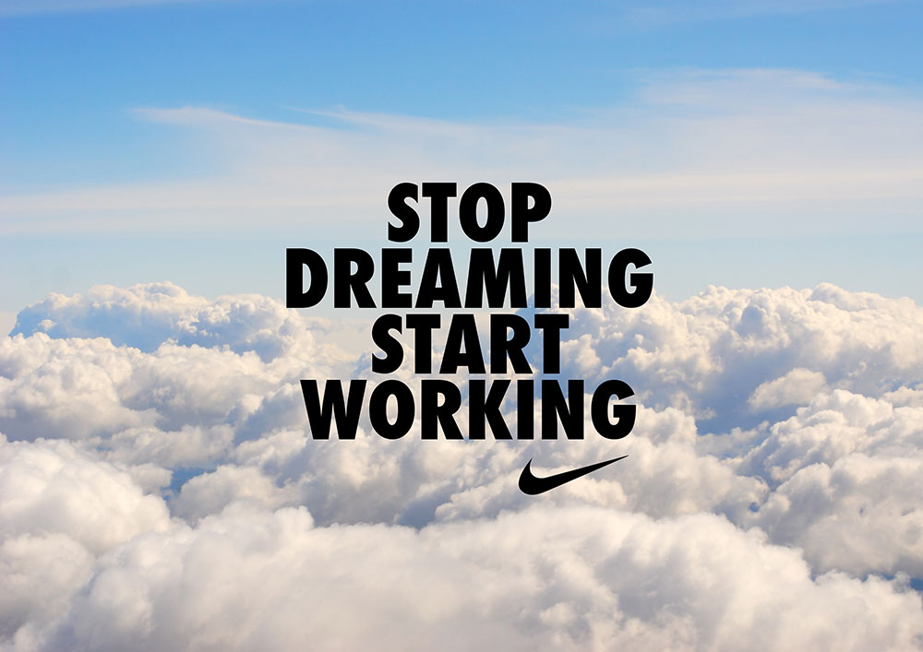

Nike Advertisement: Commands You

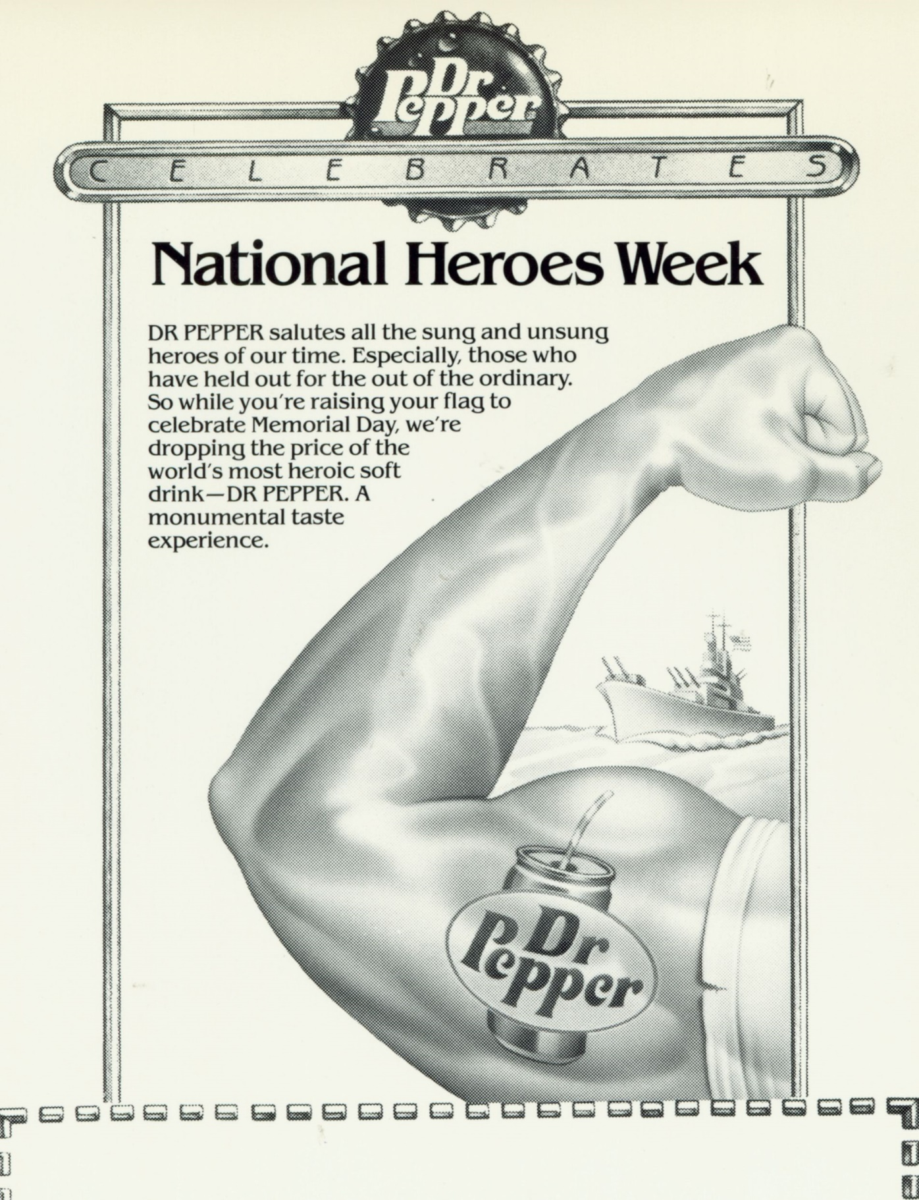”Heroes” Dr Pepper Advertisement: Good Image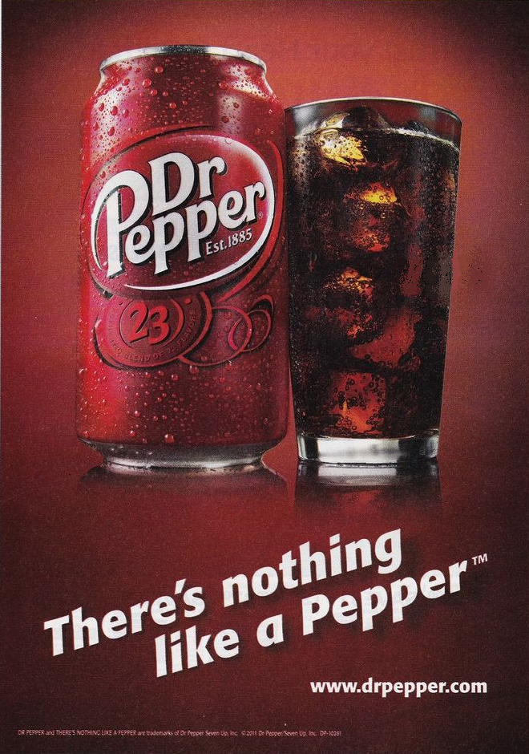

Dr Pepper Advertisement: Makes a Claim

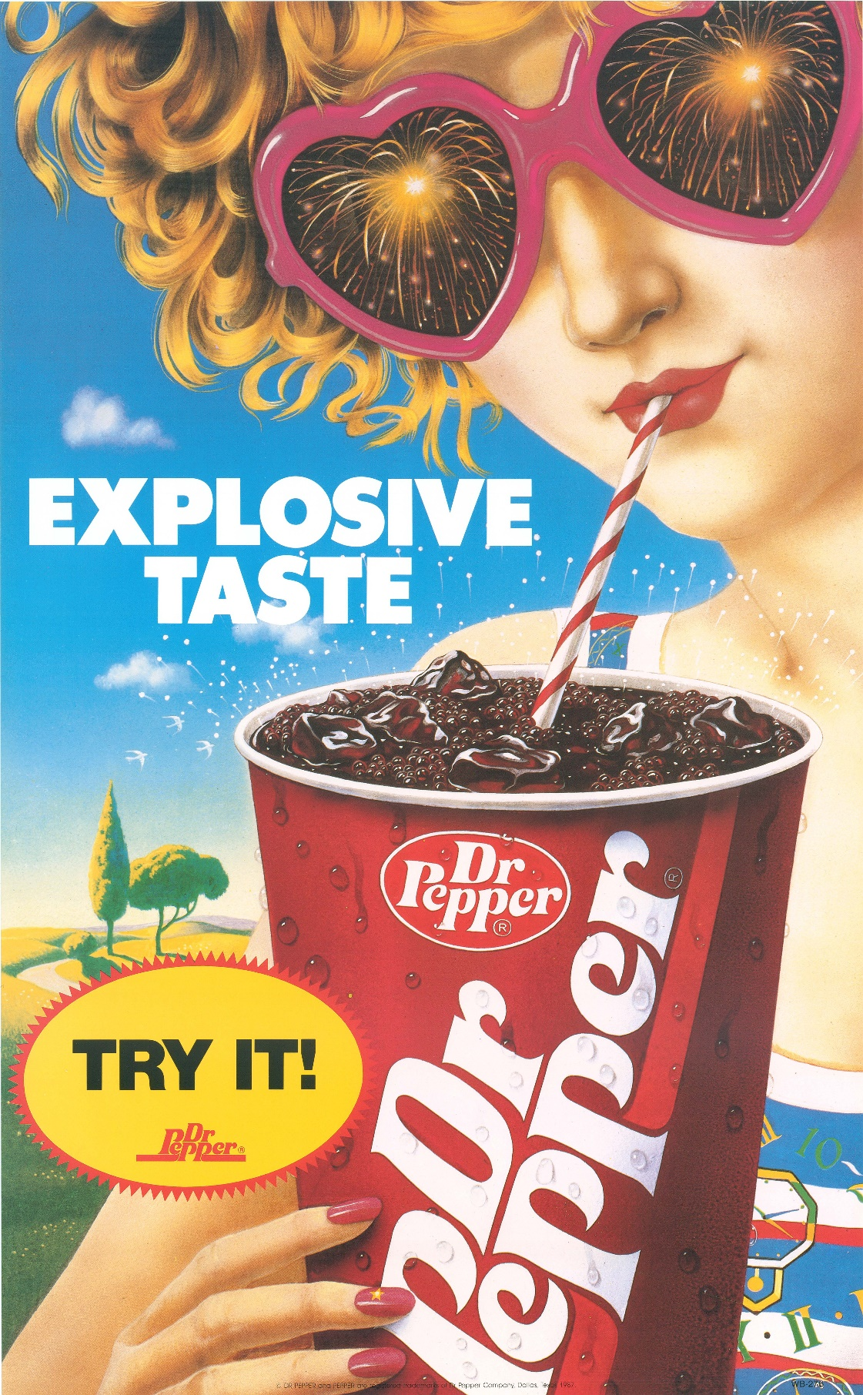

“Explosive” Dr Pepper Advertisement: Commands You

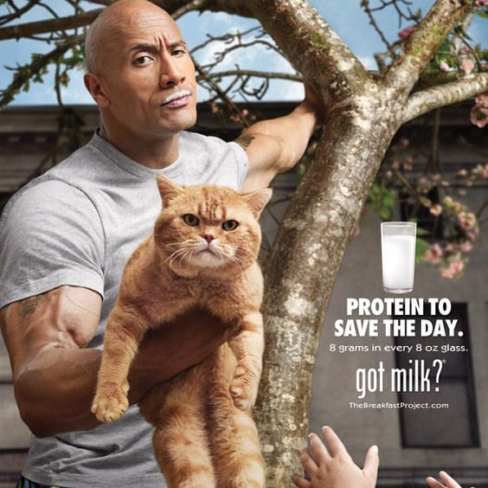

Got Milk? Advertisement: Good Image

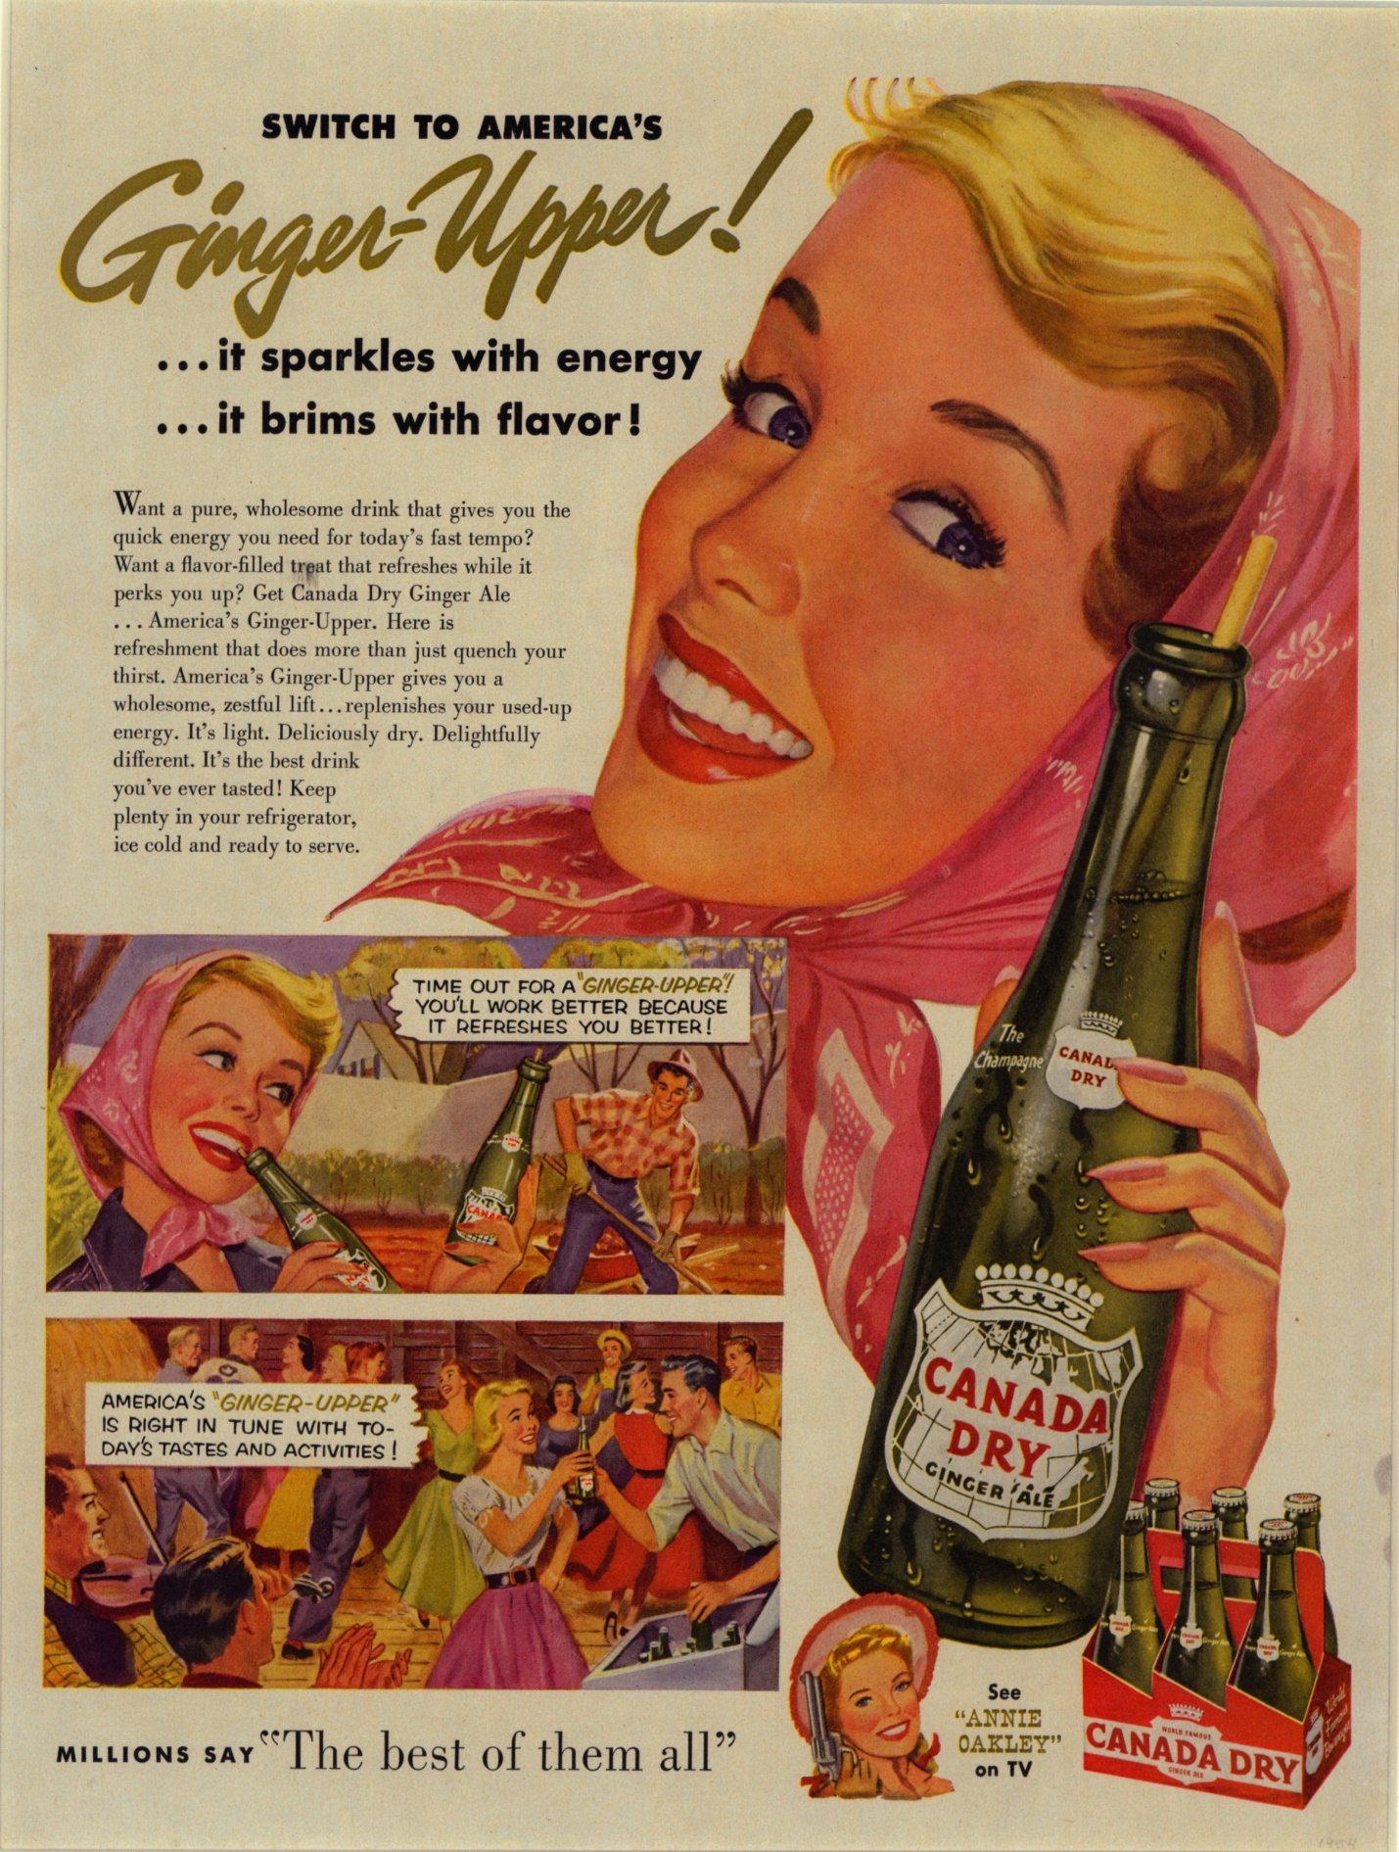

Canada Dry Advertisement: Makes a Claim

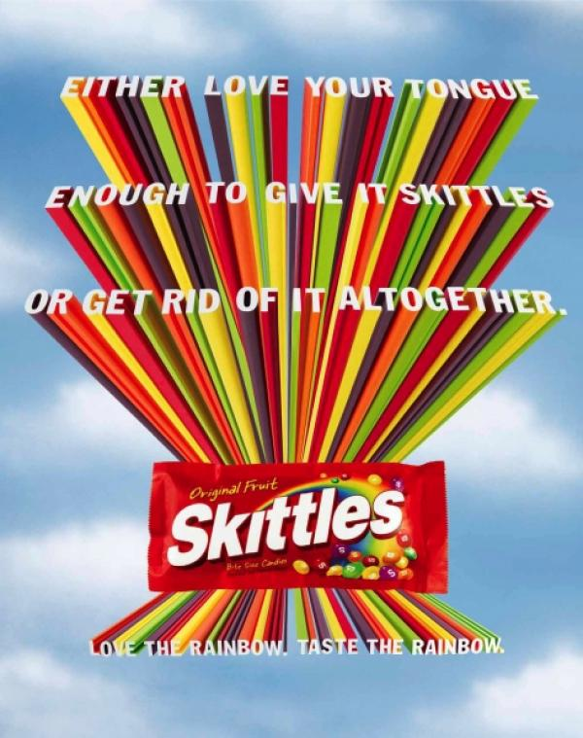

Skittles Advertisement: Commands You

Name That Logo:
 | Shell
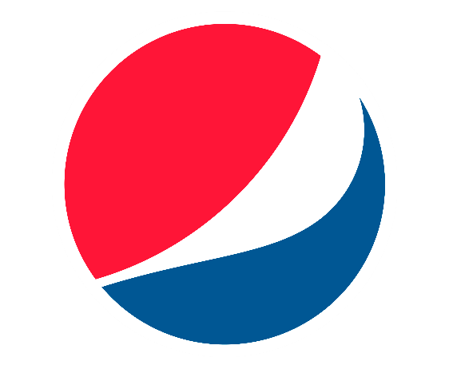 | Pepsi
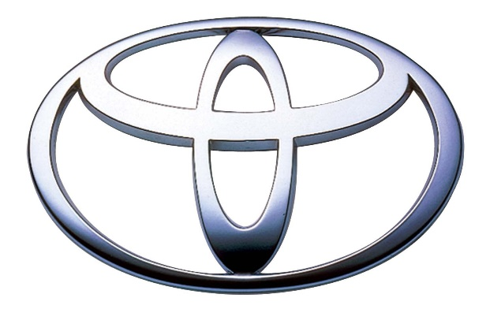 | Toyota
 | Facebook
 | Microsoft Windows
 | Chevrolet
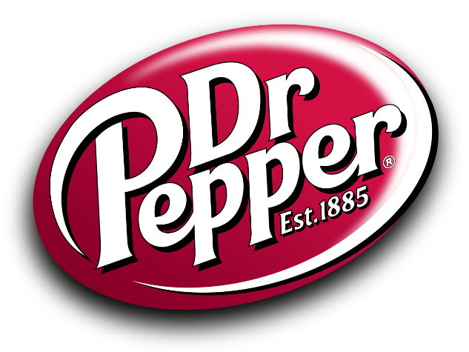 | Dr Pepper
 | American Airlines
 | Apple
 | Honda
 | Twitter
 | General Mills (bonus round)

Slogans:
- “Just do it.” –Nike (command)
- “I’m lovin’ it.” –McDonalds (good image)
- “Eat fresh.” –Subway (command)
- “Finger lickin’ good.” –KFC (makes a claim/good image)
- “Keeps going, and going, and going…” –Energizer (makes a claim)

Commercials:
- Diet Dr Pepper Lil’ Sweet Birthday Party (makes a claim…Diet DP tastes good) https://www.youtube.com/watch?v=-1H_CaCR46M
- Heinz Meet the Ketchups (good image…cute dogs associated with Heinz product) https://www.youtube.com/watch?v=z3HqIkJ9-3w
- Purple Mattress Grover Cleveland Approved (command…”do the patriotic thing…save money, sleep better!”) https://www.youtube.com/watch?v=8mG0oRj4Ba8

Enrichment:
- Have small groups of students brainstorm a short (30 seconds to 1 minute) commercial skit using the slogan they created in class. Each group can perform their commercial for the class, and the rest of the students will guess the group’s marketing strategy and rate its effectiveness.
- Check out the Dr Pepper Museum & Free Enterprise Institute’s Advertising and Marketing: Kid Style program! Schedule your group for a tour today at: https://drpeppermuseum.com/fei/programs/
- Have your students do a logo or slogan scavenger hunt, either at the Dr Pepper Museum or elsewhere. Give them 10-15 minutes to write down as many logos or slogans as they can find on an index card. The student with the most logos/slogans wins!

