Water and Communities
Grade Range: Third Grade
Subject: Social Studies and Science
Topics: Geography, Human Adaptations, Free Enterprise,
Scarcity, Water Pollution, Water Sources,
and Citizenship.

Introduction
Dear Teacher,
At the Dr Pepper Museum and Free Enterprise Institute, we believe that a meaningful field trip is more than just the hours you spent at the museum. It begins with you in your classroom. By facilitating lessons in your classroom that relate to the fieldtrip, your visit can deepen your students’ understanding of concepts.
These Inquiry Units are designed to help you create lessons for your classroom for the week of your field trip to the Dr Pepper Museum. They are cross curricular and are tied to TEKS. We suggest that you take these units and accommodate them to meet your class’s needs.
Enjoy!
Your Dr Pepper Museum Staff
A special thanks to the Baylor School of Education for developing inquiry units for the Dr Pepper Museum and Free Enterprise Institute.

Dr. Barbara Purdum-Cassidy
Molly Adams
Hannah Arnold
Marlin Black
Meredith Bringe
Katie Brown
Alicia Chamberlain
Elizabeth Downey
Ellie Duda
Natalie Elam
Makenzie Harrison
Claire Hudson
Kirby Jarzombek

Dr. Neil Shanks
Audrey Johnston
Shira Kodra
Alex Lodenberg
Chloe Marshall
Jae Moore
Grace Mueller
Audrey Sossaman
Rachel Steitz
Claire Tate
Sarah Tinlin
Abigail Traylor
Hannah Tucker

Overview
Grade Range: Third Grade

Topics:
Geography, Human Adaptations, Free Enterprise, Scarcity, Resources, water pollution, water sources and Changing Communities

Compelling Question:
How does water influence a community?

TEKS:
Third Grade: (Social Studies) 4A, 4B, 4E, 7A, 7B, 7C, 11A, and 11B
(Science) 7C

Field Trip Connection:
These lessons are designed for the week before a Waco: Home of Dr Pepper Field Trip. You can also add to the field trip by participating in a Create a Soft Drink (2 hr) program.

Inquiry Unit Plans

Unit Compelling Question:
How does water influence a community?
Lesson 1  How does location influence settlement? | Lesson 2  How does the amount of water effect a community? | Lesson 3  How does geography influence the way people access water? | Lesson 4  How does citizenship affect water? | Lesson 5  How does water impact businesses?
TEKS Covered:  (SS) 4A, 4B, 2A  (SC) 7C | TEKS Covered:  (SS) 7A, 7B  (SC) 7C | TEKS Covered:  (SS) 4A, 4B  (SC) 7C | TEKS Covered:  (SS) 11A, 11C  (SC) 7C | TEKS Covered:  (SS) 11A, 11B, 7A, 7B  (SC) 7C
Objective:  SWBAT describe how the physical environment, specifically concerning water, effects the location of a human settlement. | Objective:  SWBAT describe how water affects the economy and be able to explain the correlation between economic ideals and water as a resource. | Objective:  SWBAT describe how people get access to water around the world. | Objective:  SWBAT explain how they will be active citizens in their communities by preserving available resources. | Objective:  SWBAT identify ways water impacts the Soft Drink Industry.
Hook:  Ask students where they get their water from. After students brainstorm, visit the website here to find where water comes from where your school is. | Hook:  Show students the sources of water on earth with either the visuals (in materials) or by showing a video. (NASA: Show Me the Water) Point at that there isn’t really that much freshwater and we cannot make more water. | Hook:  Show students visuals of water pollution and ask them “if they would eat/drink it” and “what do they think caused it?” (in materials) | Hook:  Remind students of the way people found clean water in the book. Then, ask them “what if the water underground was polluted too?” | Hook:  Discuss the purpose of visiting the Dr Pepper Museum. Remind students of your expectations for the trip. Ask students to be looking and listening for ways water impacted Dr Pepper.
Body:  As a class, observe maps of early settlements. Facilitate a discussion about how the settlements are all near water. Ask students why that is.  Create an anchor chart that explains reasons why a community would settle near water.  Then, look at a topographic map of Texas and think aloud where a good place to settle a community would be. Discuss the ways the community would use water and other resources in the area. | Body:  As a class, make a list of ways you use water every day. Then, estimate how much water you use for each activity you listed each day.  Explain that communities around have access to different amounts of water. Define “scarcity” and explain that in many communities, water is scarce.  Assign groups of students an amount of water that a community may have per day: 7 gal, 50 gal, or 100 gal a day.  Ask students to make a plan to use the amount of water they were given wisely. They will make a list of the activities they will do each day with their allotted water.  Facilitate a conversation about how different communities treat/use water differently.  Ask the groups what amount of money they would pay for water. Explain that if a resource is scarce, what they do have costs more. | Body:  Explain that in many places in the world water in rivers or lakes is unsafe because of pollution or germs; in places like that people must be innovative to find safe water. Remind students that when there is not much of a resource available it is “scarce” and it can cost a lot of money.  Read students The Boy Who Harnessed the Wind by William Kamkwamba and show students the map of Africa’s ground water (in materials). Then, briefly review what happened in the story.  Using the list from earlier talk about each potential water source and why people in Malawi could not get it or how they got it.  (If you would like to extend the conversation, talk about the current water crisis that is a result of so many people using this water source here) | Body:  Facilitate an activity with your students about how water, including ground water, can be affected by pollution. Instructions for an activity can be found here.  Then, reflect on the activity as a class. Ask students how the actions of each individual home impacted the other people in the community.  Discuss what it means to be an active citizen in a community. | Body:  Visit the Dr Pepper Museum. During your tour, students will listen and look for ways water impacted the creation, distribution, and principals of the Dr Pepper Company, now KDP.  When you return to your classroom, reflect on the connections to water your students found and visit the KDP website to see the company’s corporate responsibility today (KDP website).
Product:  In groups, students will be given a topographic map of a region of the United States, by printing maps or giving students access to maps online (topographic maps), and will select a place to colonize a pretend community. Then, they will make a poster to show where their community settled, why they settled there, and how their community will use natural resources in the area. | Product:  Asks students to reflect and write about what may happen in a country that had scarce amounts of water. Could everyone afford water? How could people help? | Product:  Students will complete the worksheet about the book. (in materials) | Product:  In groups, students will write about four ways they can be an active citizen concerning water pollution and then write a paragraph explaining why it is important to do so. | Product:  Students will write a short response to answer the question “how does water impact businesses? Give two examples” Or “why is it important for businesses to be good citizens too? Give two examples”.
Unit Assessment:
Students create a multimedia project presenting on the importance of water in the community.

Student can use powerpoint, Keynote, voice recording, posters, photos, models, or anything else they think would be a good representation of knowledge with teacher approval.

Materials
Lesson 1: Maps of Settlements Near Water Sources

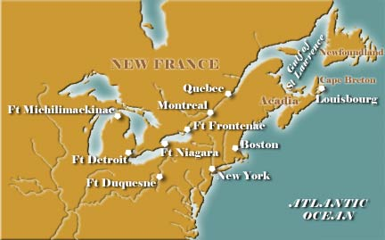
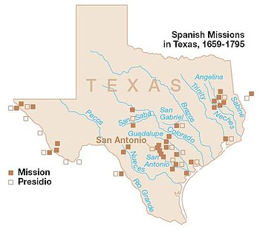

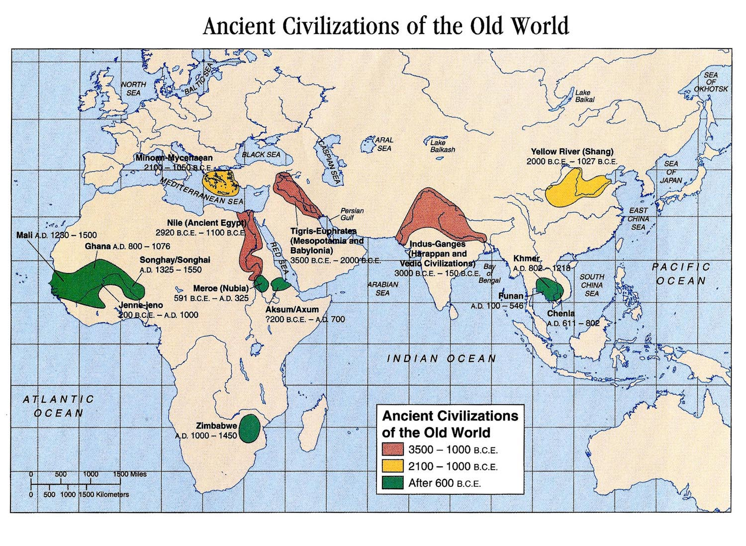
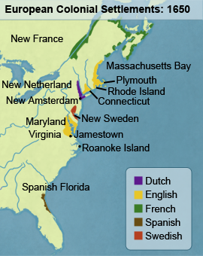

Lesson2: Visuals of the earth’s freshwater sources.
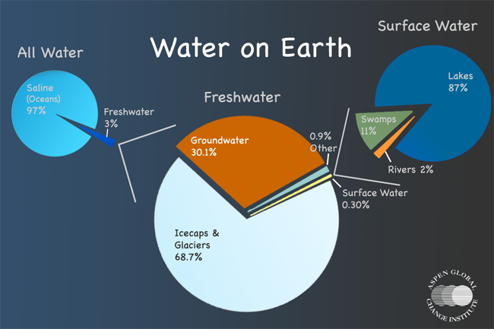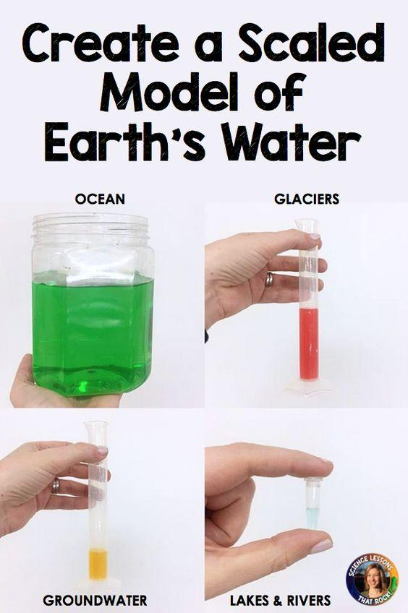

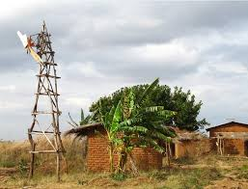
Lesson 3: Water Sources in Africa and windmill pumps
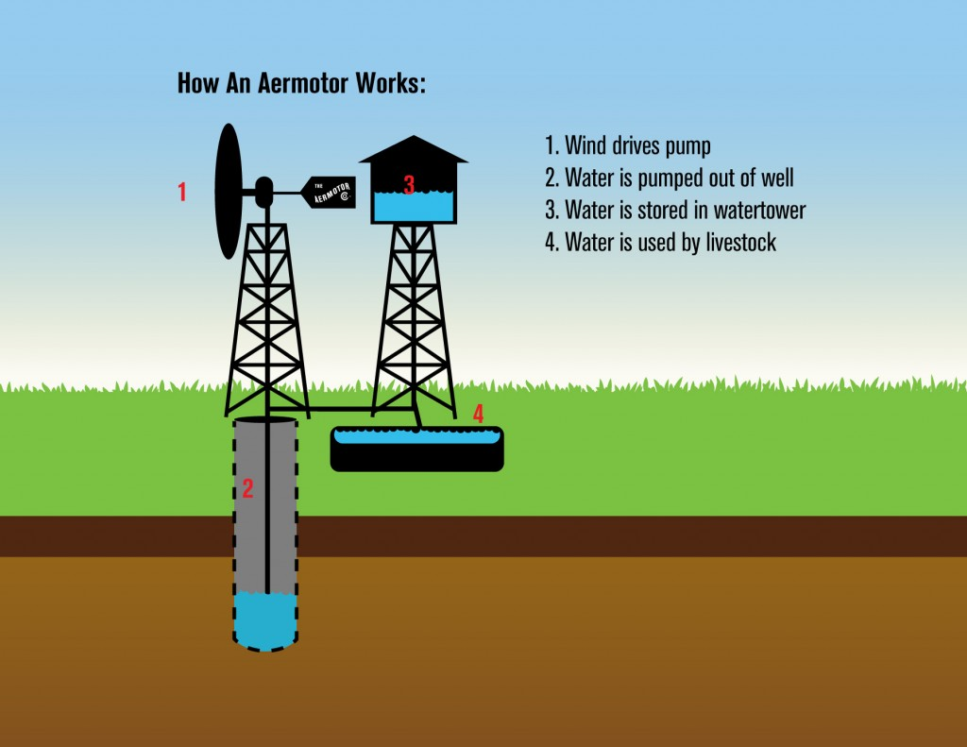
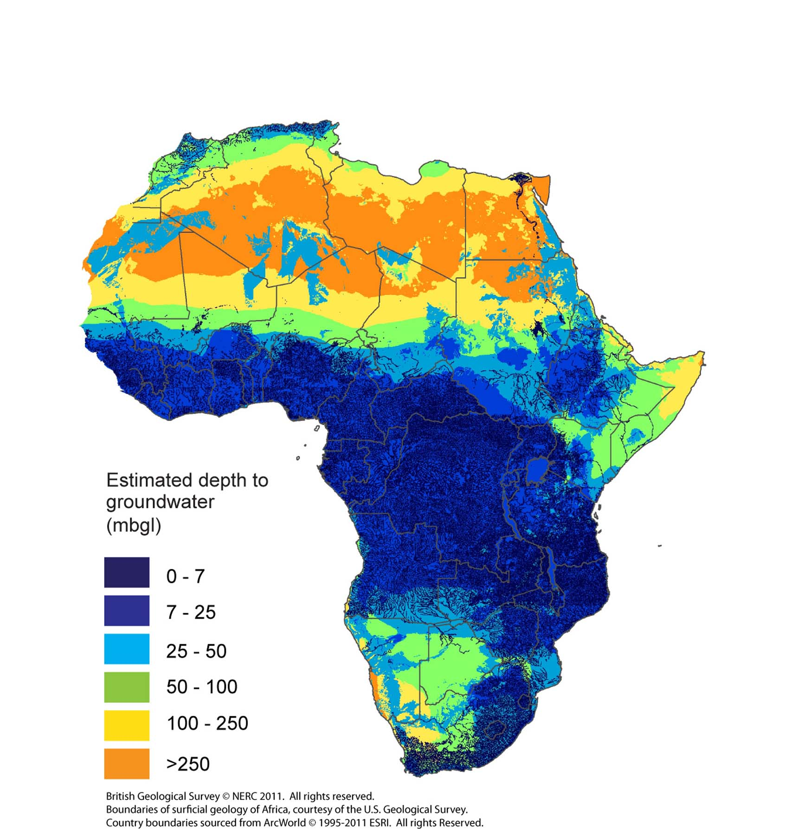

Problems and Solutions for Finding Water: The Boy Who Harnessed the Wind
Describe the problem, solution, and effect in the book and then draw a picture of each part of the story.
Problem
Effect
Solution
Lesson 4: Water Pollution Pictures
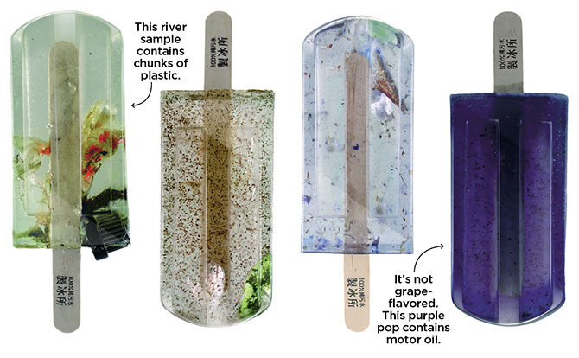
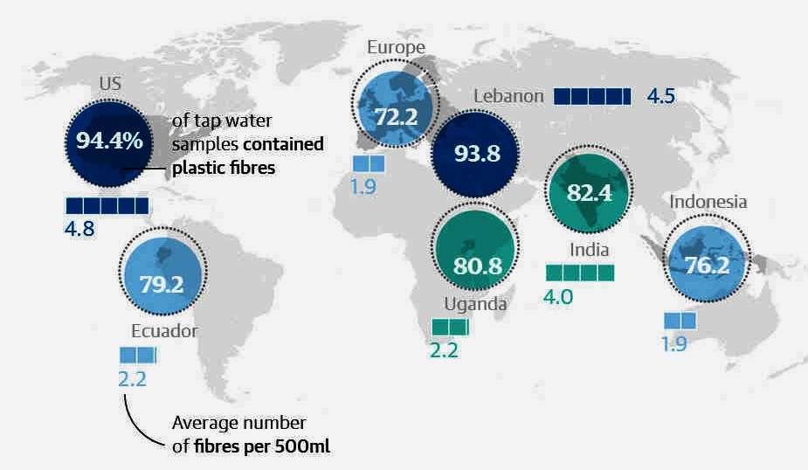
Learn about this art project here

Learn more about microplastics here

