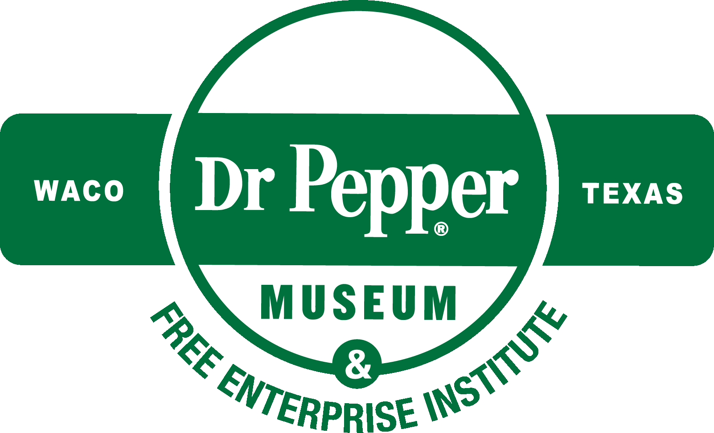
The W.W. “Foots” Clements
Free Enterprise Institute
at the Dr Pepper Museum

The Pepper Economy

Lesson Plan and Resource Guide

Introduction: What is an economy? Why are economies important? An economy is a relationship between businesses who make or provide things (producers), people who buy those things (consumers), and the money that is spent on those things.

In this lesson, students will first participate in an activity demonstrating why economic systems are useful. They will then learn about and be able to identify the difference between needs and wants, goods and services, and producers and consumers. Students will complete the lesson with a written demonstration of their knowledge.

Objectives: Students will be able to identify how needs and wants impact our economy. Students will be able to apply an understanding of how many different companies work together to create a product.

Grade Level: 2
Standards: Texas Essential Knowledge and Skills (TEKS): 113.13.10 (A), (B), (C); 113.13.19 (B)

Time Requirement: 45 minutes (1 class period)

Materials: paper, scissors, pencils, “The Pepper Economy” worksheet, printable signs for “pick a side” activity
Key Terms:
- Economy: a relationship between businesses who make or provide things, people who buy those things, and the money that is spent on those things
- Need: an object or condition required for human survival (e.g. water)
- Want: an object or condition that is desired for higher quality of life (but nonessential for human survival)
- Good: a tangible thing (like clothes or food) that can be utilized to satisfy human wants and has exchange value
- Service: a transaction in which no tangible goods are transferred from the seller to the buyer; rather, the seller performs an action (like cleaning or a haircut) to the benefit of the customer
- Producer: a person, company, or country that makes, grows, or supplies goods for sale
- Consumer: a person who purchases goods and services for personal use

Directions:
Hook: Using a can of Dr Pepper as a prop (or another drink) ask the student how many people they think it took to make that can.
Introduction: Start class by asking the students “what they think an economy is?” Using the Key Terms, explain that an economy is “a system that allows people to buy goods or services they want or need.” (5 minutes)
Goods/Wants: Next, explain to students that “in an economic system, producers provide goods and/or services to consumers, who will buy based on their needs and wants.” Then, using the Key Terms, explain the difference between needs and wants, goods and services, producers and consumers. (10 minutes)
Goods/Wants Activity: Hang the Needs, Goods, and Producers signs from the Additional Resources section on the left wall of the classroom. Hang the Wants, Services, and Consumers signs on the right wall of the classroom. Tell students that they will need to move to whichever side of the classroom matches the example you will give them (i.e. when given “TV” students should move to the Wants side of the classroom). Using the list in the Additional Resources section, do the activity in three rounds: Needs vs. Wants, Goods vs. Services, and Producers vs. Consumers. (10 minutes)
“Working Together” Economy Activity: Next, tell the students that “they will produce “cookies” to sell by tracing circles on paper, cutting out the circles, drawing 10 chocolate chips, and putting the cookie in a bag.” Split the class into two teams, ask one team to make the cookies individually and ask the other to make the cookies as a team, with one person performing each step. Afterward, count how many cookies each team made and discuss why the team that worked together made more. (15 minutes)
“Working Together” Economy: Explain to students that “Long ago, people had to meet their needs on their own. Finding food required lots of time and effort to create tools or weapons, to hunt and clean the food, etc. Eventually people learned to work together to make what they needed and wanted. Many technological improvements were made possible by collaboration, because it is easier and more efficient to work as a group and divide up tasks than to try to do it all individually. Like the students’ cookie team work, an economy works because different companies specialize in different things and trade for the other things they need.” (5 minutes)
“Working Together” Dr Pepper: Pass out “The Pepper Economy” worksheet. Tell the students that any product requires hundreds of steps to make. For example, to make Dr Pepper, you need water, flavored syrup, and aluminum cans, but to make those ingredients, you need raw sugar, aluminum, etc. It is more efficient for Dr Pepper to buy some of these ingredients than trying to make everything from scratch. Have students complete the worksheet, either on their own or as a class. (10 minutes)

Close: Again, ask the students “how many people they think work together to make the Dr Pepper you asked them about earlier possible?”. Ask students to write their estimate and why they believe that number is correct.

Assessment: Students should be able to accurately identify the difference between needs and wants, goods and services, and producers and consumers. Observe the results of the “pick a side” activity and collect the students’ exit sentences at the end of class to assess their level of comprehension.

Additional Resources: Includes list of examples and signs (pp. 7-12) for “pick a side” activity, instructions for folding origami fortune-tellers (p. 5), and “The Pepper Economy” worksheet (p. 6).

Needs: broccoli (healthy food); medicine; house; jacket; shoes; water

Wants: cake; TV; iPhone; bicycle; car; books; education

Goods: steak; pencil; sugar; Dr Pepper; video game

Services: cleaning; waitressing; haircut; food delivery; security

Producers: construction worker; nurse; baker; artist

Consumers: lady at grocery store; boy reading a book; girl drinking Dr Pepper

Enrichment:
- Check out the Dr Pepper Museum & Free Enterprise Institute’s Waco: Home of Dr Pepper program to learn more about how Dr Pepper contributed to the local economy! Schedule your group for a tour today at: https://drpeppermuseum.com/fei/programs/
- Read The Tuttle Twins and the Miraculous Pencil by Connor Boyack with your students to learn more about the complex system required to produce even a singular pencil.

Instructions for Folding an Origami Fortune-teller
- Use an 8-inch square piece of paper. If you don’t have origami paper, fold a rectangular sheet of 8.5 x 11 inch paper diagonally into a square, crease sharply, and cut off the excess.
- Fold paper diagonally the other way, then crease sharply and unfold. The paper should now have an X running through the middle of it.
- Turn paper over and fold all four corners in to the center.
- Turn paper over again and fold all four corners in to the center.
- Optional: Fold the diamond in half both lengthwise and widthwise. The paper should now look like a rectangle, with two squares on either side, with their ends open.
- Insert your fingers into the open flaps and push up to expand the fortune teller.

After the lesson, the students can add fortunes to their fortune-teller and take it home.

Here is a link to a helpful video tutorial if you need a visual aid: https://www.youtube.com/watch?v=_DyeNBA1Q0M

building

Water
Factory

d

machines
carbonation
aluminum
flavoring
paint

“The Pepper Economy”
Dr Pepper
Word Bank:
building
filtering
workers
sugar
mining

Cans
Syrup

mining

Need

Want

Good

Service

Producer

Consumer

