Producers, Consumers, and the Economy
Grade: 2nd Grade
Subject: Social Studies
Topics: Producers, Consumers, Resources, Free Enterprise

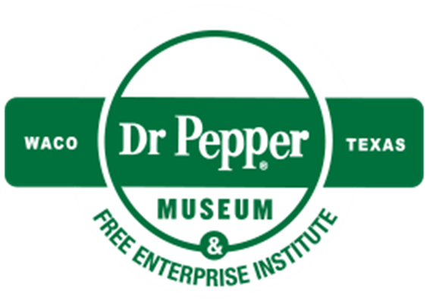

Introduction
Dear Teacher,
At the Dr Pepper Museum and Free Enterprise Institute, we believe that a meaningful field trip is more than just the hours you spent at the museum. It begins with you in your classroom. By facilitating lessons in your classroom that relate to the fieldtrip, your visit can deepen your students’ understanding of concepts.
These Inquiry Units are designed to help you create lessons for your classroom for the week of your field trip to the Dr Pepper Museum. They are cross curricular and are tied to TEKS. We suggest that you take these units and accommodate them to meet your class’s needs.
Enjoy!
Your Dr Pepper Museum Staff
A special thanks to the Baylor School of Education for developing inquiry units for the Dr Pepper Museum and Free Enterprise Institute.

Dr. Barbara Purdum-Cassidy
Molly Adams
Hannah Arnold
Marlin Black
Meredith Bringe
Katie Brown
Alicia Chamberlain
Elizabeth Downey
Ellie Duda
Natalie Elam
Makenzie Harrison
Claire Hudson
Kirby Jarzombek

Dr. Neil Shanks
Audrey Johnston
Sahira Kodra
Alex Lodenberg
Chloe Marshall
Jae Moore
Grace Mueller
Audrey Sossaman
Rachel Steitz
Claire Tate
Sarah Tinlin
Abigail Traylor
Hannah Tucker

Overview
Grade Range: 2nd Grade

Topics: Producers, Consumers, Resources, Free Enterprise

Compelling Question:
How do producers and consumers affect our economy?

TEKS:
Second Grade: (10) A, B, and C

Field Trip Connection:
These lesson is designed for the week of a Create a Soft Drink program

Inquiry Unit Plans

Unit Compelling Question:
How do producers and consumers affect our economy?
Lesson 1  What are producers and consumer? | Lesson 2 (FIELD TRIP DAY)  What are the steps producers go through to develop a natural resource to a finished product for consumers to buy? | Lesson 3  How can I produce a product that consumers will want to buy? | Lesson 4  Why is it important to produce a marketable product? | Lesson 5  What are techniques that producers use to get consumers to buy their product?
TEKS Covered:  (10) A | TEKS Covered:  (10) C | TEKS Covered:  (10) A | TEKS Covered:  (10) A B C | TEKS Covered:  (10) A B C
Objective:  SWBAT identify differences between a producer and a consumer by sorting characteristics of a consumer vs. producer. | Objective:  SWBAT examine the development of a product by attending a field trip to the Dr Pepper Museum. | Objective:  SWBAT produce a product that is marketable to consumers. | Objective:  SWBAT identify what makes a good product by acting as a consumer for the class products produced. | Objective:  SWBAT identify roles of producers and consumers by writing a letter to the CEO of a company.
Hook:  Show the class a pencil and ask them “How many people do you think it takes to make this pencil”. As a class, think of all the people that were involved in making a pencil. (use this video as a resource) | Hook:  Before the field trip, as a class estimate who the producers and consumers of Dr Pepper are. | Hook:  Show the students pictures of Dr Pepper advertisements (in materials) and ask them which Dr Pepper they would prefer to buy. Ask them what about the can makes them want to buy that can. | Hook:  Using the three advertisements (in materials), think aloud as if you were a shopper trying to decide the best purchase. | Hook:  Watch a commercial for Hot Dr Pepper (here). Then, tell the students the story of hot Dr Pepper: People did not want to buy a cold drink when it was cold outside. Dr Pepper listened to what the consumers wanted and developed and advertised Hot Dr Pepper.
Body: Anchor Chart  Create a t-chart comparing producers and consumers. First, define producers and consumers as a class and write a simple definition of each (you can relate this definitions to the scientific definitions). Then, ask students to contribute examples of each. As a class, discuss the differences between the two and how they work together. | Body: Museum Tour  Students will tour the museum and then visit the museum classroom to make their own soft drink. | Body:  Answer the following questions for Dr Pepper: What is the good/service? Why was it produced? Who is the consumer? How is the good/service presented to convince the consumer to buy it? (You can answer these questions for their sodas as well). | Body:  Ask each group to present their product. Encourage the students to think like consumers as they listen to the presentations. | Body:  Remind students that it takes many different people to make a product. At KDP, there is a Marketing team that researches what people want and creates advertisements. There is also a Research and Development department that creates new drinks. Then, as a class, brain storm suggestions for either or both departments about ways they could better advertise or develop products for second graders.
Product: Sorting Sheet  Students will sort different characteristics of producers and consumers with a graphic organizer (in materials). | Product: Little CASD  Students will create their own soft drink and complete a coloring page to design advertisements for their soda. | Product:  In groups, students create a plan for a new good/service and advertise that product using a worksheet (in materials). Then, ask students to create a “bill board” for their product. | Product:  After the presentations either, ask students to vote on the product they would most likely buy or have students writing a reflection about the product they would most likely buy. | Product:  Students will write a letter to the marketing or R&D department at KDP with advice for their future products. If you choose, you can email copies of the student letters to pr@keurig.com or mail them to the KDP head quarters.
Assessment:  Assess student t-charts for accuracy. | Assessment:  Assess completed soft drinks and ad page. | Assessment:  Assess completed worksheets and bill boards. | Assessment:  Assess student participation or reflections. | Assessment:  Assess student letters.

Materials
Lesson 1: Example anchor chart
Producer | Consumer
A person or business that makes a good or provides a service. | A person that buys a good or service.
EX: Making Blue Bell Ice cream | EX: Eating Blue Bell Ice cream
Examples  A Farmer  A Chef  A Musician | Examples  My mom buying groceries  Me eating at a restaurant  My sister listening to music

Producers and Consumers

Directions: Cut out the following boxes on the black line and organize the pieces by a consumer
or producer.

Producers | Consumers

Going to the Movies | Making a Dress | Teaching a student | Driving a taxi
Checking out a book | Buying a pair of shoes | Cutting hair | Painting nails
Painting a sculpture | Ordering pizza | Fixing a roof | Selling candy bars
Making a salad | Delivering pizzas | Making a pie | Ordering a new toy
Paying for a movie | Protecting the community | Inventing a new medicine | Buying groceries

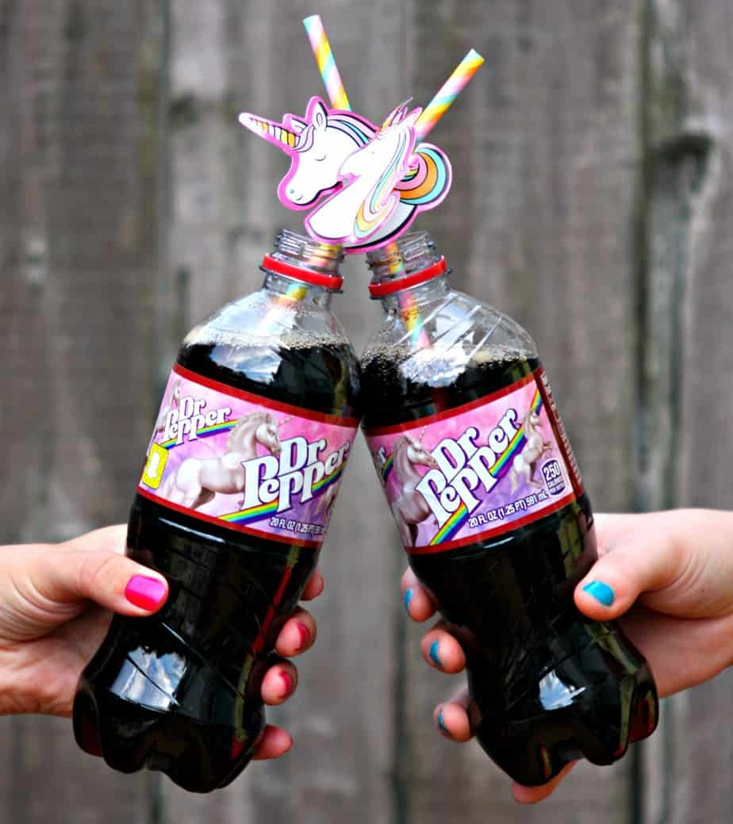
Lesson 3: Pictures of Different Dr Pepper Advertisements
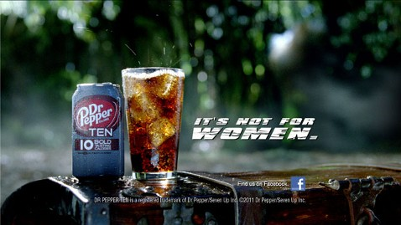
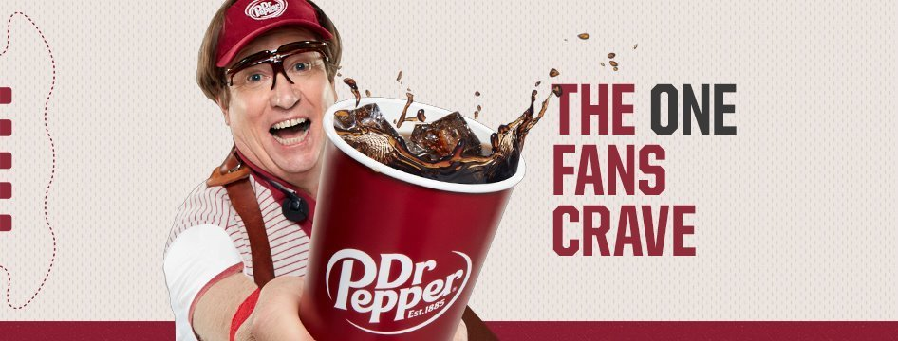
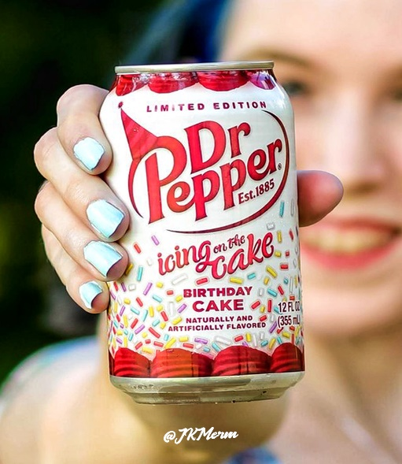

Be an Entrepreneur!

Directions: Think of a new Good or Service, then, answer the following questions for your new business.

What is the good/service?

Why was it produced?

Who is the consumer?

How is the good/service presented to convince the consumer to buy it?

