Persuasive Writing Lemonade Stand
Grade Range: Second Grade
Subject: Social Studies and English
Topics: Persuasive Writing, Free Enterprise, Author’s Purpose,
Advertising, and Marketing

Introduction
Dear Teacher,
At the Dr Pepper Museum and Free Enterprise Institute, we believe that a meaningful field trip is more than just the hours you spent at the museum. It begins with you in your classroom. By facilitating lessons in your classroom that relate to the fieldtrip, your visit can deepen your students’ understanding of concepts.
These Inquiry Units are designed to help you create lessons for your classroom for the week of your field trip to the Dr Pepper Museum. They are cross curricular and are tied to TEKS. We suggest that you take these units and accommodate them to meet your class’s needs.
Enjoy!
Your Dr Pepper Museum Staff
A special thanks to the Baylor School of Education for developing inquiry units for the Dr Pepper Museum and Free Enterprise Institute.

Dr. Barbara Purdum-Cassidy
Molly Adams
Hannah Arnold
Marlin Black
Meredith Bowman
Jordan Bringe
Katie Brown
Alicia Chamberlain
Elizabeth Downey
Ellie Duda
Natalie Elam
Makenzie Harrison
Claire Hudson

Dr. Neil Shanks
Kirby Jarzombek
Audrey Johnston
Alex Londenberg
Chloe Marshall
Jae Moore
Grace Mueller
Audrey Sossaman
Rachel Steitz
Claire Tate
Sarah Tinlin
Abigail Traylor
Hannah Tucker

Overview
Grade Range: Second Grade

Topics:
Persuasive Writing, Free Enterprise, Author’s Purpose, Advertising, and Marketing
Compelling Question:
How is persuasive writing used in advertising?

TEKS:
Second Grade: (Social Studies) 9(B), 10(A)(B), 18(B), and 19(B).
(English) 16(A)(B), 20, and 27

Field Trip Connection:
These lessons are designed for the week of a VIP: Very Important Pepper Field Trip. You can also add to the field trip by participating in a Create a Soft Drink (2 hr) program.

Inquiry Unit Plans

Unit Compelling Question:
How is persuasive writing used in advertisements?
Lesson 1  What are advertisements? | Lesson 2  How does a real, working company use persuasive writing to sell their products? | Lesson 3  How can we create a successful marketing campaign? | Lesson 4  What should we include in our product to ensure a successful lemonade stand? | Lesson 5  How can we sell the most lemonade?
TEKS Covered:  (SS) 9(B), 10(A)(B), 18(B), and 19(B).  (ENG)16(A)(B), 20, and 27 | TEKS Covered:  (SS) 9(B), 10(A)(B), 18(B), and 19(B).  (ENG)16(A)(B), 20, and 27 | TEKS Covered:  (SS) 9(B), 10(A)(B), 18(B), and 19(B).  (ENG)16(A)(B), 20, and 27 | TEKS Covered:  (SS) 9(B), 10(A)(B), 18(B), and 19(B).  (ENG)16(A)(B), 20, and 27 | TEKS Covered:  (SS) 9(B), 10(A)(B), 18(B), and 19(B).  (ENG)16(A)(B), 20, and 27
Objective:  SWBAT apply knowledge of author’s purpose to advertisements by evaluating the effectiveness of an advertisement. | Objective:  SWBAT identify persuasive techniques used in advertisements in history. | Objective:  SWBAT create an advertising plan for a lemonade stand. | Objective:  SWBAT create advertisements for a lemonade stand. | Objective:  SWBAT evaluate the effectiveness of advertising campaigns.
Hook:  Read a book that utilizes persuasive writing like I Want an Iguana by Karen Kaufman Orloff or a book from this website. | Hook:  Discuss the purpose of visiting the Dr Pepper Museum. Remind students of your expectations for the trip. Ask students to complete a field trip journal during the field trip. | Hook:  Give each students a sticky note and ask them to write their own definition for “Free Enterprise” on the note. Then, as a class create a definition for Free Enterprise (it may be helpful to define each word separately). | Hook:  Show students an advertisement (in materials) and ask them to identify what the advertisement is selling and what strategy or “secret message” they are using to persuade consumers. | Hook:  Ask students to make a list of as many jingles they know (ex: write the word Dr Pepper rather than “… don’t you want to be a pepper too?”). See which students has the most and ask them to perform them for the class.
Body:  As a class identify the author’s purpose for the book. Define “persuade” for the students.  Explain that persuasive writing can be found outside of books. As a class, make a list of other places people use persuasive writing.  Explain that producers, people who make a product, try to persuade consumers, people who could buy things, to buy their product. Explain that in an advertisement, like a commercial, a producer will try to persuade consumers to buy a product by sharing a “secret message” about the product. As a class, watch some commercials and determine what the commercials are selling and the “secret message” they are sharing about the product. (Dr Pepper Cherriot) (Dr Pepper Jazz) (Avengers) (Dr Pepper 10) | Body:  Visit the Dr Pepper Museum. During your visit, students fill out a “field Journal” (print student field journals ahead of time). | Body:  Review the highlights of the field trip and ask students to share what they learned.  Discuss the advertisements seen and talked about during the field trip. Ask students to share what they believe make up an effective marketing campaign.  Explain that in groups students will host a lemonade stand for another class or grade. Explain that each group will be given the exact same lemonade to “sell”, but they will use advertising to persuade students to buy their lemonade.  In groups, students will discuss their marketing strategies and create a plan for their advertisements using the worksheet. | Body:  Review expectations for the lemonade stand advertisement. Give students the remaining time to complete their worksheet and advertisements. | Body:  In groups, ask students to create a quick jingle for their lemonade stand.  Provide students with lemonade and cups. Allow students time to set up their stands with advertisements and lemonade. Then, provide expectations for the lemonade market.  Provide consumers fake money, procedures, and expectations for the lemonade market. (If there is time, students can perform their jingles or advertise their product to the consumers prior to the market).  Students will sell their lemonade, using marketing and advertising strategies.
Product:  As a class, watch another commercial (Godzilla Dr Pepper). As individuals, students will identify what the commercial was advertising and what the “secret message” was by writing their responses. | Product:  Students will complete a field journal during their field trip. | Product:  Students will complete the worksheet about the book. (in materials) | Product:  Students will create advertisements for | Product:  After the marketplace, ask students to count their money and reflect on the success of their advertising strategies.
Unit Assessment:
Assess student’s overall effectiveness of their advertisements and how they evaluated their own use of persuasive writing at their lemonade stand.

Materials
Lesson 3: Advertisement
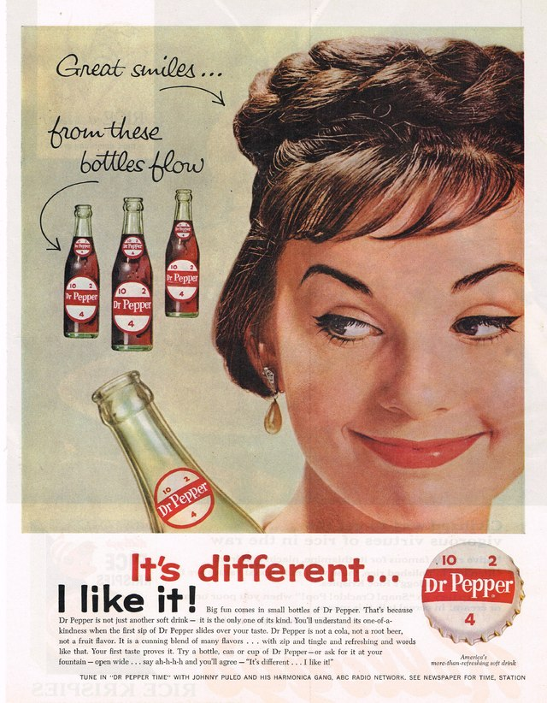
Dr. Pepper Field Trip Notes
First Floor

- What type of advertising do you see?

- On the lion poster, what are they telling us about Dr. Pepper?

Second Floor
- What did the commercials tell us?

- How did the commercials change over the years?

- Which commercial was your favorite? Why?

- Why did Dr. Pepper use the numbers 10, 2, and 4 in advertisements?

Reflection Questions
- What was your favorite advertisement in the museum?

- Why do you think the producers of Dr. Pepper used so many different types of advertisements?

Lemonade Stand Advertisement Plan
Complete the advertisement plan below to determine how you will persuade people to buy your lemonade.

Our lemonade stand’s name is: ___________________________________________________
Some adjectives to describe our lemonade are….
__________________ __________________ __________________ __________________
The “secret message” we will tell consumers in our advertisements is…
_______________________________________________________________________________________________________________________________________________________________________________________________________________________________________
Our slogan for our lemonade is…
_____________________________________________________________________________

Draw poster designs for your lemonade stand below:

Lesson 5: Money to be Printed and Copied
