10 Minutes of Social Studies: Needs and Wants
Lessons from the Dr Pepper Museum to help you teach economics concepts, even in the midst of a busy day.
Objective: SWBAT explain how basic human needs can be met such as through self-producing, purchasing, and trading.
TEKS: K.5 A B C
(6) Economics. The student understands that basic human needs and wants are met in many ways. The student is expected to:
(A) identify basic human needs of food, clothing, and shelter;
(B) explain the difference between needs and wants; and
(C) explain how basic human needs can be met such as through self-producing, purchasing, and trading.
Day | Tool | Connection
Day 1 Engage | Do:  As a class, pretend you are visiting an island in the middle of the ocean. “Pack” a suitcase by drawing things students need and want to bring on different sides of the suitcase. | Say:  Tell students that “A need is something we must have to live: food, water, shelter… A want is something we would like to have, but do not need: toys, Dr Pepper, t.v….”
Day 2 Explore | Play Video:  As a class, watch a video about community helpers/jobs: Needs and Wants. Science for Kids | Ask:  As individuals, ask students to respond to “pack” their own suitcase for a trip of things they need and want.
Day 3 Explain | Read:  As a class, read a book pertaining to acquiring needs/wants: Maisy Mouse Goes Shopping, Use Your Noodle, or Shopping with Mom. | Discuss:  As a class, discuss what types of things their family purchases at the store that they need and/or want.
Day 4 Elaborate | Do:  In small groups, tell the students to pretend that they are going to open their own store! They need to decide what needs and wants they want to sell in their store and draw them in the window. | Say:  Explain that “People get what they need by making it themselves (growing veggies in a garden), buying them (buying veggies at the store), or trading with other people (giving a neighbor with a garden a piece of art in exchange from veggies).
Day 5 Evaluate | Play Video  As a class, watch a video about thinking about needs/wants when shopping: The Berenstain Bears | Ask:  As individuals, students will respond to the following question: “Why is it important to know needs and wants when you grocery shop?

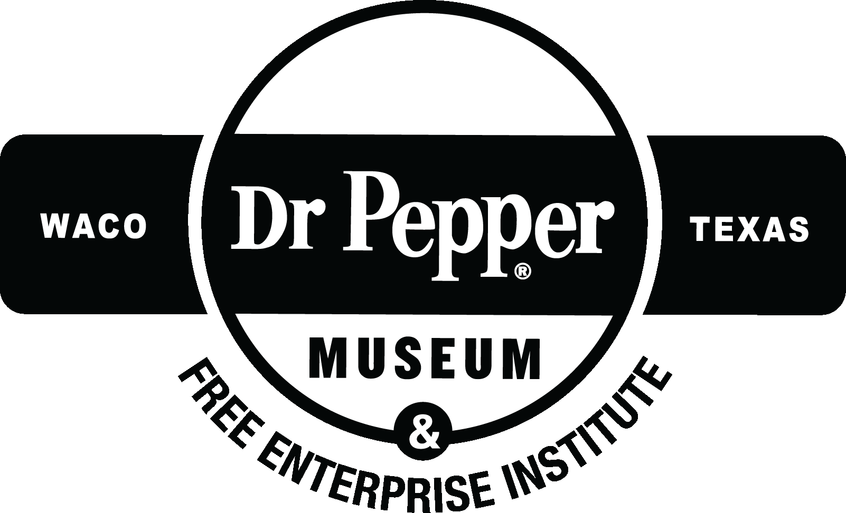
RESOURCES:
Day 1:
Lesson 1: Island Picture (Aunu’u in American Samoa)

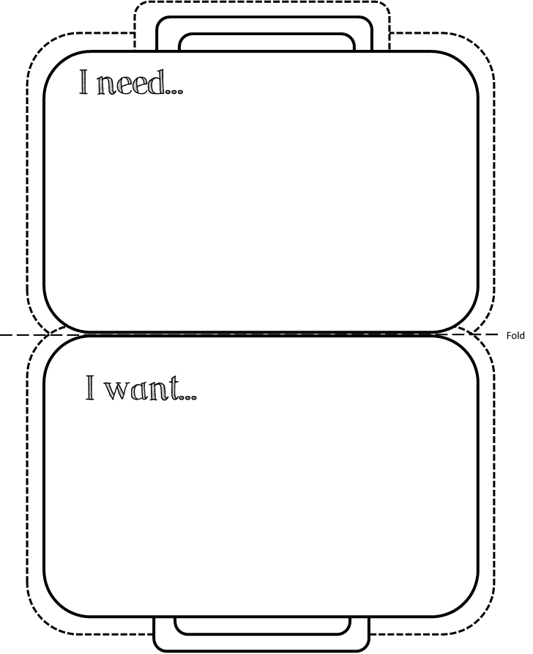
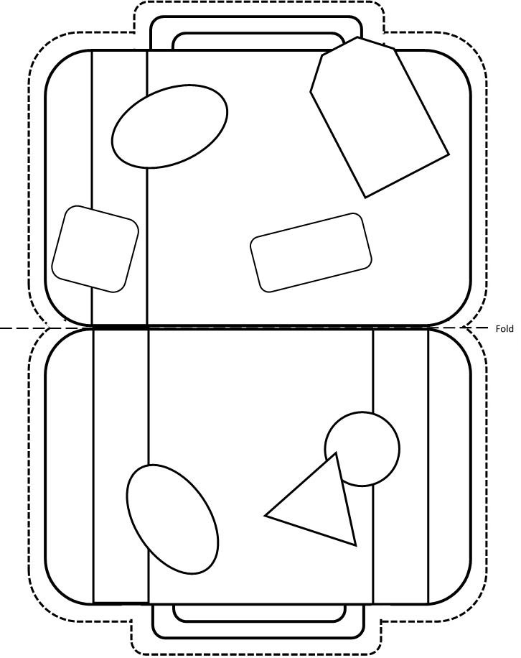

Day 2: Our Store
