10 Minutes of Social Studies: Producers and Consumers
Lessons from the Dr Pepper Museum to help you teach economics concepts, even in the midst of a busy day.
Objective: SWBAT describe the process a product is made and sold from natural resource to consumer.
TEKS: 2.7 A B C
(10) Economics. The student understands the roles of producers and consumers in the production of goods and services. The student is expected to:
(A) distinguish between producing and consuming;
(B) identify ways in which people are both producers and consumers; and
(C) examine the development of a product from a natural resource to a finished product.
Day | Tool | Connection
Day 1 Engage | Do:  As a class, sort the images into different groups of the student’s choosing. Then, sort the images into producers and consumers. | Say:  Tell students that “A producer makes something that a consumer can buy.”
Day 2 Explore | Play Video:  As a class, watch a video about how a pencil is made: I, Pencil The Movie or How a Pencil is Made, how to | Ask:  In small groups, ask students to answer the question: “How many different steps and producers are needed to make a pencil?” (as a teacher, consider I, Pencil)
Day 3 Explain | Read:  As a class, read a graphic to show where parts of a pencil come from: National Geographic Geography of a Pencil. | Discuss:  As a class, discuss where the components of a pencil come from around the world and how many people must work together to make a pencil.
Day 4 Elaborate | Do:  In small groups, ask students to identify ways a person is both a producer and a consumer from a picture. | Say:  Explain that “ People can be producers and consumers. For example, you can produce a Frappuccino, and you also bought a pink shirt someone else produced.”
Day 5 Evaluate | Play Video  As a class, watch a video about how something is made: Lego, Hot Dogs, or Highlighters. | Ask:  As individuals, students will respond to the following question: “Who is a consumer and who is producer in the video?”

RESOURCES:
Day 1:
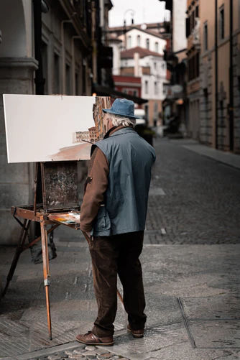
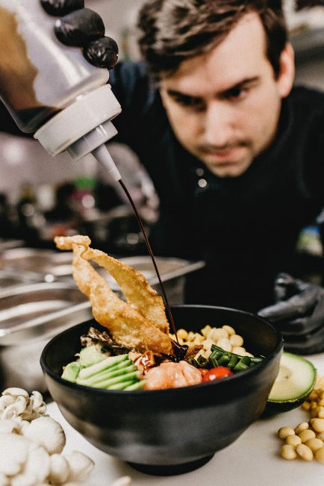
Images are from Unsplash (https://unsplash.com/)

ddddddddddd

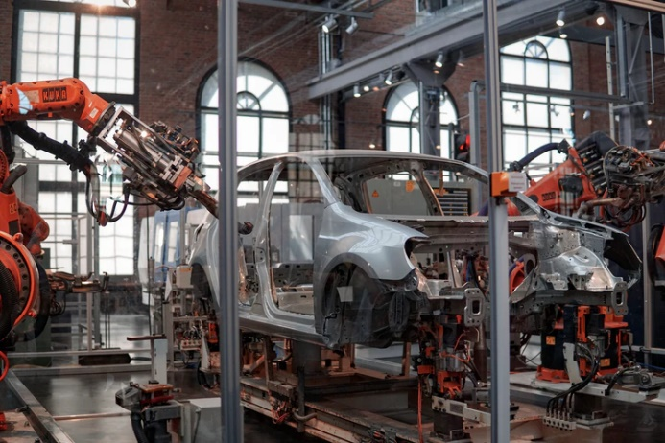

Day 4:
