Economic
^
The American Revolution
Grade Range: Fifth Grade
Subject: U.S. History


Table of Contents

Overview 3
Causes for Colonization 6
Colonial Currency Warm-Up 15
Think like an Economist Independent Assignment 17
The Extremely Fictional Tale of Dr Pepper Plants 19
Paying for the US Revolution 21
The Early US Economy: Classroom Debate 31
Tariffs Warm-Up 36
Modern Taxes Independent Assignment 37

Overview
Event | General Economic Connection | TEKS | Lessons
Exploration and Colonization  Causes and effects of European colonization in the United States beginning in 1565, the founding of St. Augustine. Explain when, where, and why groups of people explored, colonized, and settled in the United States, including the search for religious freedom and economic gain. | Why did European Countries want to expand? (God, Glory, GOLD).  -England was in the middle of an economic depression and the Enclosure Movement led to an increase in poverty and crime.  -Joint-Stock Companies allowed for people to spread the risk and the profit from an exploration or settlement.  -Headright System gifted a settler land in exchange for the people they paid to bring with them to the colony. These people were indentured servants, working for seven years to earn their freedom or dying in the process.  -Jamestown was settled with the anticipation of gold, like that found by Spain. Many of the settlers were goldsmiths and jewelers, people who “would rather starve than farm”.  -Slavery, was prevalent in the British Colonies and was a large part of their early economy crops like tobacco were a main export of the colonies and are primarily produced by slaves. | 5.1 (A) | Causes for Colonization
Early Governments in the Colonies | Why would the colonists want a representational government?  - To manage business transactions and currency; the official currency in the colonies was the British shilling, but it was scarce. The colonist used Spanish pieces of eight, minted their own coins, made promise notes, and bartered.  - To protect their private property and investments. |  | Colonial Currency Warm Up  Think like an Economist Independent Assignment
Causes of the American Revolution  The conflict between the American Colonies and Great Britain that led to American independence: French and Indian War, the Boston Tea Party. | What is Mercantilism?  -Mercantilism is the economic theory that there is a fixed amount of wealth in the world and a country should/can increase their amount of that wealth by exporting more than it imports. Many countries in Europe did not have enough resources within their borders to not import.  -A “mother” country takes raw materials from its colony, then produces goods and sells them back to the colony and other countries.  -England had set and high prices, so colonists got better “deals” by smuggling goods from other countries.  What is a tax?  -A tax is additional money added to a purchase/sale that goes to support the government and through it the community.  -Taxes can also be used to control what people buy. The British used taxes to regulate trade, attempting to force colonists to buy only British goods; it caused colonists to smuggle. Today, things like soda are taxed to dissuade people from buying unhealthy products.  -The British military had to borrow over 150 million pounds to pay for the French and Indian War, they raised colonial taxes to cover the costs. Today, taxes are used to pay for roads, schools, the military etc.  -The Sugar Act of 1764 lowered the tax on sugar imports from the Caribbean to 3 cents, only they began enforcing the tax by having British, rather than the more lenient colonial, courts try smuggling cases. | 5.2(A) | The Extremely Fictional Tale of the Dr Pepper Plants
Important People in the American Revolution  The founding fathers and patriotic heroes and their motivations and contributions during the revolutionary war: John Adams, Samuel Adams, Benjamin Franklin, Nathan Hale, Thomas Jefferson, the Sons of Liberty, and George Washington. | What were the motivations of the founding fathers?  -One powerful motivator for early patriots was economic; colonial businesses struggled under British rule. Many founding fathers (George Washington, Thomas Jefferson, Benjamin Franklin etc.) owned plantations or other businesses that would benefit from a free nation. | 5.2(B) | Founding Father’s Businesses Research Projects
Events of the American Revolution | How are political decisions impacted by the economy?  -There was discord in the Continental Congress about the signing of the Declaration of Independence because of the economy in slave states. States like Virginia were not losing as much under British rule and were concerned about their right to own slaves under colonial rule.
Results of the American Revolution  Results of the American Revolution: establishment of the U.S.A. and development of the U.S. Military. | How did the establishment United States impact businesses within the country?  -There was discord in the Continental Congress about the signing of the  How did the colonial army pay for the US Revolution?  -War are expensive, soldiers were to be paid after a three year contract, weapons, food, and clothes were necessary, and many loyalties were bought.  -The continental army paid for most of the war themselves with individual states and the Continental Congress printing money, selling bonds, and giving debt certificates(IOU) to wealthy Americans, loan from European countries, and confiscating and selling Loyalist property.  How did the United States pay for it’s military?  -Militaries cost money! Under the Articles of Confederation, there was no way for the government to pay for a military, if it were able to have one.  -Tariffs and taxes were used to fund a federal military under the Constitution. | 5.2(C) | Paying for the US Revolution
Articles of Confederation and the US Constitution  The issues that led to the US Constitution: weakness of the Articles of Confederation. The contributions of individuals to create the U.S. constitution. | Why did the Articles of Confederation fail?  -Without the power to tax, the federal government had no way of funding any of their efforts.  Development of the US Constitution  - The constitution protects an individual’s right to private property, speech, etc., many people interpret these to apply to businesses. In theory, the constitution and the Bill of Rights provide structure for a Free Market Economy. | 5.3(A) | Create a Constitution
Problems in the New Republic | What were the different opinions about the early US economy?  -The Federalist party, led by Alexander Hamilton, supported a National Bank, tariffs, and more government intervention in the economy.  -The Democratic-Republican party, led by Thomas Jefferson, supported state banks, agriculture, and the free market.  How does a country’s economy impact its stability?  -A country needs to be accountable to have international support, loans, and trade.  -A country needs money to fund governments and militaries.  How did a National Debt and National Bank impact the USA?  -Debt is the “negative money” or money that a person or government owes. The longer the money is “owed” the more interest it accumulates.  -After the US Revolution and under the Articles of Confederation, each state had its own currency, banks, and debt. On their own, the states were not seen as able to repay those debts and were unlikely to inspire international trade.  -The National Debt combined the debt from each state into on debt that the country was responsible for. Northern states, who had the most debt, were for this change while southern states, who had less debt, were reluctant. The National Debt is still in existence today.  -The National Bank standardized the US currency and controlled the printing of money. |  | Planning an Economy Classroom Debate
Developing a Banking System | What is a tariff?  -A tariff is a specific tax on imported goods.  -A protective tariff is a tariff that is put in place to encourage people to purchase less imported goods to protect businesses in a country from international competition. | 8.4(B) | Tariffs Warm Up  Modern Taxes Independent Activity
Development of US Political Parties | What were the different opinions about the early US economy?  -The Federalist party, led by Alexander Hamilton, supported a National Bank, tariffs, and more government intervention in the economy.  -The Democratic-Republican party, led by Thomas Jefferson, supported state banks, agriculture, and the free market. | 8.5(C) | Planning an Economy Classroom Debate
War of 1812  Causes, important events, and effect of the war. | How do wars impact the economy?  - The War of 1812 was paid for with taxes and tariffs. Pres. Madison was authorized to borrow $32.5 million for the cause. | 8.5(D) | Tariffs Warm Up

Causes for Colonization
Grade Level Focus: Eighth Grade
Topic: Causes for Colonization
Compelling Question: Why did the British people choose to go live in the American Colonies?
TEKS: 8.2(A)(B)
Materials: A handout, group images to be cut out., and explanations are included after the lesson plan.

Engage | What did it really mean to move to the colonies?  - Show students the real Estate Advertisement and discuss their concerns.
Explore | Guess the Order of Events  - Put students in four small groups and give each group a set of pictures.  - Explaining that each group represents a different type of person who moved to the American colonies. Each picture is a clue that represents something that occurred in England that led to a person’s move to the colonies. Together, the pictures create a chain reaction that led to English subjects move to the American colonies. Ask students to work as a group to guess which order would make since and then create an explanation of what occurred.  - Give students five to ten minutes to order the images and create a theory.
Explain | Explain the Events  - Provide each student with a handout.  - Give each group the explanation for their pictures, allow them time to review it and correct their picture order. Then, ask them to complete their section of the handout.  - Ask each group to present their pictures by taping them to the board or using a document camera and to explain what each picture represents. As they explain, instruct other students to complete their notes on the handout.  - Group A: The Criminals  - Fence: Land Enclosure was when wealthy landowners began fencing off their land, land that have previously been available to anyone to graze their animals, hunt on, and walk through.  - Empty Plate: Because they could no longer graze animals or hunt on most of the land, many people could not make enough money or get enough food.  - Jail: Because they did not have basic resources, more people began to steal, which was considered a felony.  - Ship: Many of these criminals were sent to the colonies because the English jails were full and expensive to run.  - Group B: Indentured Servants  - Fence: Land Enclosure was when wealthy landowners began fencing off their land, land that have previously been available to anyone to graze their animals, hunt on, and walk through.  - Empty Plate: Because they could no longer graze animals or hunt on most of the land, many people could not make enough money or get enough food.  - Land: The headright system promised wealthy colonists fifty acres of land for every person they paid to come with them to the colonies.  - Wanted ad: Because people were so poor and because the headright system provided the opportunity, many poor people moved to the colonies as indentured servants.  - 7: Indentured servants worked for seven years, if they did not die before then they would be granted their freedom and money to start a new life.  - Group C: Businessman  - Spanish Flag: Spain had settlements that had profited by finding gold in the new world.  - The Virginia Company: Joint Stock Companies were ventures paid for by many different people in England. In theory, many people would share the risk and the reward rather than on person risking everything.  - Anvil: Because they believed settlements like Jamestown would have gold, the people recruited for the venture were all men and were mostly jewelers and blacksmiths.  - Empty Plate: Because they were only prepared to find gold, settlements like Jamestown struggled to survive in the colonies.  - Corn: Because they were struggling to adjust to their new living conditions, native tribes taught the settlers how to survive in their new environment, like how to plant corn.  - Group D: Slaves  - Tobacco Plant: Colonists discovered crops like tobacco.  - Money: Crops like tobacco were a very profitable export to other countries and colonies, however, they were labor intensive.  - Triangle: Because these crops were so labor-intensive there was a Triangular slave trade between the American Colonies, Europe, and Africa that allowed for slaves to be brought to the colonies  - Field: Because they were bought, slaves and their children worked on the plantations for their entire lives.
Elaborate | Independent Reflections  - Ask students to write a response to the following question: How do you think the types of people who colonized the American colonies impact the success of the colony?
Evaluate | To assess student understanding of this topic, ask students to describe one or four of the types of people who colonized America and explain why.
Extension | This activity can be extended to include colonists who were escaping religious persecution and colonists who were seeking notoriety.

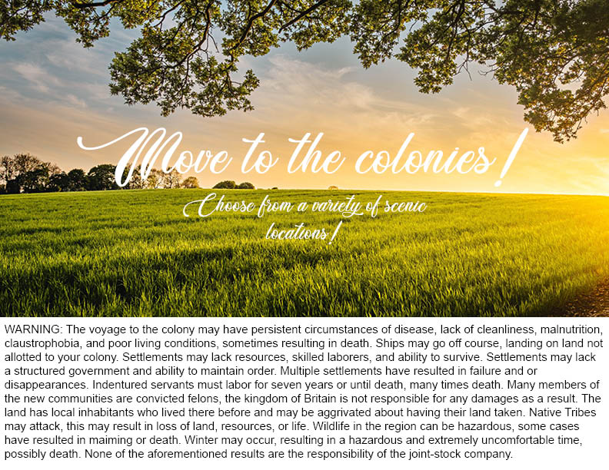Why did people move to the American Colonies?
Who does this group represent? | Draw the picture and write a brief description of what it represents
A.
B.
C.
D.

Group A:
Group A: The Criminals
- Fence: Land Enclosure was when wealthy landowners began fencing off their land, land that have previously been available to anyone to graze their animals, hunt on, and walk through.
- Empty Plate: Because they could no longer graze animals or hunt on most of the land, many people could not make enough money or get enough food.
- Jail: Because they did not have basic resources, more people began to steal, which was considered a felony.
- Ship: Many of these criminals were sent to the colonies because the English jails were full and expensive to run.


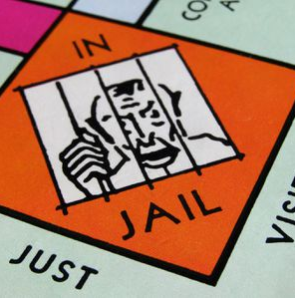

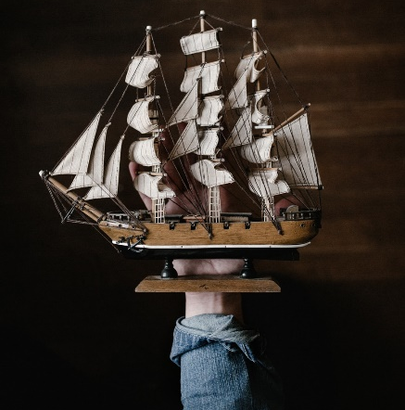

Group B
Group B: Indentured Servants
- Fence: Land Enclosure is when wealthy landowners began fencing off their land, land that have previously been available to anyone to graze their animals, hunt on, and walk through.
- Empty Plate: Because they could no longer graze animals or hunt on most of the land, many people could not make enough money or get enough food.
- Land: The Headright System promised wealthy colonists fifty acres of land for every person they paid to come with the to the colonies.
- Wanted ad: Because people were so poor and because the Headright System provided the opportunity, many poor people moved to the colonies as indentured servants.
- 7: Indentured servants worked for seven years, if they did not die before then they would be granted their freedom and money to start a new life.


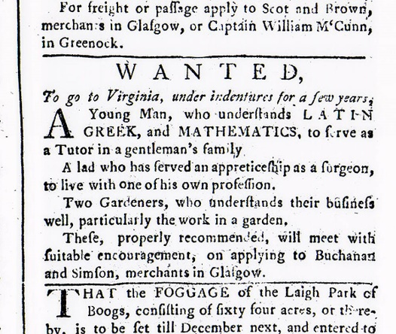
7

Group C
Group C: Businessmen
- Spanish Flag: Spain had settlements that had profited by finding gold in the new world.
- The Virginia Company: Joint Stock Companies were ventures paid for by many different people in England. In theory, many people would share the risk and the reward rather than on person risking everything.
- Anvil: Because they believed settlements like Jamestown would find gold, the people recruited for the venture were all men and were mostly jewelers and blacksmiths.
- Empty Plate: Because they were only prepared to find gold, settlements like Jamestown struggled to survive in the colonies.
- Corn: Because they were struggling to adjust to their new living conditions, native tribes taught the settlers how to survive in their new environment, like how to plant corn.

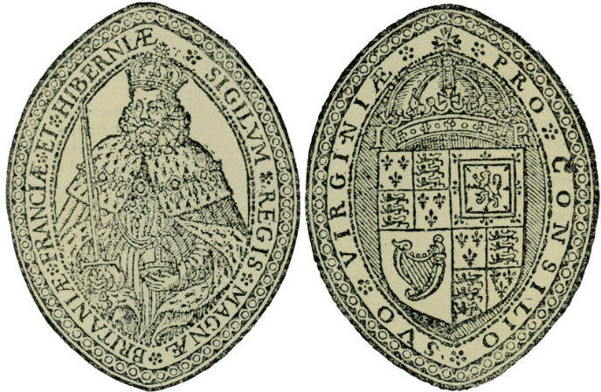

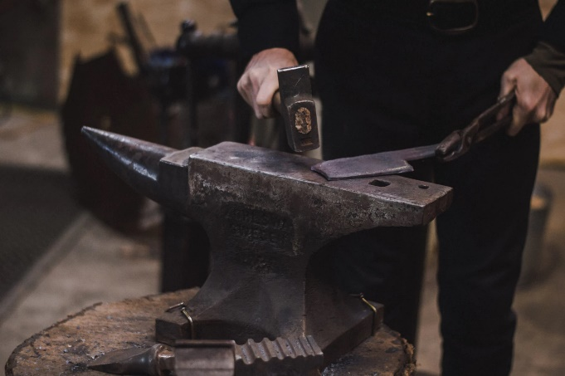


Group D
Group D: Slaves
- Tobacco Plant: Colonists discovered crops like tobacco.
- Money: Crops like tobacco were a very profitable export to other countries and colonies, however, they were labor intensive.
- Triangle: Because these crops were so labor-intensive there was a Triangular Slave Trade between the colonies, Europe, and Africa that allowed for slaves to be brought to the colonies
- Field: Because they were bought, slaves and their children worked on the plantations for their entire lives.



Colonial Currency Warm-Up
Grade Level Focus: Eighth Grade
Topic: Early Governments in the American Colonies
Compelling Question: Why did the colonists want/need a local government?
TEKS: 8.3(A)(B)
Materials: The graphic

Engage | What did it really mean to move to the colonies?  - Show students the graphic and ask them to review it and respond to the question: Why would a local government be helpful, considering the many types of currency in the colonies?
Explanation | Quick Discussion  - Briefly discuss the currencies on the graphic and why there were so many different currencies in the colonies (It may be helpful to discuss current US currency or how many countries use the Euro to make trade and travel easier).  - Invite the students to share their responses to the question.

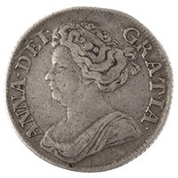
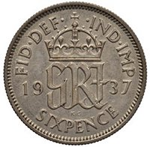
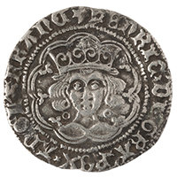
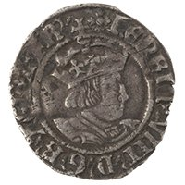
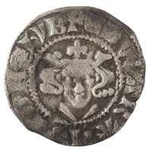
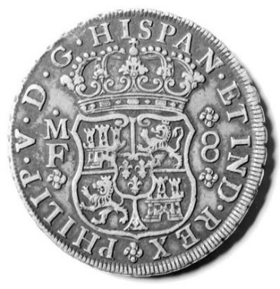

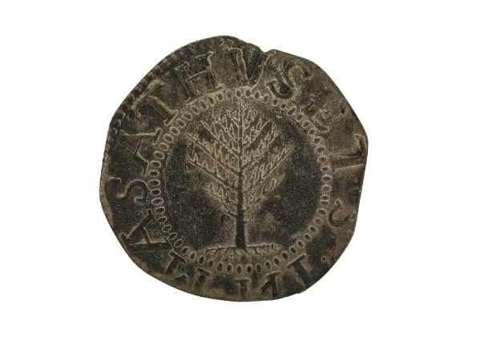
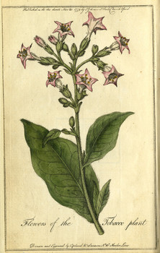
The official currency in the colonies was the British. Because the British did not want to send valuable metals to the colonies, it was very hard to find.
Shilling (12 pence) Sixpence Groat (four pence) Tuppence (half groat) Penny
Because British money was scarce, colonists had to become creative and find their own currency, however, officially it was illegal for the colonies to make their own money.
Spanish Pieces of Eight Wampum Boston Pine Tree Shilling Tobacco
Why would a local government be helpful, considering the many types of currency used in the colonies?

Think like an Economist Independent Assignment
Grade Level Focus: Eighth Grade
Topic: Early Governments in the American Colonies
Compelling Question: Why did the colonists want/need a local government?
TEKS: 8.3(A)(B)
Materials: The handout

Independent Assignment | What is an Economist?  - Explain that typically in a History class, students are asked to think like a historian, but for this activity they will need to think like an economist.  - As a class, define what an historian is and the types of questions a historian would ask.  - As a class, define what an economist is and the types of questions an economist would ask.
Explanation | What is an Economic Historian?  - Students will respond to two short answer questions and one question with a paragraph response: What does an Economic Historian do? What are some questions an Economic Historian would typically ask? Why did the colonists want/need a local government?

Think Like an Economist
Using your understanding of historians and economists, answer the following questions about the role of an Economic Historian.
- What does an Economic Historian do?

- What are some questions an Economic Historian would typically ask?

Using your understanding of early governments in colonial America, respond to the following question as if you were an Economic Historian. Answer with a paragraph that includes your answer and historic evidence to prove your response.
- Why did the colonists want/need a local government?

The Extremely Fictional Tale of Dr Pepper Plants

Grade Level Focus: Eighth Grade
Topic: Mercantilism
Compelling Question: Why did the American colonists rebel?
TEKS: 8.4(A)
Materials: Hand out and PowerPoint (the power point can be downloaded separately from the DPMFEI Website)

Engage | What could make people this mad?  - Using the power point (slide 2) and as a class, analyze the two pictures of colonial protests (burning of stamps and the Boston Tea Party). Discuss what students see in the pictures and what they think it could mean.
Explore | The Extremely Fictional Tale of Dr Pepper Plants  - Using the Power Point (slides 3-13), tell students the “Extremely Fictional Tale of the Dr Pepper Plans”, a metaphor for mercantilism in Colonial America. Read each slide and comment on the pictures as needed.
Explain | The Extremely True Tale of the Causes of the American Revolution  - Provide each student with a handout. Instruct students to complete the notes during the explanation.  - Using the Power Point (slides 14-22), explain how the story connects to the real events leading up to the American Revolution. Reach each slide and comment on the pictures as needed.
Elaborate | Independent Reflections  - As a class, look at the two pictures of colonial protests again. This time explain what is actually happening in the pictures: Colonists are destroying taxes items (stamped paper or imported tea) to protest the high taxes.  - As individuals, students will write a brief reflection to respond to the following question: How are protests in which the taxed item are destroyed effective or ineffective?
Evaluate | To assess student understanding of this topic, ask students to define Mercantilism and explain how it became a problem in Colonial America.

The Economic Causes of the American Revolution
Complete the notes below using the example of “The Extremely Fictional Tale of the Dr Pepper Plants” and the “Extremely True Tale of the Causes of the American Revolution” Power Points.
- What is Mercantilism?

  - Export:

  - Import:

  - How did England reduce its number of imports?

- What is a problem with Mercantilism?

  - Why is competition between businesses good for consumers?

  - How did American Colonists deal with this problem with Mercantilism?

- What is taxation?
  - What are two things taxes are used for?

  - Why did the English need to raise taxes?

  - Why were the American colonists upset about the taxes?

  - What, in addition to taxes, did the British do that upset the colonists?

Paying for the US Revolution
Grade Level Focus: Eighth Grade
Topic: Causes for Colonization
Compelling Question: How did the Continental Army pay for the American Revolution
TEKS: 8.2(A)(B)
Materials: A handout, group images to be cut out., and explanations are included after the lesson plan.

Engage | Wars cost money  - Share with your student some of the following statistics about US spending on the different wars (found at USA Today):  - War of 1812: $1.78 billion  - Mexican-American War: $2.72 billion  - American Revolution: $2.75 billion  - American Civil War : $22.99 billion (Confederacy) $68.17 billion (Union)  - WW1: $381.8 billion  - War in Afghanistan: $910.47 billion  - WW2: 4.6 trillion
Explore | Costs of the American Revolution  - Place primary sources that exhibit types of spending during the American Revolution around the classroom.  - Soldiers in the Continental Army sketch  - Washington’s Financial Papers  - Revolutionary War pay voucher  - Thomas Jefferson’s financial and military estimates  - George Washington’s Queries letter  - Instruct students to walk around the room, review the sources, and take notes on the different things the colonial army spent money on.  - Ask students to share what they found while reading the primary sources.
Explain | How the Colonial Army Paid for the American Revolution  - Show students the pie graph of how the Continental Army paid for the war and discuss (learn more here).
Elaborate | The Problem with Printing and Promising Money  - Ask the class “Why the United States doesn’t just print money whenever they need it?”.  - Then, use an example like “If there is only one Dr Pepper in the world and everyone wants it, it will have a high value. But if there are literally trillions of Dr Peppers in the world, it will have a low value”. Explain that the more of something there is the less value one of it is worth. The more US money printed means that each individual is worth very little.  - Show the students the Zimbobwe 100 Trillion Dollar Bill. Explain that because the country of Zimbobwe printed so much money, the 100 trillion bill is only worth $0.40 cents in USD!  - Ask the class what is bad about spending money that you don’t have (debt). Briefly discuss how personal debt and a country’s debt can have negative consequences.
Evaluate | To assess student understanding of this topic, ask students to identify two ways the Continental Army paid for the American Revolution.
Extension | This activity can be extended to address the National Debt and National Bank that began due to the debt from the American Revolution.

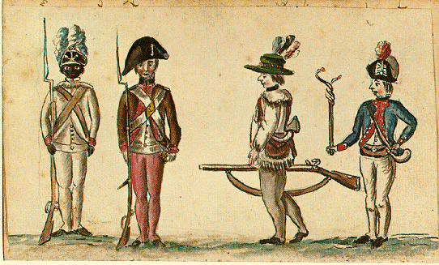
Soldiers of the Continental Army, sketch by a French army officer, circa 1781

In total, around 230,000 soldiers served in the Continental Army and there were 145,000 militiamen.

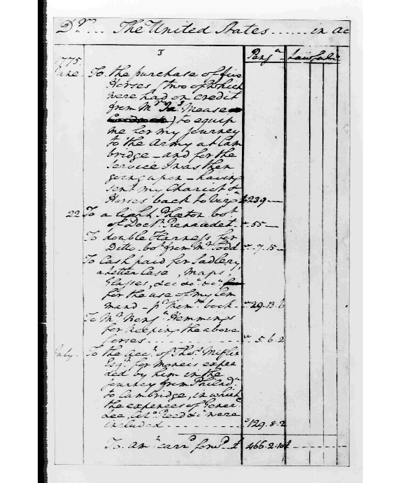
The first page of George Washington’s personal financial papers after being chosen as the General of the Continental Army.

"As to pay, Sir, I beg leave to assure the Congress, that, as no pecuniary consideration could have tempted me to have accepted this arduous employment, at the expense of my domestic ease and happiness, I do not wish to make any profit form it. I will keep an exact account of my expenses. Those, I doubt not, they will discharge, and that is all I desire." – George Washington

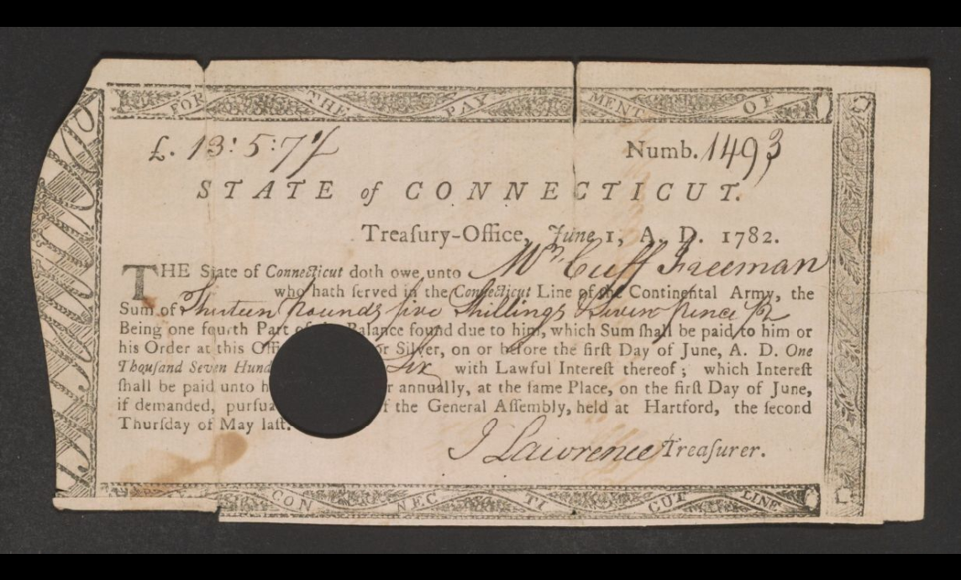
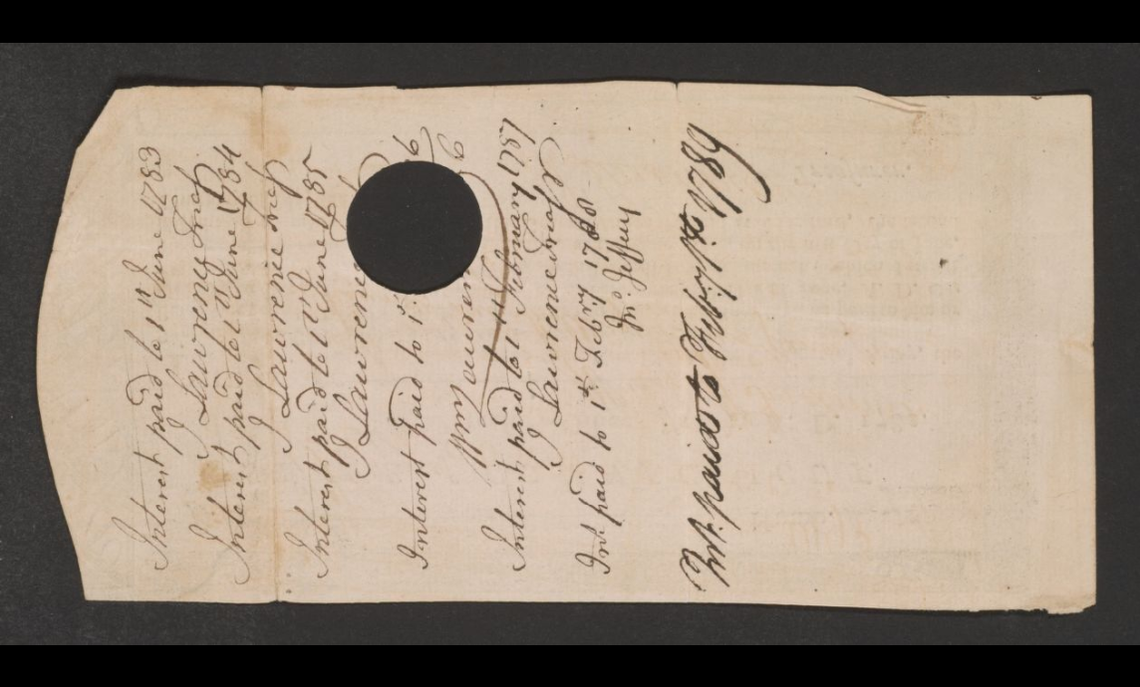
Revolutionary War documents, a pay voucher with notes for Cuff Freeman, who had served on the Continental line for Connecticut, 1780-1789.

On average, soldiers were paid about $6.25 a month.

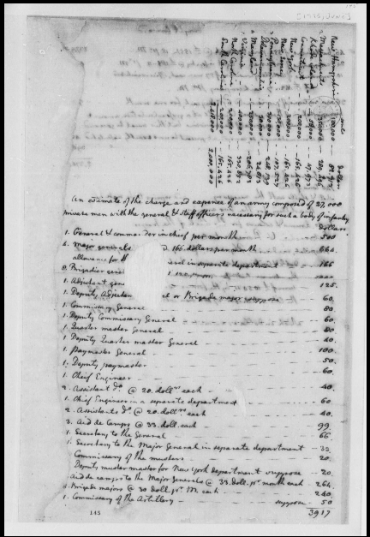
Thomas Jefferson, June-July 1775, Financial and Military Estimates for Continental Defense

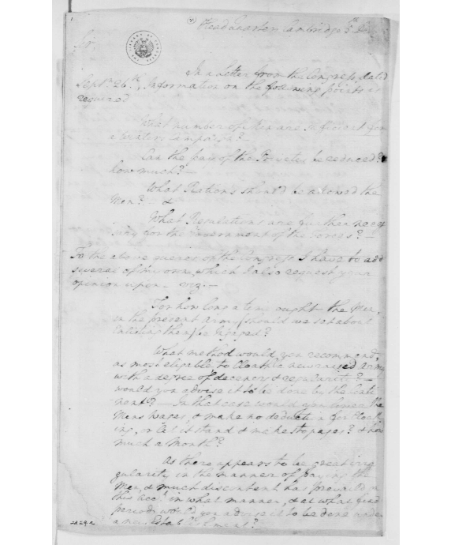
.
“ Sir: In a Letter from the Congress, dated 26th September, Information on the following points is required1 :

What number of men are sufficient for a Winters Campaign?

Can the pay of the Privates be reduced and how much?

What Rations should be allowed the Men?

What Regulations are further necessary for the Government of the Forces?

To the above queries of the Congress, I have to add several of my own, which I also request your Opinion upon viz.:—

For how long a time ought the Men in the present Army (should we set about enlisting them) be Ingaged?

What method would you recommend, as most eligable to Cloath a new raised Army with a degree of Decency and regularity? Would you advise it to be done by the Continent? In that case would you lower the Men's Wages, and make no deduction for Cloathing, or let it stand, and make stoppages? and how much a month?...”

George Washington Papers, Series 4, General Correspondence: George Washington writes to the Continental Army General Officers, October 5, 1775, Queries

Examples of money printed by states, money printed by congress, and a debt issued by congress.
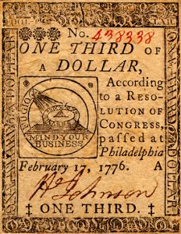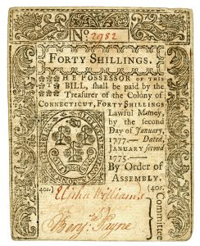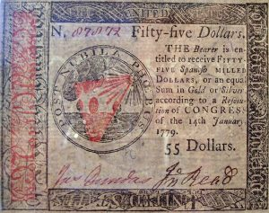
Example of Zimbabwe 100 hundred trillion dollar bill, worth $0.40 USD
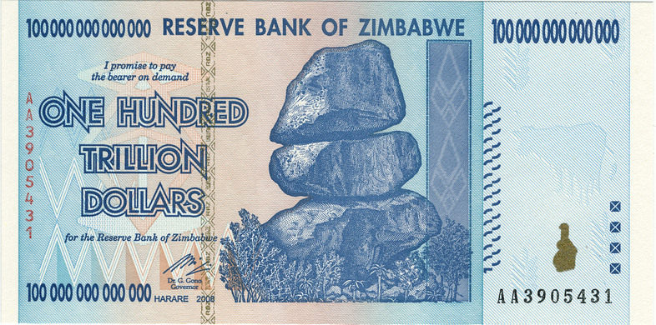
How did the Continental Army Pay for the Revolutionary War?

Congress sold bonds to wealthy Americans

Congress printed its own money

Congress received from Europe

Congress issued its own debt certificates

States printed their own money

States issued their own debt certificates

Planning an Economy Classroom Debate
Grade Level Focus: Eighth Grade
Topic: Early Political Parties and The Early US Economy
Compelling Question: How was our economy created the way it is?
TEKS: 8.4(A)(B) and 8.5(C)
Materials: Handout

Engage | Jefferson v Hamilton  - As a class, watch a video about the debates between Alexander Hamilton and Thomas Jefferson (ex: John Adams, Hamilton, or American Historical Theater)
Explore | Research  - Explain that when the Founding Fathers were planning the new US government, they had to plan the US banks and economy. There were two groups of people that had different opinions about the new economy and government.  - Divide the class into two (or four) groups and assign each either Federalists or Democratic-Republicans. Provide each student with a handout and each group with a description of their party and any classroom resources available to them to use.  - Instruct the groups to research their party, take notes on the handout, and plan a 3-minute argument to present to the class as a group.  - Give students time to prepare as a group.
Explain | Debate  - Instruct students to complete the rest of their handout while they listen to the opposing group’s arguments.  - Give each group time to present their 3-minute argument and answer questions from the apposing side.
Elaborate | Independent Reflection  - As individuals, students will write a brief reflection to respond to the following question: Which party’s plan do you think was best? Answer the question and then provide two pieces of evidence from the classroom debate to support it.
Evaluate | To assess student work of this topic, use the rubric.
Extension | This activity can be extended to address the National Debt and National Bank that began due to this debate.

Planning an Economy Classroom Debate

Group Work | The student contributed to the group work and collaborated with the group. | /20
Handout | The student completed the handout with accurate and clear information. | /20
Debate | The group presented a clear, accurate, and persuasive argument. | /60
 | Total | /100

Planning an Economy Classroom Debate
Use the points below, your textbook, and other available resources to take notes about the Federalist party and plan a 3-minute argument for the classroom debate.

Federalist Party | Democratic-Republican Party
Who led this party?  What group of people typically supported this party?  Additional Information: | Who led this party?  What group of people typically supported this party?  Additional Information:

Which party’s plan do you think was best? Answer the question and then provide two pieces of evidence from the classroom debate to support it.

The Federalist Party
Use the points below, your textbook, and other available resources to take notes about the Federalist party and plan a 3-minute argument for the classroom debate.

Basic Summary
- Rule by the wealthy class - Emphasis on manufacturing
- Strong federal government - Loose interpretation of the Constitution
- British alliance - National Bank
- Protective Tariffs - led by Alexander Hamilton

Below, make a plan for your 3-minute argument for the classroom debate.

The Democratic-Republican Party
Use the points below, your textbook, and other available resources to take notes about the Democratic-Republican party and plan a 3-minute argument for the classroom debate.

Basic Summary
- Rule by the people - Emphasis on agriculture
- Strong state government - Strict interpretation of the Constitution
- French alliance - State Bank
- Free Trade - led by Alexander Hamilton

Below, make a plan for your 3-minute argument for the classroom debate.

Tariffs Warm-Up
Grade Level Focus: Eighth Grade
Topic: Modern Tariffs
Compelling Question: What do modern tariffs do?
TEKS: 8.4(B) and 8.5(E)
Materials:

Engage | What did it really mean to move to the colonies?  - Show students a record of early tariffs in the United States (ex: French and US tariff 1788).
Explanation | Quick Discussion  - Remind students that tariffs were one of the causes for the American Revolution, were quickly part of the early economy, and are still in existence today. Remind them that a tariff is additional money added to international imported goods and is a way to protect the country’s businesses.  - Watch a clip about modern tariffs (Please carefully review and select the video that fits your class: Pres. Trump and EU, Pres. Trump and China, or the Impact of China Tariffs).  - Ask the students to write down a summary of the video they watched, explaining who the tariff impacts and why it is in place.

Modern Taxes Independent Assignment
Grade Level Focus: Eighth Grade
Topic: Early Governments in the American Colonies
Compelling Question: Why are there taxes?
TEKS: 8.4(B)
Materials: The worksheet

Explanation | What did it really mean to move to the colonies?  - Remind students that a tax is money added to a purchase that goes to support the government and community.  - As a class, make a list of items they know were taxes in history.  - As a class, define what an economist is and the types of questions an economist would ask.
Independent Assignment | Quick Discussion  - Students will research a modern tax of their choosing and answer the follow questions about the tax:  - What is the purpose of this tax?  - Who does the tax impact the most?  - Do you believe this tax is worthwhile?

Modern Taxes Independent Assignment

Using internet articles, newspaper articles, or the news, research a modern tax and respond to the following questions about that tax.

- Tax:________________________________________________________________________

- Name of Resource: ___________________________________________________________

- What is taxed?

- Where is the tax?

- What is the purpose of the tax?

- Who does the tax impact the most?

- Do you believe this tax is worthwhile? Why or why not?

Sources
Causes for Colonization:
Stock Photos from https://unsplash.com/
Colonial Currency Warm Up:
Time Article: Early American Colonists Had a Cash Problem by Sharon Murphy
Think Like an Economist Independent Assignment:
Economist Article: Economic History is Dead; Long Live Economic History? By C.R.
The Extremely Fictional Tale of Dr Pepper Plants:
Boston Tea Party image from the Library of Congress by N. Currier
Stamp Act Protest image from the Library of Congress
Paying for the American Revolution:
USA Today Money Article: What Were the Most Expensive Wars in US History?
Soldiers of the Continental Army sketch from the Library of Congress by a French army officer
George Washington’s Personal Financial Papers from the Library of Congress by George Washington
Revolutionary War Pay Voucher from the Library of Congress
Financial and Military Estimates for Continental Defense from the Library of Congress by Thomas Jefferson
George Washington’s letters from the Library of Congress by George Washington
Revolutionary War Timeline from the Library of Congress
Planning an Economy Classroom Debate:
PBS American Experience Article: The Duel
Referenced Teacher Resources from History with Bolman by Ms. Bolman
Tariffs Warm-Up:
Observations on New Tariff from the Library of Congress
The Washington Post Article: Trump is Using Tariffs to Advance a Radical Free-Trade Agenda by Marc Thiessen
CNBC Article: Trump says US will impose 10% tariffs on another $300 billion of Chinese goods starting Sept. 1 by Yun Li
CBS News Article: 5 US industries hit hardest by Trump’s latest China tariffs by Rachel Layne
Taxation Independent Assignment:
Policy Review Article: The Colonial Roots of American Taxation, 1607-1700 by Alvin Rabushka
Debt.org Article: Types of Taxes

